We gather in solidarity with women religious for
Communal Contemplative Prayer – Date, 20xx

Settle into the immense Love in which we live and move and have our being....
As I sit here, the beating of my heart,
the ebb and flow of my breathing, the movements of my mind
are all signs of God's ongoing creation of me.
I pause for a moment, and become aware
of this presence of God within me….
Notice if some words or images here lead you to rest in God. Follow them, or
just follow the Spirit.
The Welcoming Prayer by Father Thomas Keating
Welcome, welcome, welcome.
I welcome everything that comes to me today, because I know it's for my healing.
I welcome all thoughts, feelings, emotions, persons, situations, and conditions.
I let go of my desire for power and control.
I let go of my desire for affection, esteem, approval, and pleasure.
I let go of my desire for survival and security.
I let go of my desire to change any situation, condition, person or myself.
I open to the love and presence of God and God's action within. Amen.
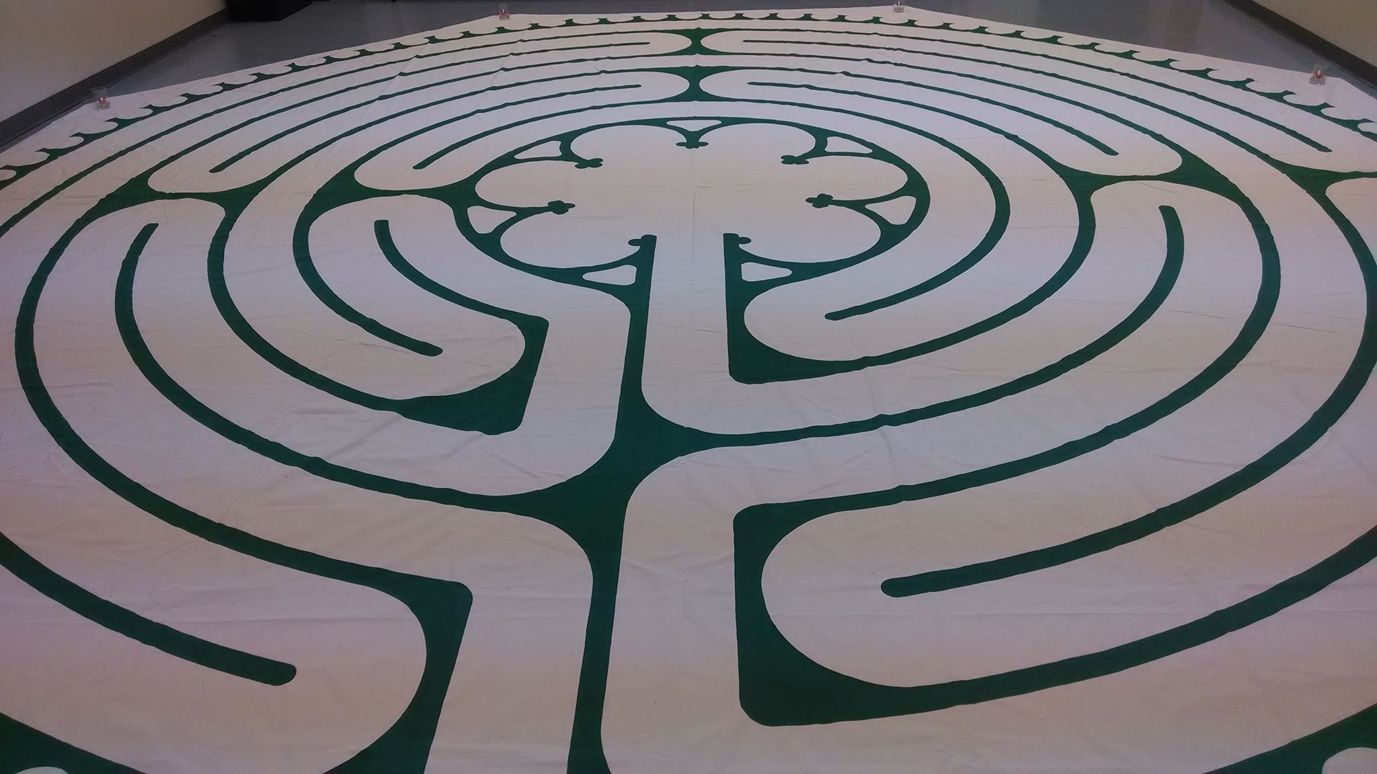
30 minutes of silence

We welcome one another’s reflections and prayers.

Closing: Dear God, may we never forget how much we need each other. After all, we are connected through your creation. Let us not be afraid to talk, to laugh, to cry, and to share stories and our lives with each other. Amen.

Or: Come, Holy Spirit. Fill the hearts of your faithful and kindle in us the fire of your love. Send forth your Spirit and we shall be created, and You shall renew the face of Earth. Amen.

Settling in: modified from Sacred Space, a website of the Irish Jesuits

Labyrinth image from Western North Carolina United Methodist Conference - https://www.wnccumc.org/labyrinth
First Closing prayer option: Maria Shriver’s Sunday Paper https://www.mariashriversundaypaper.com/

