Solidarity with Sisters Communal Contemplative Prayer – July 21-22, 2020
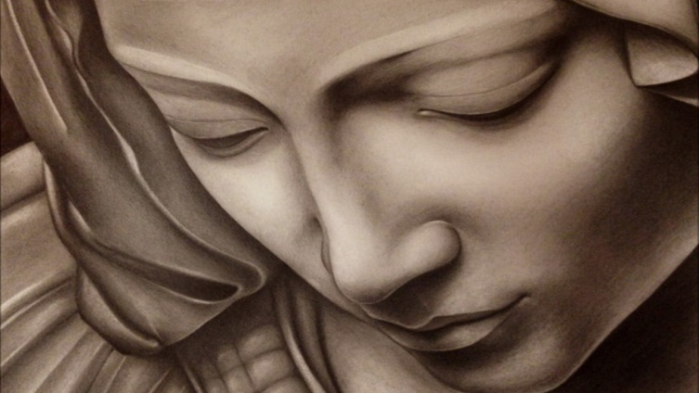
GATHERING

O God who creates and who gives breath,
be with us now as we come to you

with the great longings of our world

and of our selves.

We come together

trusting that the Spirit will be at work in us.

Help us to let go and to let come.
La Pieta di Michelangelo by David Franceschini

Help us to live the questions

and to move with you, in you, and toward you,

ever open to what is waiting to be born in us.

BEING HERE: Come as you are, in divine presence…

We are here because we believe God is with us and in us. Let’s let that belief in our heads spread into our bodies and our hearts. Feel the ways your body is supported right now, and rest into that support…. and be aware of God’s support. Feel your breath move in and out, how your chest and stomach rise and fall… and know that the Spirit is moving in you as surely and gently as the air. Let your breath slow and deepen as you relax into divine love. Let’s take one deep breath to be here… one to be here together… and one to let God fill us during 10 minutes of silence.

(10 minutes of silence)

AWARENESS

We are here to rest in God and to be transformed in God. So let us listen to the poem “A Litany for Those not Ready for Healing” by Dr. Yolanda Pierce:

Let us not rush to the language of healing, before understanding the fullness of the injury and the depth of the wound.

Let us not rush to offer a band-aid, when the gaping wound requires surgery and complete reconstruction.

Let us not offer false equivalencies, thereby diminishing the particular pain being felt in a a particular circumstance in a particular historical moment.

Let us not speak of reconciliation without speaking of reparations and restoration, or how we can repair the breach and how we can restore the loss.

Let us not rush past the loss of this mother’s child, this father’s child…someone’s beloved son.

Let us not value property over people; let us not protect material objects while human lives hang in the balance.

Let us not value a false peace over a righteous justice.

Let us not be afraid to sit with the ugliness, the messiness, and the pain that is life in community together.

Let us not offer clichés to the grieving, those whose hearts are being torn asunder.

Instead…

Let us mourn black and brown men and women, those killed extrajudicially every 28 hours.

Let us lament the loss of a teenager, dead at the hands of a police officer who described him as a demon.

Let us weep at a criminal justice system, which is neither blind nor just.

Let us call for the mourning men and the wailing women, those willing to rend their garments of privilege and ease, and sit in the ashes of this nation’s original sin.

Let us be silent when we don’t know what to say.

Let us be humble and listen to the pain, rage, and grief pouring from the lips of our neighbors and friends.

Let us decrease, so that our brothers and sisters who live on the underside of history may increase.

Let us pray with our eyes open and our feet firmly planted on the ground

Let us listen to the shattering glass and let us smell the purifying fires, for it is the language of the unheard.

God, in your mercy…
Show me my own complicity in injustice.
Convict me for my indifference.
Forgive me when I have remained silent.
Equip me with a zeal for righteousness.
Never let me grow accustomed or acclimated to unrighteousness.

Holy One, help us to let go and let come as we enter into 20 minutes of silence with you.

(20 minutes of silence)

INTENTION

Let’s invite each other to share the prayers that arise in us now. Our response will be: Holy One, hear our prayer.

God of mercy, help us to see ourselves and reality with your eyes. Help us to be alert for ways to be useful, along with the Leadership Conference of Women Religious and many congregations of Catholic sisters. Together give us courage to be your people. For this we pray. Holy One, hear our prayer.

(Shared prayers)
CLOSING

O Great Love, we place all of our prayers, those spoken and those unspoken, into your care, and we entrust the outcome to you. As we do, we use the words of Bishop Ken Untener: “This is what we are about: We plant seeds that one day will grow. We water seeds already planted, knowing that they hold future promise. We lay foundations that will need further development. We provide yeast that produces effects beyond our capabilities…. We are prophets of a future not our own.” And so together we pray: Come, Holy Spirit. Fill the hearts of your faithful and kindle in us the fire of your love. Send forth your Spirit and we shall be created, and you shall renew the face of the earth. Amen.

SIGN OF PEACE

