Solidarity with Sisters’ Communal Contemplative Prayer – August 4-5, 2020

GATHERING
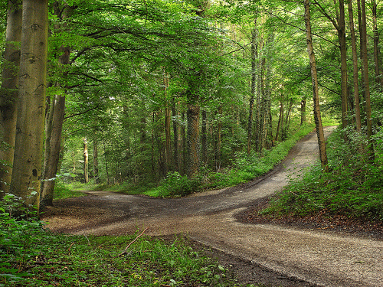
O God who creates and who gives breath,
be with us now as we come to you

with the great longings of our world

and of our selves.

We come together

trusting that the Spirit will be at work in us.

Help us to let go and to let come.

Help us to live the questions

and to move with you, in you, and toward you,

ever open to what is waiting to be born.

BEING HERE: Come as you are, in divine presence…

Let’s make space in ourselves for God. Let your body soften and relax – your neck… shoulders… torso… legs… feet…. Feel the support of your chair and of the floor…. Notice your breath and let it slow and deepen…. Let the Spirit flow into you with every breath…. Let’s take one deep breath to be here… one to be together… and one to welcome God. Let’s welcome the Spirit during 10 minutes of silence.

(10 minutes of silence)

AWARENESS

On August 12, the Leadership Conference of Women Religious will begin their annual Assembly, online. The theme is “God’s Infinite Vision: Our Journey to the Borders and Beyond.” Let us pray with a blessing that the sisters have been using in preparation. It is by John O’Donohue and is titled “The Interim Time,”

When near the end of day, life has drained
Out of light, and it is too soon
For the mind of night to have darkened things,
No place looks like itself, loss of outline
Makes everything look strangely in-between,
Unsure of what has been, or what might come.
In this wan light, even trees seem groundless.
In a while it will be night, but nothing
Here seems to believe the relief of darkness.
You are in this time of the interim
Where everything seems withheld.
The path you took to get here has washed out;
The way forward is still concealed from you.
"The old is not old enough to have died away;
The new is still too young to be born."
You cannot lay claim to anything;
In this place of dusk,
Your eyes are blurred;
And there is no mirror.
Everyone else has lost sight of your heart
And you can see nowhere to put your trust;
You know you have to make your own way
through.
As far as you can, hold your confidence.
Do not allow confusion to squander
This call which is loosening
Your roots in false ground,
That you might come free
From all you have outgrown.
What is being transfigured here is your mind,
And it is difficult and slow to become new.
The more faithfully you can endure here,
The more refined your heart will become
For your arrival in the new dawn.

Let us take this poem into 20 minutes of silence with our God of infinite vision.

(20 minutes of silence)

INTENTION

Let’s invite each other to share the prayers that arise in us now. Our response will be: Holy One, hear our prayer.

God of Infinite Vision, pour your presence into the Leadership Conference of Women Religious as they prepare to gather next week in their online Assembly. Show them your paths to the borders and beyond. Show us, too, and nourish our mutual solidarity. For this we pray. Holy One, hear our prayer.

(Shared prayers)
CLOSING

O Great Love, we place all of our prayers, those spoken and those unspoken, into your care, and we entrust the outcome to you. As we close, we are inspired by the words of Sister Eloise Garcia:
How might our prayers and intentions be joined across [communities]
for the common good of the whole Earth community
to help lift the spirits of a people, especially
in the wake of closed churches, synagogues, mosques, and other places of worship?
What would happen if Catholic sisters [and other lay people]
were to unleash the power of their lifetimes of prayer and contemplative practice
to hold the safety and protection of all peoples across the world as a sacred intention?
And so together we pray: Come, Holy Spirit. Fill the hearts of your faithful and kindle in us the fire of your love. Send forth your Spirit and we shall be created, and you shall renew the face of the earth. Amen.
SIGN OF PEACE

