We gather in solidarity with women religious for
Communal Contemplative Prayer – Date, 202x

Settle into the immense Love in which we live and move and have our being....
As I sit here, the beating of my heart,
the ebb and flow of my breathing, the movements of my mind
are all signs of God's ongoing creation of me.
I pause for a moment, and become aware
of this presence of God within me….
Notice if something here leads you to rest in Holy Mystery. Follow that path, or
just follow the Spirit.
“Living Peacefully with Complex, Unanswerable Questions”
Excerpt 1, by Sister Nicole Trahan

Moving through the world without being able to clearly see what may be directly ahead can be unsettling. However, it can also be a hopeful experience. With uncertainty comes opportunity. When the path ahead is not clear and the destination difficult to make out, it provides an opportunity to re-imagine, to re-shape, to be flexible and nimble.
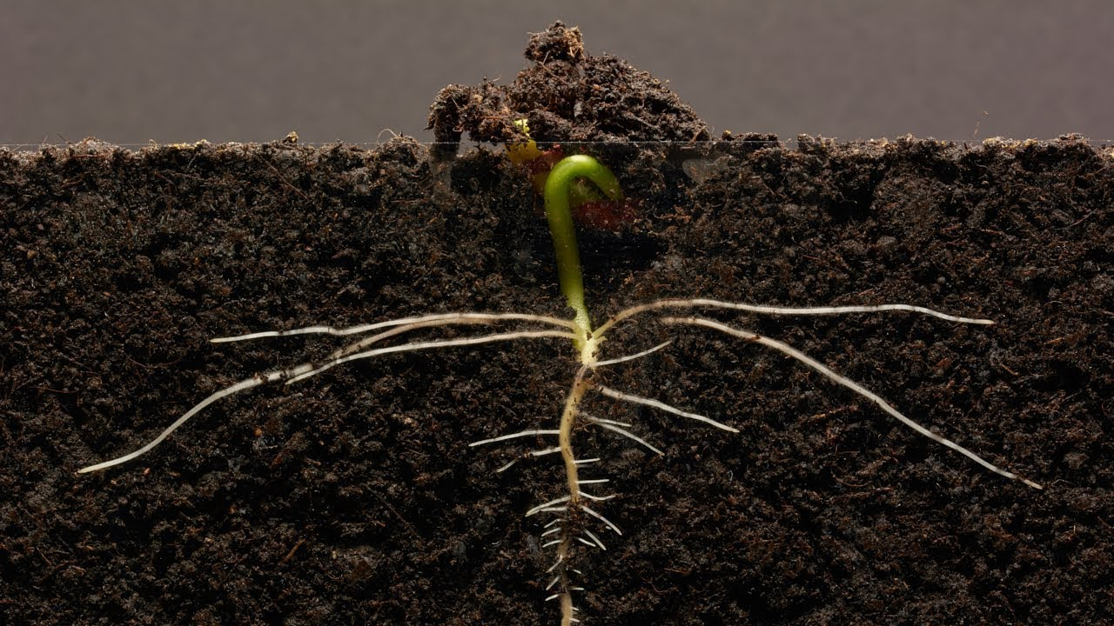
Not being able to give definitive answers can feel defeating, if not framed differently. The frame or lens I like is the image of an unfolding path or one that we are building as we walk on it. With an emphasis on creativity, openness to the Spirit, and working together to build our common future, it is easier to be hopeful.

30 minutes of silence

We welcome one another’s reflections and prayers.

Closing: Dear God, may we never forget how much we need each other. After all, we are connected through your creation. Let us not be afraid to talk, to laugh, to cry, and to share stories and our lives with each other. Amen.

Or: Come, Holy Spirit. Fill the hearts of your faithful and kindle in us the fire of your love. Send forth your Spirit and we shall be created, and You shall renew the face of Earth. Amen.

Settling in: modified from Sacred Space, a website of the Irish Jesuits

Reading: from the Winter 2022 Occasional Papers of the Leadership Conference of Women Religious, on the theme “The Unknown: A Place of Potential and Possibility.” This excerpt is from the article whose title is cited above, in which Sister Annmarie Sanders interviews four younger women religious: Felician Sister Grace Marie Del Priore, Humility of Mary Sister Ellis McCulloh, Marianist Sister Nicole Trahan, and Jane Aseltytine, a Sister of the Immaculate Heart of Mary of Monroe, Michigan.
Image: “Bean time lapse: 25 days, Soil Cross Section” – by GPhase https://www.youtube.com/watch?v=w77zPAtVTuI
First Closing prayer option: Maria Shriver’s Sunday Paper https://www.mariashriversundaypaper.com/

