We gather in solidarity with women religious for
Communal Contemplative Prayer – Date, 202x

Settle into the immense Love in which we live and move and have our being....
As I sit here, the beating of my heart,
the ebb and flow of my breathing, the movements of my mind
are all signs of God's ongoing creation of me.
I pause for a moment, and become aware
of this presence of God within me….
Notice if something here leads you to the Holy One. Follow that path, or
just follow the Spirit.
“Living Peacefully with Complex, Unanswerable Questions”
Excerpt 4, by Sister Jane Aseltyne

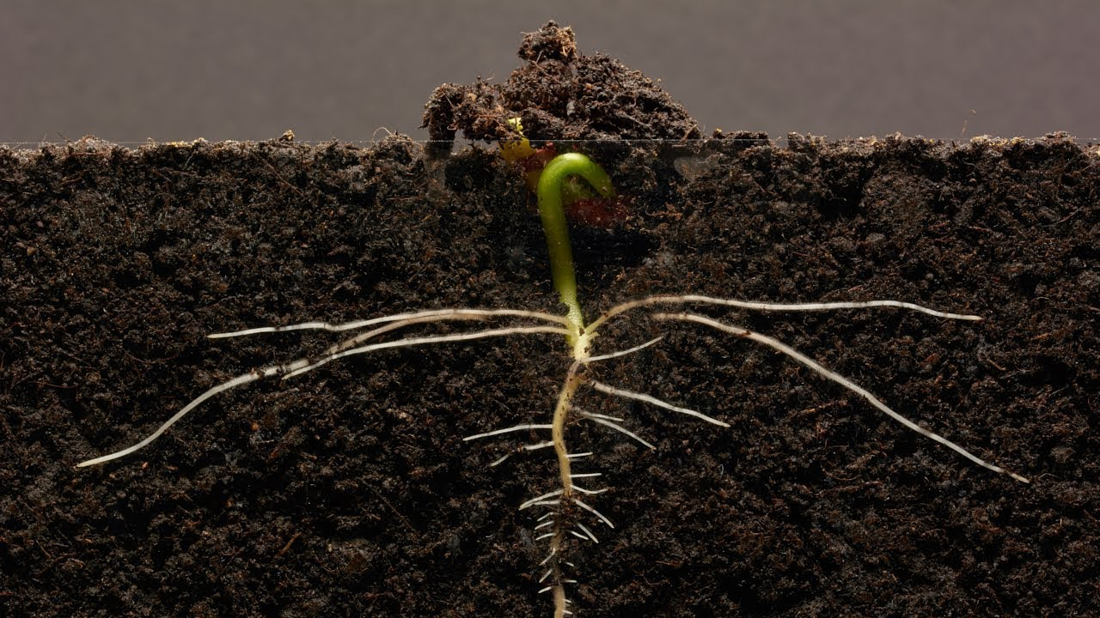
Etty Hillesum was a young Dutch Jewish woman who refused offers to go into hiding during World War II. Instead, she went to Auschwitz with her people, where she was eventually killed. Her book, An Interrupted Life, is a collection of her writings between 1941 and 1943 amid the German occupation. In the thick of the horrors of the war, Etty managed to write about peace:

“Ultimately, we have just one moral duty: to reclaim large areas of peace in ourselves, more and more peace, and to reflect it toward others. And the more peace there is in us, the more peace there will also be in our troubled world.”

30 minutes of silence

We welcome one another’s reflections and prayers.

Closing: Dear God, may we never forget how much we need each other. After all, we are connected through your creation. Let us not be afraid to talk, to laugh, to cry, and to share stories and our lives with each other. Amen.

Or: Come, Holy Spirit. Fill the hearts of your faithful and kindle in us the fire of your love. Send forth your Spirit and we shall be created, and You shall renew the face of Earth. Amen.

Settling in: modified from Sacred Space, a website of the Irish Jesuits

Reading: from the Winter 2022 Occasional Papers of the Leadership Conference of Women Religious, on the theme “The Unknown: A Place of Potential and Possibility.” This excerpt is from the article whose title is cited above, in which Sister Annmarie Sanders interviews four younger women religious: Felician Sister Grace Marie Del Priore, Humility of Mary Sister Ellis McCulloh, Marianist Sister Nicole Trahan, and Jane Aseltytine, a Sister of the Immaculate Heart of Mary of Monroe, Michigan.
Image: “Bean time lapse: 25 days, Soil Cross Section” – by GPhase https://www.youtube.com/watch?v=w77zPAtVTuI
First Closing prayer option: Maria Shriver’s Sunday Paper https://www.mariashriversundaypaper.com/

