We gather in solidarity with women religious for
Communal Contemplative Prayer – Date, 202x

Settle into the immense Love in which we live and move and have our being....
As I sit here, the beating of my heart,
the ebb and flow of my breathing, the movements of my mind
are all signs of God's ongoing creation of me.
I pause for a moment, and become aware
of this presence of God within me….
Notice if something here leads you to the Holy One. Follow that path, or
just follow the Spirit.
“Living Peacefully with Complex, Unanswerable Questions”
Excerpt 1, by Sister Nicole Trahan

Moving through the world without being able to clearly see what may be directly ahead can be unsettling. However, it can also be a hopeful experience. With uncertainty comes opportunity. When the path ahead is not clear and the destination difficult to make out, it provides an opportunity to re-imagine, to re-shape, to be flexible and nimble.

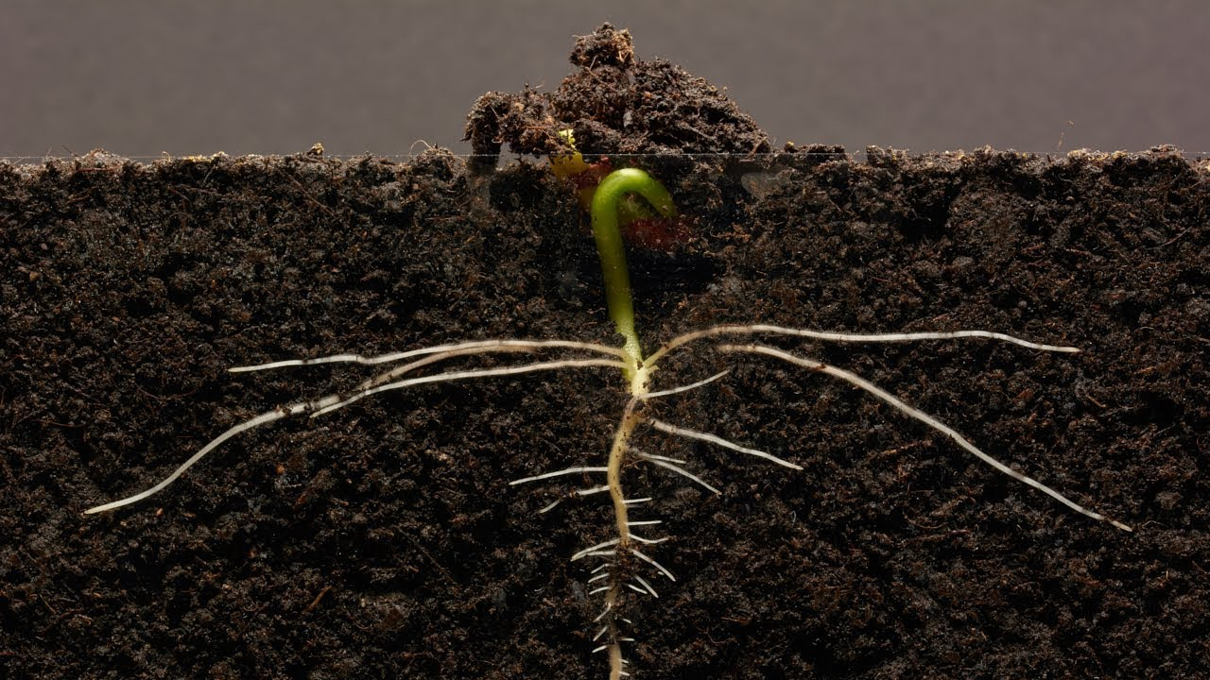
Not being able to give definitive answers can feel defeating, if not framed differently. The frame or lens I like is the image of an unfolding path or one that we are building s we walk on it. With an emphasis on creativity, openness to the Spirit, and working together to build our common future, it is easier to be hopeful.

“Living Peacefully with Complex, Unanswerable Questions”
Excerpt 2, by Sister Grace Marie Del Priore

Questions often lead not to definitive answers, but to more questions. For me, they are opportunities to explore the deeper meanings stirring in my heart and mind. What continues to propel us on the spiritual journey? For me, there is freedom and joy in embracing the questions and allowing them to inform our lives and our future.

Children inspire me to live peacefully with uncertainty. They’re playful, with a sense of adventure. They’re open to what comes and have fun with it. They can do this because they trust their parents, they know they’re safe and cared for. In the same way, I can trust the Holy One to hold me tenderly.

“Living Peacefully with Complex, Unanswerable Questions”
Excerpt 3, by Sister Ellis McCulloh

For a long time, my constant prayer mantras have been, “Be where your feet are” and “When you pray, move your feet.” I am most inclined to live 100 steps ahead of the present moment – dreaming about ways to respond, planning events well into the future, thinking about my next ministry, etc. Regular spiritual direction, prayer, and time with friends and community help me stay grounded in the present moment. They remind me that the future isn’t mine to plan, but mine (ours) to live into. Our next step isn’t a giant hurdle to be leapt, but a constant moving forward and listening, learning, and being challenged by all the voices around me.

For me, the larger questions are about what is at the heart of life. What continues to propel us on the spiritual journey? For me, there is freedom and joy in embracing the questions and allowing them to inform our lives and our future

“Living Peacefully with Complex, Unanswerable Questions”
Excerpt 4, by Sister Jane Aseltyne

Etty Hillesum was a young Dutch Jewish woman who refused offers to go into hiding during World War II. Instead, she went to Auschwitz with her people, where she was eventually killed. Her book, An Interrupted Life, is a collection of her writings between 1941 and 1943 amid the German occupation. In the thick of the horrors of the war, Etty managed to write about peace:

Ultimately, we have just one moral duty: to reclaim large areas of peace in ourselves, more and more peace, and to reflect it toward others. And the more peace there is in us, the more peace there will also be in our troubled world.

30 minutes of silence

We welcome one another’s reflections and prayers.

Closing: Dear God, may we never forget how much we need each other. After all, we are connected through your creation. Let us not be afraid to talk, to laugh, to cry, and to share stories and our lives with each other. Amen.

Or: Come, Holy Spirit. Fill the hearts of your faithful and kindle in us the fire of your love. Send forth your Spirit and we shall be created, and You shall renew the face of Earth. Amen.

Settling in: modified from Sacred Space, a website of the Irish Jesuits

Reading: from the Winter 2022 Occasional Papers of the Leadership Conference of Women Religious, on the theme “The Unknown: A Place of Potential and Possibility.” This excerpt is from the article whose title is cited above, in which Sister Annmarie Sanders interviews four younger women religious: Felician Sister Grace Marie Del Priore, Humility of Mary Sister Ellis McCulloh, Marianist Sister Nicole Trahan, and Jane Aseltytine, a Sister of the Immaculate Heart of Mary of Monroe, Michigan.
Image: “Bean time lapse: 25 days, Soil Cross Section” – by GPhase https://www.youtube.com/watch?v=w77zPAtVTuI
First Closing prayer option: Maria Shriver’s Sunday Paper https://www.mariashriversundaypaper.com/

