We gather in solidarity with women religious for
Communal Contemplative Prayer – Date, 202x

Settle into the immense Love in which we live and move and have our being....
As I sit here, the beating of my heart,
the ebb and flow of my breathing, the movements of my mind
are all signs of God's ongoing creation of me.
I pause for a moment, and become aware
of this presence of God within me….
Notice if some words or images here lead you to rest in God. Follow them, or
just follow the Spirit.
A reading from Catherine de Hueck Doherty,
a Russian-Canadian Catholic social worker, in her book Poustinia.
(Poustinia is a Russian word for a small, sparsely furnished cabin or room where one goes
to pray and fast alone in the presence of Holy Mystery.)

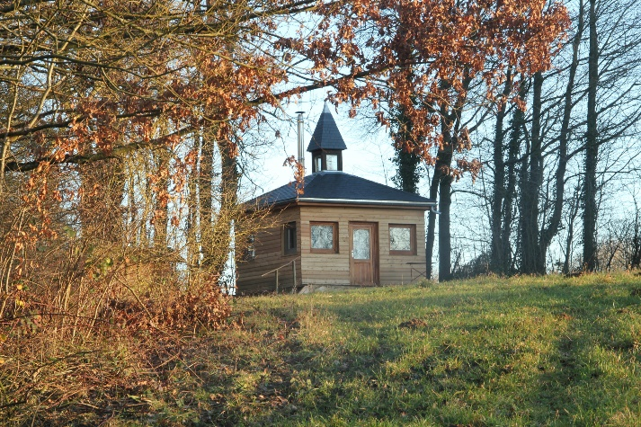
There is a poustinia of the heart. Why should my heart be removed from the Holy One while I am talking to you? When you are in love with someone, it seems that the face of the beloved is before you when you drive, when you type, when you are taking out insurance, and so on. Somehow or other we can encompass these two realities, the face of the beloved and whatever we happen to be doing. Prayer is like that.

30 minutes of silence

We welcome one another’s reflections and prayers.

Closing: Dear God, may we never forget how much we need each other. After all, we are connected through your creation. Let us not be afraid to talk, to laugh, to cry, and to share stories and our lives with each other. Amen.

Or: Come, Holy Spirit. Fill the hearts of your faithful and kindle in us the fire of your love. Send forth your Spirit and we shall be created, and You shall renew the face of Earth. Amen.

Settling in: modified from Sacred Space, a website of the Irish Jesuits

Reading: from Pax Chrsti’s wonderful out-of-print book, Peacemaking Day by Day, Volume 3 (Nov. 29)
First Closing prayer option: Maria Shriver’s Sunday Paper https://www.mariashriversundaypaper.com/

