We gather in solidarity with women religious for
Communal Contemplative Prayer – Date, 20xx

Settle into the immense Love in which we live and move and have our being....
As I sit here, the beating of my heart,
the ebb and flow of my breathing, the movements of my mind
are all signs of God's ongoing creation of me.
I pause for a moment, and become aware
of this presence of God within me.

“Angels” by Mary Oliver
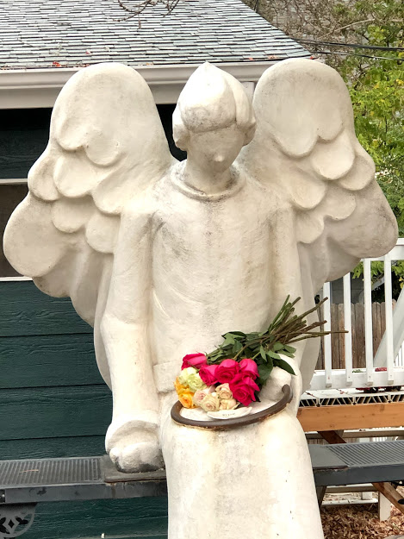
You might see an angel anytime
and anywhere. Of course you have
to open your eyes to a kind of
second level, but it’s not really
hard. The whole business of
what’s reality and what isn’t has
never been solved and probably
never will be. So I don’t care to
be too definite about anything.
I have a lot of edges called Perhaps
and almost nothing you can call
Certainty. For myself, but not
for other people. That’s a place
you just can’t get into, not
entirely anyway, other people’s
heads.
I’ll just leave you with this.
I don’t care how many angels can
dance on the head of a pin. It’s
enough to know that for some people
they exist, and that they dance.
30 minutes of silence

We welcome one another’s reflections and prayers.

Closing: Dear God, may we never forget how much we need each other. After all, we are connected through your creation. Let us not be afraid to talk, to laugh, to cry, and to share stories and our lives with each other. Amen.

Or: Come, Holy Spirit. Fill the hearts of your faithful and kindle in us the fire of your love. Send forth your Spirit and we shall be created, and You shall renew the face of Earth. Amen.

Settling in: modified from Sacred Space, a website of the Irish Jesuits

Poem thanks to Kathleen Cross. Image thanks to https://writerinthepines.com/2021/02/11/angels-by-mary-oliver/

First Closing prayer option: Maria Shriver’s Sunday Paper https://www.mariashriversundaypaper.com/

