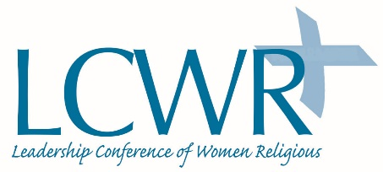
Leadership Conference of Women Religious -- 2018 Assembly
“Being the Presence of Love: The Power of Communion”
Assembly Schedule

Tuesday, August 7, 2018
7:00 – 8:30 PM | Opening of the Assembly | Open to media
Wednesday, August 8, 2018
7:30 AM | Eucharistic Liturgy | Open to media
9:00 AM | Opening to the Graces of the Assembly | Open to media
9:15 AM | Presidential Address: Teresa Maya, CCVI | Open to media
10:30 AM | Break
11:15 AM | Deepening Groups (breakout sessions of contemplative dialogue in groups of seven)
12:30 PM | Lunch break
2:00 PM | Emerging Wisdom Reflections | Open to media
2:15 PM | Keynote Session: In the Image of the Trinity: To Be Is To Be In Relation – Gloria Schaab, SSJ | Open to media
3:45 PM | Break
4:30 PM | Process | Open to media
5:15 PM | Executive Session – Candidates’ Forum
5:45 PM | Being the Presence of Love Reflection | Open to media
6:00 PM | Closing
8:30 PM | Communal Contemplation (optional) – Park View | Open to media
Thursday, August 9, 2018
7:30 AM | Eucharistic Liturgy | Open to media
8:50 AM | Voting on officers | Open to media
9:00 AM | Keynote Address: Trinity as Source, Word, and Spirit of Love: Relationship to the Core of Reality – Heidi Russell | Open to media
10:30 AM | Break
11:15 AM | Deepening Groups (breakout sessions of contemplative dialogue in groups of seven)
12:30 PM | Lunch break
2:30 PM | Emerging Wisdom Reflections | Open to media
2:45 PM | Executive Session: LCWR Matters
4:00 PM | Break
4:30 PM | Executive Session: LCWR Matters
5:20 PM | Being the Presence of Love Reflection | Open to media
5:30 PM | Closing
8:30 PM | Communal Contemplation (optional) Park View | Open to media
Friday, August 10, 2018
7:30 AM | Communal Contemplation (optional) Park View | Open to media
9:00 AM | Keynote Session: The Mystery of the Incarnation: Revelation of the Triune God as a Vulnerable God – Simon Pedro Arnold, OSB | Open to media
10:30 AM | Break
11:00 AM | Assembly Resolution Hearing | Open to media
11:45 AM | Being in Communion: Standing Against Racism (includes procession to Old Courthouse | Open to Media
12:15 PM | Lunch break
2:00 PM | Concluding Process | Open to media
2:45 PM | Blessing of LCWR Leadership | Open to media
3:15 PM | Break
3:45 PM | Eucharistic Liturgy | Open to media
7:00 PM banquet starts, award presentation – 7:30 (approx.) | Presentation of LCWR Outstanding Leadership Award to Sister Anita Baird, DHM (This will take place during the closing banquet. Unfortunately due to space, we cannot accommodate the media with a meal at the banquet.) | Open to media

Schedule as of July 5, 2018 (subject to change)

