**Solidarity with Sisters’ Communal Prayer**

**Sunday, Jan. 15, 2023**

**Second Sunday in Ordinary Time**

*God shows no partiality. (Acts 10:35)*

**HELLOs** and then Zoom host mutes everyone.

**WELCOME  (Debbie Ballard)**

Welcome, everyone!

* Introductions – people who haven’t been here before?
* Kathy and Lin Linabery, Norb Bufka and I had the pleasure of preparing the prayer for today.
* Thanks to Linda Donaldson and Reggie Ott for singing today and to Terri Butel for sharing music and slides. Thanks to George Fulk, Peg Duchesne, Maryann Dolan, Charlotte Cook, Judy Sholes, Kathy Heller, Nancy Sushinsky, Sr. Jo’Ann De Quattro, and Jim De Quattro for reading and leading us in prayer.
* We are always looking for new readers. If you’d like to read on Jan. 22, please contact Cecilia and Mary and on Jan. 29, Richard. Their email addresses are in Chat. This really helps planners. Thank you!
* We want to remind you that you will receive your invitation and script for this coming Sunday from Lynn Bufka. The zoom address will be the same through Pentecost.

**SETTLING IN (Debbie Ballard)**

Let’s move from greeting each other to making our hearts quiet for the coming of God. Take a deep breath…. Again… Let your breath carry ease into the muscles of your face…. And into your neck and shoulders.… Let your breath fill you… Soften you… And carry you into the peace of God…. Here… Now… Together….

**Debbie**: Now let us listen and join in singing our opening song as we enter our celebration.

**OPENING SONG                         All Are Welcome**

**Terri:** All are Welcome by Marty Haugen (with lyrics) <https://www.google.com/search?q=hynn+all+are+welcome&rlz=1C1SQJL_enUS766US766&oq=hynn+all+are+welcome&aqs=chrome..69i57.9868j0j7&sourceid=chrome&ie=UTF-8#fpstate=ive&vld=cid:0fce4790,vid:N9bOiAxwi4U>

(Debbie: Introduce Jo’AnnDe Quattro if Jo’Ann does not begin.)

**GREETING and Gathering Prayer (Jo’Ann De Quattro)**

Beloved Community, rejoice!Emmanuel is alive in us!  Alleluia!  Alleluia!

**All:** Thanks be to God!  Alleluia!  Alleluia!

We gather because God comes to us, not only in a singular Christmas event but also in each person and in each generation’s lifetime. The scriptures tell us a long-treasured story of salvation for a people beloved of God. We are called today to tell this story in a fresh, compelling way – with our lives. We ask to make the pathway straight for the coming of God.

And so we pray: Emmanuel, God with us, we give you this next hour with confidence that you will act in us and through us. We believe that you will give us light for our next step. Blessed Be.

(Debbie: introduce George Fulk if he doesn’t start.)

**INTRODUCTION TO THEME  (George Fulk)**

During Advent we heard the cry of John the Baptist to change our ways and believe the good news. Today we celebrate the Baptism of Jesus by John in the Jordan river. The meaning of baptism in Jesus’ day was very different from our own. Even though we use the word “purification” for the rite, it was really a ritual of separation. Jews used specially prepared baths called mikvehs at the temple to cleanse themselves, and thus exclude unclean Gentiles or others with unclean practices.

The baptism of Jesus was quite different. It was in a public place, in a river of flowing water. This suggests that a symbolic meaning of the Baptism of Jesus was one of inclusion, not separation. This is borne out in our third readings from Acts and Paul’s Letter to the Galatians.

We hope our prayer today will embody this meaning of baptism as we sing with Linda “We have put on Christ. In Christ we have been baptized.”

**SUNG ANTIPHON (Linda Donaldson)**

We have put on Christ, in Christ we have been baptized.

Alleluia, Alleluia! (repeat)

Debbie: Now Peg Duchesne will read from Matthew’s gospel, Chapter 3:13-17, followed by questions and silence for reflection. Feel free to stay with whatever question calls you.  

**READING 1 (Peg Duchesne)**

Jesus came from Galilee to John at the Jordan

to be baptized by him. John tried to prevent him, saying,

“I need to be baptized by you, and yet you are coming to me?”

Jesus said to him in reply, “Allow it now, for thus it is fitting for us

to fulfill all righteousness.” Then John reluctantly agreed. allowed him.

After Jesus was baptized, he came up from the water and behold,

the heavens were opened for him, and he saw the Spirit of God descending like a dove

and coming upon him. And a voice came from the heavens, saying,

“This is my Own, my beloved, with whom I am well pleased.”

**REFLECTIVE QUESTIONS 1 (Jim De Quattro)**

Reflect on why Jesus insisted that John baptize him.

How has your understanding or experience of baptism evolved through the years?

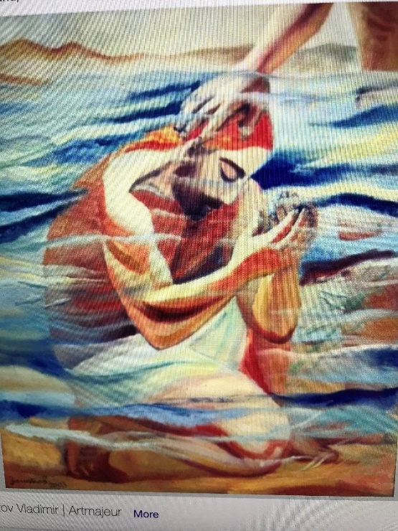Most of us here today were baptized as infants at least 50 years ago. These baptisms were typically private rituals. How would you feel about being baptized as an adult in a public place like a river, with strangers present?

**COMMUNAL SILENCE**  **(Terri:** Share slide 1 with “Baptism of Jesus by John,” time 2:00, chime, stop slide.**)**

**Debbie:** Kathy Linabery will now read from an adaptation of an excerpt from writings by Brian D. McLaren.

**READING 2 (Kathy Linabery)**

In those days, baptism had two distinct meanings.

For conventional temple adherents, it meant separating oneself from Gentiles (people of foreign religions) and conforming to a conventional establishment identity.

For some groups, it meant separating oneself from one’s conventional compatriots and taking on a radical, counter establishment identity, like the Essenes.

For both, it meant washing away contamination; separation from unclean acts, things, places, and people; the establishment of a distinct and oppositional identity.

The baptism of Jesus was far different from these two meanings. It took place in a public area, not the temple precinct or within a private group. It took place in a river, possibly muddy, not in a private prepared bath.

Christian Baptism signals immersion into Christ, so that from now on, inside the identity of Christ, we look out at the other through his eyes, so to speak. It is immersion into the kingdom or commonwealth of God, so that we now see all people from the perspective of this new filial citizenship, an identity that does not separate us from anyone else nor does it put us in a new super identity.

**REFLECTIVE QUESTIONS 2 (Jim De Quattro)**

How does this understanding of baptism affect your way of seeing others near you and in the larger world?

What does it mean for you to look at the world through the eyes of Jesus?

Recall a time when you looked at a person or situation through the eyes of Jesus and saw something unexpected.

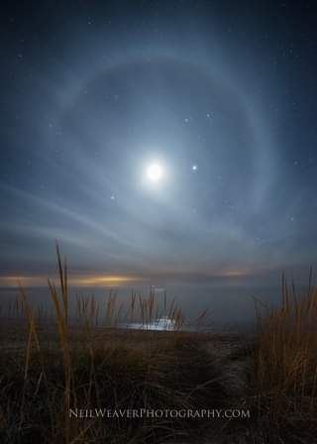**COMMUNAL SILENCE**    **(Terri:** Share slide 2, time 2:00, chime, stop slide2.)

**Debbie**: Now Charlotte Cook will read from the Book of Acts and the letter of St. Paul to the Galatians, followed by a short reflection.

**READING 3 (Charlotte Cook)**

Acts 10:34-35

Peter proceeded to speak to those gathered in the house of Cornelius, saying:

“In truth, I see that God shows no partiality.

Rather, in every nation, whoever fears God and acts uprightly

is acceptable to God.

*(Pause)*

St. Paul wrote to the Galatians (3:28):

There is neither Jew nor Gentile, neither slave nor free, nor is there male and female, for you are all one in Christ Jesus.

*(Pause)*

These two readings call us to view our baptism as something more than initiation into discipleship or the Church, which it certainly is, but it calls us to a way of life that views the world in a broader vision through the eyes of Jesus.

That vision calls us to see no partiality among people but only see them as children of God. We are called not to divide people into groups like gays and straights, blacks and whites, Americans and immigrants, Christians and Muslims and Jews, nor even the baptized and atheists. We are all children of God.

*(Slight pause)*

**REFLECTIVE QUESTIONS 3 (Jim De Quattro)**

How do these readings move you into a change of heart and a way of seeing others?

In what ways are you called to stop dividing people into “good” and “bad”?

Consider a person or group that it is hard for you see as children of God. (pause) Sit with the feelings that arise in you.

**COMMUNAL SILENCE**   **(Terri:** Share slide 3, time 2:00, chime, stop slide.**)**

Selma march anniversary

**SUNG ANTIPHON at the end of silence        (Linda Donaldson)**

We have put on Christ, in Christ we have been baptized.

Alleluia, Alleluia! (repeat)

**Debbie:**  Nancy Sushinsky will now lead our sharing.

**SHARING  (Nancy Sushinsky)**

We invite you to share briefly what emerged in **your** heart this morning as you listened and as you reflected on these readings.  That helps us to glimpse the many ways God is among us.  We welcome new voices, and we also know that the wisdom of this community includes both words shared and silent listening.  And let's leave a breath of silence between speakers which allows us to take in more fully what was just said.

We begin in silence as we gather our reflections.  *[Long pause.]*

Please unmute yourself to speak, and mute again afterwards.  Who would like to begin?

(Sharing)

*[Let sharing continue for about 20 minutes ending by twenty minutes after the hour.]*

Thank you.  We have to stop now, and we can continue after the final song, as we often do.

Nancy Sushinsky: Now Kathy Heller will lead us in prayer.

**PRAYERS OF THE COMMUNITY (Kathy Heller)**

We begin our ordinary time by celebrating our rebirth in baptism and bring to God what is in our hearts. Our response will be: **Spirit of Love, hear our prayer**.

Our baptism invites us to share the best part of ourselves.  Help us during this new year to mirror Jesus in our thoughts, desires, words, and actions.

For this we pray: **Spirit of Love, hear our prayer**.

God among us, animate the Leadership Conference of Women Religious as they ask not simply what they are to do for your kingdom, but how they are to be your love.  For this we pray: **Spirit of Love, hear our prayer**.

For all who care with tenderness for the sick and dying;

who allow compassion to replace indifference;

who reach out to those who struggle to believe in their own goodness;

who serve us in ways we overlook.

For this we pray: **Spirit of Love, hear our prayer**.

That the leaders of our country will act and speak in ways that unite and not divide our country. For this we pray: **Spirit of Love, hear our prayer**.

May the example of Jesus, and the call of our baptism,

fill us with enthusiasm for life each day.

We remember that You are the Living Water

who quenches our thirst and gives us zest for living.

With grateful hearts, we pray: **Spirit of Love, hear our prayer**.

Now let’s remember the feelings and prayers that arose in us as we shared reflections, and also the prayers we carry with us.  *[Pause.]*

Now, for what else shall we pray?  Please remember to unmute and mute yourself.

(People speak.)  **Spirit of Love, hear our prayer**.

Thank you.

O God, we give you all our prayers, spoken and unspoken.  We will do all that we can to put our prayers into action – while entrusting the outcome to you.  Amen.

**Kathy Heller**: now Maryann Dolan will lead us in the Celebration of Communion:

**CELEBRATION OF COMMUNION  (Maryann Dolan)**

O Great Love, we are humbled and emboldened

to know that you trust us to be your body in this world.

We are part of that body as we let go of all that separates us from you,

and as we embrace one another and your entire creation with merciful love.

We give you thanks for your presence in and among us.  *[Pause.]*

We remember the night before Jesus died.

At dinner with friends, Jesus knew all that would soon be asked of them,

and, loving them to the end, Jesus showed them how to care for each other

as they went out into the world.

First Jesus washed their feet

and said, “… as I have done for you, you should also do.”

Then he looked at what was in front of them, the bread and the wine,

gifts of Earth and the work of human hands, and blessed them.

So let us, too, invite God right now into what is front and center in our lives

knowing that God will indeed enter what we offer – and bless it.  *[Pause.]*

Holy One, make us your bread of abundance.  Make us your wine of joy.

Let even our fragments be plenty to share.

Amen.

**Maryann Dolan:**  Now Norb Bufka will lead us in the Our Father, Our Mother.

**OUR FATHER, OUR MOTHER         (Norb Bufka)**

Now let us join our hearts as if we could join our hands to pray in harmony with all beloved by God in the words that Jesus gave us:

***All (muted):***

Our Father, Our Mother, who unite heaven and earth, holy is your name.

Your kingdom come.

Your will be done on earth as it is in heaven.

Give us this day our living bread,

and forgive us our trespasses as we forgive those who trespass against us,

and do not let us fall into temptation, but deliver us from evil.

For the kingdom, the power, and the glory are yours, now and forever.  Amen.

**Debbie**: Judy Sholes will lead us in the final blessing:

**FINAL BLESSING (Judy Sholes)**

In the name of the One who came as servant,

we ask for compassion.

In the name of the poor from whom we must learn,

we ask for humility.

In the name of oppressed people, who have suffered too long,

we ask for a sense of urgency.

In the name of the Spirit who calls us,

we ask for integrity.

Finally, in our own name and in our need, we pray.

Bless us with all that we need to serve you in truth and to go forth in peace.

Amen.

**Judy Sholes:** let us now listen to or sing along with Reggie Ott in our closing hymn “I’ve Got Peace like a River.”

**CLOSING SONG: “I’ve Got Peace like a River” (Reggie Ott)**

I’ve got peace like a river;

I’ve got peace like a river;

I’ve got peace like a river, in my soul.

I’ve got river, in my soul

I’ve got joy like a fountain;

I’ve got joy like a fountain;

I’ve got joy like a fountain, in my soul.

I’ve got fountain in my soul.

I’ve got love like an ocean;

I’ve got love like an ocean;

I’ve got love like an ocean, in my soul.

I’ve got ocean in my soul.

**RESOURCES**

Brian D. McLaren, *Why Did Jesus, Moses, the Buddha, and Mohammed Cross the Road?*, 2012, page 183.

Moonbow image:

<https://m.facebook.com/photo.php?fbid=4340550886022485&id=119135548164061&set=a.445310158879930&source=48&eav=Afa449z4NHsjKuECwAjyWqq_xVfkvZqBQLxDNLEgTLP6l6JLNjM8JNVZd0p95oxec5c&paipv=0>

Note:- Onekama, Michigan - We are approaching the time of year when the atmospheric conditions yield interesting views. This is a moon bow captured by Neil Weaver at Empire in Northwest Michigan. Here is more information on sun pillars, sun dogs and sun halos https://www.weather.gov/arx/why_halos_sundogs_pillars | Facebook

Selma image: <https://images.search.yahoo.com/images/view;_ylt=AwrhcZAO8pBjE2sNZ77BGOd_;_ylu=Y29sbwNiZjEEcG9zAzIEdnRpZAMEc2VjA3Nj?p=obama+marching+across+selma+bridge&back=https%3A%2F%2Fsearch.yahoo.com%2Fsearch%3Fp%3Dobama%2Bmarching%2Bacross%2Bselma%2Bbridge%26ei%3DUTF-8&no=1&fr=ipad&h=2333&w=3500&imgurl=s.yimg.com%2Fuu%2Fapi%2Fres%2F1.2%2F.ppJuAn07HojAzuu7hfPFA--%7EB%2FaD0yMzMzO3c9MzUwMDtzbT0xO2FwcGlkPXl0YWNoeW9u%2Fhttp%3A%2F%2Fmedia.zenfs.com%2Fen_us%2FNews%2FReuters%2F2015-03-07T221951Z_1894051887_GM1EB380HHU01_RTRMADP_3_USA-CIVILRIGHTS-SELMA.JPG&rurl=https%3A%2F%2Fwww.yahoo.com%2Fnews%2Fphotos%2Fselma-marks-50th-anniversary-of-march-across-the-edmund-pettus-bridge-1425711535-slideshow%2Fobama-delivers-remarks-edmund-pettus-bridge-selma-alabama-photo-204736982.html&size=703KB&name=Selma+marks+50th+anniversary+of+march+across+the+Edmund+Pettus+Bridge&oid=OIP.ozLiftfju4a-DJ_HLVglTwHaE7&tt=Selma+marks+50th+anniversary+of+march+across+the+Edmund+Pettus+Bridge&sigr=l.BDjTw2E048&sigi=7vjMVOr8OYRr&sigb=gHrqLUsKh3EI&sign=AV43t_A0ddFS&sigt=AV43t_A0ddFS>