Solidarity with Sisters’ Communal Prayer for Advent
December 4, 2022 - Second Sunday
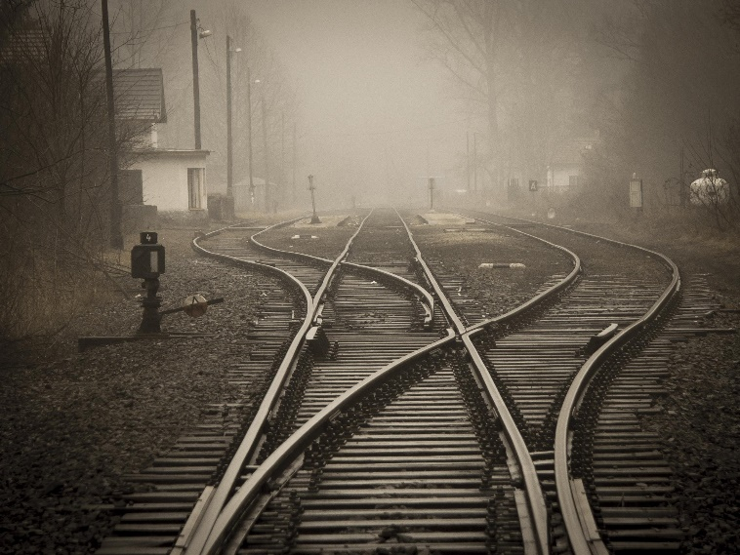

“Change your hearts and minds, for the reign of heaven
is about to break in upon you!”

All: bring your Advent wreath or 1 or 2 candles to light.

HELLOs and then the Zoom host mutes everyone. (Betty Thompson)

WELCOME (Terri Butel)

Welcome, everyone!
- Introductions – people who haven’t been here before?
- I prepared today’s communal prayer.
- Thanks to Alicia & George Urban for lighting their Advent wreath with us and leading petitions.
- Thanks to Debra Street and Marilyn Voigt for leading our opening antiphon.
- Thanks to the people who will be reading and leading us in prayer today: Debbie Ballard, Lynn Bufka, Norb Bufka, Ann Masters, Mary Ott, Judy Sholes, Rose Marie Smith, and Betty Thompson.
- We’d love to know a Sunday when you would like to read!

SETTLING IN (Mary Ott)

Let’s move from greeting each other to making our hearts quiet for the coming of God. Take a deep breath…. Again… Let your breath carry ease into the muscles of your face…. And into your neck and shoulders.… Let your breath fill you… Soften you… And carry you into the peace of God…. Here… Now… Together….

Now let us welcome the light.

OPENING AND LIGHTING OF ADVENT WREATH (Debra Street & Marilyn Voigt, Alicia & George Urban)
Sung Antiphonal Opening:
Singer 1: (Debra) You are Wisdom, from the Mouth of God.
Singer 2: (Marilyn) Come, O Come, Emmanuel.
Singer 1: You are Wisdom, playing before God.
Singer 2: Come, O Come, Emmanuel.
Singer 1: You are Wisdom, wondrous word of God.
Singer 2: Come, O Come, Emmanuel.
Singer 1: You are Wisdom, loving friend to God.
Singer 2: Come, O Come, Emmanuel.

Household for This Week – Alicia & George Urban: Please join us in lighting your Advent candles. (Light candles.) We pray – God of light, shine your love into the hidden corners of our lives. Give us light for our next steps.
Singer 2 (Marilyn and all, muted): Rejoice! Rejoice, Emmanuel shall come to you, O Israel.

GATHERING PRAYER (Debbie Ballard)

We gather because God comes to us, not only in a singular Christmas event but also in each person and in each generation’s lifetime. The scriptures tell us a long-treasured story of salvation for a people beloved of God. We are called today to tell this story in a fresh, compelling way – with our lives. We ask to make the pathway straight for the coming of God.
And so we pray: Emmanuel, God with us, we give you this next hour with confidence that you will act in us and through us. We believe that you will give us light for our next step. Amen.

INTRODUCTION TO THEME (Terri Butel)

Each Advent we hear the familiar stories that lead us toward Bethlehem. This year we are invited to look at this time with three-dimensional vision: first Jesus’ coming 200o years ago to Bethlehem; and God coming to us in our lives and at our death; and today the “breaking in” of the reign of God.

Today’s theme is about cleaning house. Let us use our Advent waiting to de-clutter the way for Christ’s coming into our hearts this year, a year like no other.

Now Lynn Bufka will read from the book of Isaiah. Then Ann Masters will offer questions for our reflection. You can stay with whatever question calls you. (pause)
READING 1: Isaiah 11: 1 –9 (Lynn Bufka)
Then a shoot will sprout from the stump of Jesse;
from Jesse’s roots, a branch will blossom:
The spirit of YHWH will rest on you -
a spirit of wisdom and understanding,
a spirit of counsel and strength,
a spirit of knowledge and reverence for YHWH.
You will delight in obeying YHWH,
and you won’t judge by appearances,
or make decisions by hearsay.
You will treat poor people with fairness
and will uphold the rights of the land's downtrodden.
With a single word you will strike down tyrants…
Justice will be the belt around your waist -
faithfulness will gird you up.
Then the wolf will dwell with the lamb,
and the leopard will lie down with the young goat;
the calf and the lion cub will graze together,
and a little child will lead them.
The cow will feed with the bear;
their young will lie down together.
The lion will eat hay like the ox.
The baby will play next to the den of the cobra,
and the toddler will dance over the viper’s nest.
There will be no harm, no destruction anywhere in my holy mountain;
for as water fills the sea,
so the land will be filled with knowledge of YHWH.

QUESTIONS 1 (Pause after each question.) (Ann Masters)

Which of the mentioned gifts of the Spirit were given to you and how do you make use of it to ‘uphold the downtrodden’?

Imagine in detail a peaceful encounter of “wolves and lambs” you would invite to gather in your hospitality. Conversation? Food? Music?

COMMUNAL SILENCE (Betty - Share slide 1.)

Betty: Now Rose Marie Smith will read from the Gospel of Matthew.
READING 2 – Matthew 3:1-3, 5 (Rose Marie Smith)
At this time John the Baptizer appeared, preaching in the desert of Judea, proclaiming, “Change your hearts and minds, for the reign of heaven is about to break in upon you!”

It was John that the prophet Isaiah described when he said:
“A herald’s voice cries in the desert,
‘Prepare the way of our God,
make straight the paths of God!’”
At that time Jerusalem, all Judea, and the whole region around the Jordan were going out to him. John baptized them in the Jordan River as they confessed their sins.
QUESTIONS 2 (Pause after each question.) (Ann Masters)

About what do you most need to change your heart or mind? How do you commit to begin?

What obstacles clutter God’s path to you this Advent? How do you commit to make the path straight?

COMMUNAL SILENCE (Betty - Share slide 2.)

Betty: Let’s listen as Judy Sholes reads an adaptation from “Putting John the Baptist Back into Advent”, a homily by Fr. Francis Clooney, SJ.

READING 3 – (Judy Sholes)

Today’s first reading from Isaiah promises that the Holy One to come will change all living beings, deep down – all will learn to live in peace. Imagine those impossible and dangerous conversations you long to have, the countries that have been at war since they first drew their borders, all soothed and relaxed.
This promised messiah is worth the wait, especially since we know we cannot create the peaceable kingdom ourselves; we struggle to change ourselves, much less the world around us.
However, Advent waiting is not passive; it must seep inside us and stir up something… restlessness, at least, or even better, a new insight that could change us “deep down.” Fr. Clooney wondered if John the Baptist meditated on Isaiah’s words, and if they might have been the source of his yearning for a more peaceable Israel. Could they have been what prompted John to flee to the desert, to clear a path right through his own body and mind and heart to be ready for God?
At least when John urged the people to change, he was only asking of them what he had first demanded of himself. His words, then and now, invite us to understand this waiting as a purification, an honest examination and clearing of a path through ourselves as individuals and as community.
God comes, but perhaps in smaller and quieter ways than we hope: just one sword becomes a plowshare, just one wolf lies down with a lamb, just one lion becomes vegetarian, and just one child plays with one viper who is no longer deadly. There will be just one Christmas coming of Jesus for each of us this year, the shift to a holy mountain of peace and justice, beginning one heart at a time.
QUESTIONS 3 (Pause after each question.) (Ann Masters)

When have you experienced waiting that became a needed purification?

"What one word or small action have you noticed that points to God's coming this year?"

What change of heart do you ask of Christ this Advent?

COMMUNAL SILENCE (Betty - Share slide 3.)

Betty: Debbie Ballard will lead us in sharing our personal reflections.

SHARING (Debbie Ballard)

We invite you to briefly share what emerged in your heart this morning as you listened and as you reflected on these readings. That helps us to glimpse the many ways God is among us. We welcome new voices, and we also know that the wisdom of this community includes both words shared and silent listening. And let’s leave a bridge of silence between speakers.

We begin in silence as we gather our reflections. (Long pause.)

Please unmute yourself to speak, and mute again afterwards.

Who would like to begin?

(Sharing)

(Let sharing continue for about 20 minutes. Long silences often indicate fruitful reflection.)

Thank you for your insights and thoughts. We have to stop now, and we can continue after the final song, as we often do. Now let us pray, led by Alicia & George Urban.

PRAYERS OF THE COMMUNITY (Alicia & George Urban)

Let us pause and gather the prayers that are rising in us. (Pause.)

Our response will be: Promised One, hear our prayer.

In thanksgiving for this community of faith that sustains us in so many ways, we pray… Promised One, hear our prayer.

Pope Francis’ monthly intention: That volunteer non-profit organizations committed to human development find people dedicated to the common good and ceaselessly seek out new paths to international cooperation, we pray… Promised One, hear our prayer.

For those who have died seeking justice for the oppressed. Today we remember the 4 churchwomen who were murdered 42 years ago this weekend in El Salvador. For this we pray… Promised One, hear our prayer.

74 years ago (12/10/1948), the Universal Declaration of Human Rights was proclaimed by the United Nations General Assembly in Paris; may we work for the day that no person is ever denied their rights, we pray… Promised One, hear our prayer.

For the Leadership Conference of Women Religious and all committed sisters and brothers who joyfully, steadfastly, and unconditionally reach out to all in need, we pray…Promised One, hear our prayer.

For what else shall we pray? Please remember to unmute and mute yourself.

(People speak.) (Response) Promised One, hear our prayer.

Thank you.

O God, we give you all our prayers, spoken and unspoken. We will do all that we can to put our prayers into action – while entrusting the outcome to you. Amen.

OFFERTORY (Betty Thompson, Terri Butel)

Betty Thompson: Each of us has traditional ways of Advent preparation. Today Terri Butel will share an Advent practice she and her husband David have appreciated.

Betty Thompson: We thank you, Holy One, for all that we treasure in our lives, all that sustains our lives. In grateful quiet, each of us will now tell you something we will do or offer this week for you and your creation. (Pause.)

Amen.

CELEBRATION OF COMMUNION (Rose Marie Smith)

O Great Love, we are humbled and emboldened
to know that you trust us to be your body in this world.
We are part of that body as we let go of all that separates us from you,
and as we embrace one another and your entire creation with merciful love.
We give you thanks for your presence in and among us. [Pause.]

We remember the night before Jesus died.
At dinner with friends, Jesus knew all that would soon be asked of them,
and, loving them to the end, Jesus showed them how to care for each other
as they went out into the world.
First Jesus washed their feet
and said, “… as I have done for you, you should also do.”
Then he looked at what was in front of them, the bread and the cup,
gifts of the earth and work of human hands, and blessed them.
So let us, too, invite God right now into what is front and center in our lives
knowing that God will indeed enter what we offer – and bless it. [Pause.]

Holy One, make us your bread of abundance. Make us your wine of joy.
Let even our fragments be plenty to share.
Amen.
(Pause)
Now Norb Bufka will lead us in the prayer Jesus taught.

OUR FATHER, OUR MOTHER (Norb Bufka)

Now let us join our hearts with all who seek the coming of God, using the words that Jesus gave us:

All (muted): Our Father, Our Mother, who are in heaven, hallowed be your name.
Your kingdom come. Your will be done on earth as it is in heaven.
Give us this day our daily bread
and forgive us our trespasses as we forgive those who trespass against us,
and do not let us fall into temptation, but deliver us from evil
for the kingdom, the power, and the glory are yours, now and forever. Amen.

FINAL BLESSING (Lynn Bufka)

O God,
Let this Advent season transform us.
As we are tempted to become busier with obligations and plans and expectations,
help us let go so that we are free to experience you in new ways.
Help us to name and remove the obstacles that stand between us
so that every day of Advent is a day of encountering you.
Amen.

CLOSING SONG Every Valley
https://www.youtube.com/watch?v=tjiQUPGScG0

Every valley shall be exalted
and every hill made low.
And all God’s people
shall see together the glory of the Lord.

A voice cries out in the wilderness,
“Prepare the way of the Lord,
Make straight in the desert a highway,
a highway for our God.” Refrain

Comfort all my people.
The time for war is gone.
The blind shall see, the deaf shall hear,
the lame shall leap for joy. Refrain

Stand up on the mountain top.
O lift your voice to the world.
Sing joyfully, Jerusalem:
“Behold, behold your God.” Refrain

Resources:
Reading 1 & 2: The Inclusive Bible
Reading 3: Adapted from “Putting John the Baptist Back into Advent”, Homily by Francis X Clooney, SJ, Parkman Professor of Divinity, Professor of Comparative Theology, Harvard Divinity School. https://projects.iq.harvard.edu/francisclooney/blog/advent-john-baptist
Images: Railroad tracks, Pexels, https://www.pexels.com/photo/railroad-tracks-in-city-258510/
Petitions: Pope Francis’ monthly intentions - https://www.usccb.org/prayers/popes-monthly-intentions-2022
Universal Declaration of Human Rights: https://www.un.org/en/about-us/universal-declaration-of-human-rights
Closing song: Every Valley, Bob Dufford, OCP.

