Solidarity with Sisters’ Communal Prayer For May 15, 2022
Fifth Sunday of Easter

“As I have loved you,..” JN 13:34

Fifth Sunday of Easter – Shelburne and Primrose United Churches
https://images.squarespace-cdn.com/content/v1/5e683c9f64018e48a7328ebc/1619744772637-5DO0X12096QL9P94ZRUY/tr1.jpg

HELLOs and then Betty mutes everyone. (Betty Thompson)

WELCOME (Richard McGinnis)

Welcome, everyone!
- Introductions – people who haven’t been here before?
- I prepared today’s communal prayer.
- Thanks to the people who will be reading and leading us in music and prayer today: Linda Donaldson, Reggie Ott, Mia Brown, Tim Brown, Anne Regan, Judy Sholes, Kathy Linaberry, Lin Linaberry, Kate Monagan, Kathy Heller, Maryann Dolan, Paula Lake, and Rose Marie Smith.
- If you’d like to read on future Sundays, please get in touch.

SETTLING IN (Richard McGinnis)

Let’s quiet ourselves so we can be attentive to what God hopes for us today. Notice your breath as it goes in and out…. Let it slow and deepen… and slowly fill you with the peace of Christ. We begin with 3 deep breaths. One to be here… one to be together… and one to welcome in the Spirit who never leaves us.

Now Linda Donaldson will lead us into our prayer together.

OPENING SONG - Prayer of St. Francis: Make Me a Channel of Your Peace (Linda Donaldson)

Make me a channel of your peace.
Where there is hatred let me bring your love.
Where there is injury, your pardon, Lord.
And where there’s doubt, true faith in You.

Make me a channel of Your peace.
Where there’s despair in life let me bring hope.
Where there is darkness, only light.
And where there’s sadness, ever joy.

Oh Master, grant that I my never seek
So much to be consoled as to console,
To be understood as to understand,
To be loved as to love with all my soul.

Make me a channel of your peace.
It is in pardoning that we are pardoned,
In giving of ourselves that we receive,
And in dying that we’re born to eternal life.

GREETING (Mia Brown)

Let us rejoice, for Jesus Christ is risen! Alleluia! Alleluia!

All: Christ is risen indeed! Alleluia! Alleluia!

CALL TO WORSHIP/ GATHERING PRAYER (Mia Brown)

We come together today to stand beside the disciples as they – and we – deepen our experience of the Risen One alive with us. It is the light of the Risen One that lets us see our next step. And so we pray.

Holy One, over and over during this season we hear Jesus say, “Peace be with you.”
Teach us how to be a community of contagious peace and hope.
In a world and among loved ones with heart-breaking needs,
show us how to be your heart.
May we inquire, nudge, and challenge each other
to imagine what none us could conceive alone.
Amen.

INTRODUCTION TO THEME (Richard McGinnis)

With the resurrection of Jesus, we are living in a new and evolving reality in which we have been given a unique role. God gave us the vocation to continue the work of creation. Jesus has invited us to become collaborators in this reality by giving us a commandment to love one another as he loved us. This is not an undertaking that we can accomplish on our own. Providentially, we don’t have to act alone, because God is dwelling with us and has promised to be with us always. The power for our mission comes from experiencing how greatly we are loved by God.

[Pause]

We receive that love by allowing Jesus to wash our feet and to feed us. Our intimate communion with Jesus and with one another is what enables us to love as Jesus did. Through self-giving service, we become the sacrament that will be a sign and source of salvation for all the world.

[Slight pause]

Richard. Now Anne Regan will read from the Book of Revelation. Tim Brown will offer questions that will lead us into silence.

READING 1 Rev 21:1-5a (Anne Regan)

The former heaven and the former earth had passed away,
and the sea was no more.
I also saw the holy city, a new Jerusalem,
coming down out of heaven from God,
prepared as a bride adorned for her husband.
I heard a loud voice from the throne saying,
“Behold, God’s dwelling is with the human race.
God will dwell with them and they will be God’s people
for the Holy One will always be with them as their God,
and will wipe every tear from their eyes,
and there shall be no more death or mourning, wailing or pain,
for the old order has passed away.”
The One who sat on the throne said,
“Behold, I make all things new.”

QUESTIONS 1 (Tim Brown)

Think of a time when God wiped away your tears. What feelings arise?
How do you experience God dwelling with us?
For what do you hope as you contemplate the evolving future of the people of God?
COMMUNAL SILENCE [Betty: Share slide w/questions and image “The New Jerusalem”, time 2:00, chime, stop slide.]

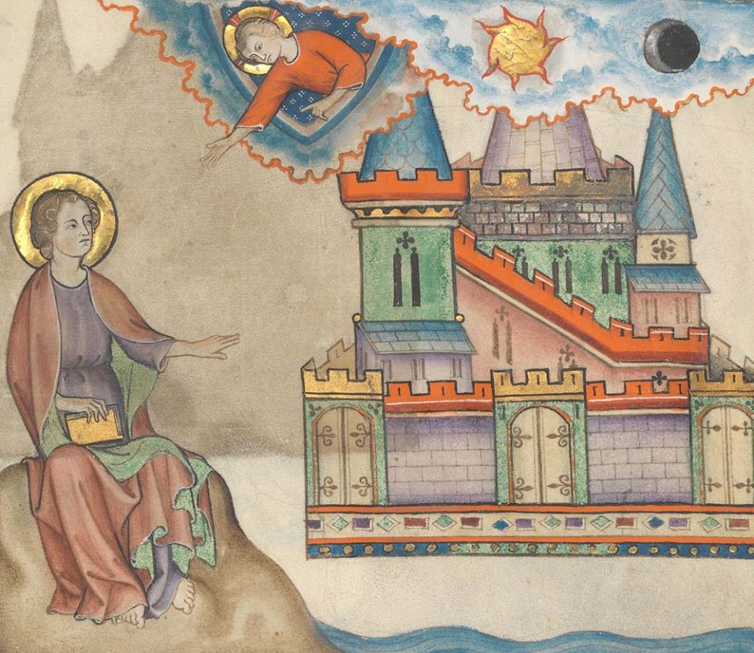
The New Jerusalem, illumination from the 14th-century French Cloisters Apocalypse (Metropolitan Museum of Art)
https://www.ncronline.org/sites/default/files/styles/article_full_width/public/DP225750%20New%20Jerusalem%20CROP.jpg?itok=TlCKQfyY

Richard: Now Judy Sholes will read from the Gospel of John after the meal at the Last Supper.

READING 2 JN 13:31-33a, 34-35 (Judy Sholes)

When Judas had left them, Jesus said:

“Now the Chosen One is glorified and will be taken to God in glory.
My children, I will be with you only a little while longer.
I give you a new commandment: love one another.
As I have loved you, so you also should love one another.
This is how all will know that you are my disciples,
if you have love for one another.”

[Slight pause]

QUESTIONS 2 (Tim Brown)

What helps when this commandment is hard for you?

How has giving yourself in service affected you?

Where do you see the power of forgiveness at work?

COMMUNAL SILENCE [Betty: Share slide w/questions and image “The Prodigal Son”, time 2:00, chime, stop slide.]

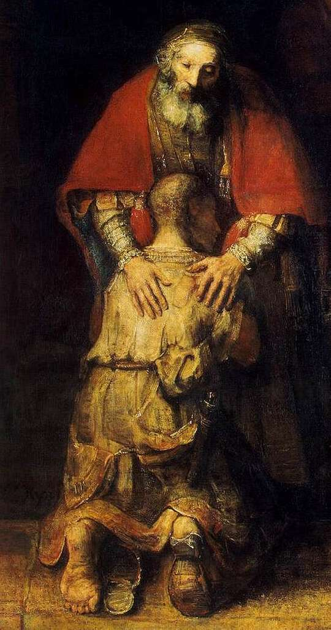
The Prodigal Son (detail), Rembrandt.
https://cdn2.picryl.com/photo/2021/12/12/rembrandt-the-return-of-the-prodigal-son-detail-wga19137-36ab9e-1024.jpg

Richard: Now Kathy Linaberry will read an adaptation of a reflection on the Scriptures by Sister of St. Joseph Mary M. McGlone.

READING 3 (Kathy Linaberry)

“To dream the impossible dream, to fight the unbeatable foe, to bear with unbearable sorrow, to run where the brave dare not go.” In “The Man of La Mancha,” Don Quixote is an extreme example of every person or group that dreams of making a better, if not perfect, world. Western thinkers from St. Benedict to Karl Marx have used their discontents to help them envision eutopia, a word which means a beautiful place for humans to thrive.
John is not hoping for a back-to-nature return to the virgin simplicity of Eden. But he is trusting that God gave humanity the vocation to continue the work of creation. John’s ideal is a city, the fruit of creation and the work of human hands.
In John’s vision, the new Jerusalem comes down from heaven, meaning that unlike the impossible dream, it is God’s creation, as real as the universe in which we now live and move. John describes the new Jerusalem as a bride prepared to meet her husband. This is a way of saying that the new creation, unlike the one in Genesis, starts with God but is not God’s unilateral project. The new creation flows from the collaboration of a loving God and humanity eager to be in union with God. It is a way of being that comes about through the mutual love of God and humankind.
At the Last Supper, Jesus commanded his disciples: “Love one another as I have loved you.” Before they could love as he did, they had to comprehend how greatly they were loved. Fulfilling Jesus’ command to love is not a task that can be accomplished, it is a response to receiving love. Jesus was telling his table companions that their communion with him and one another would empower their loving. It would reveal the glory of God just as Jesus would reveal it by being lifted up. Their self-giving service would be the sacrament that would make them a sign and source of salvation for the world.
John explains elements of the future in terms of the problems that will be overcome; there will be no more weeping, death, mourning or pain. But a unique characteristic of John’s new Jerusalem is that life here is structured only by the fact that God dwells within creation and creation dwells in God. God’s union with humanity in this new reality is neither guardianship nor companionship but an indwelling.
John’s vision is a mystery, meaning that there is always more to be discovered in it. John tells us about it so that we can try to imagine it, so that we can hope for it, so that our belief that this new Jerusalem is our destination will provide the orientation for how we live from now on.
Christ has overcome the foe and wipes out sorrow.
What remains for us now is to follow and to go where only Christ can lead us.
(Slight pause)

QUESTIONS 3 (Tim Brown)

What “impossible dream” have you seen become possible through faith?

How does your “communion with Jesus and one another” show up in the world as “sacrament”?

COMMUNAL SILENCE [Betty: Share slide w/questions and image “The Last Supper”, time 2:00, chime, stop slide.]

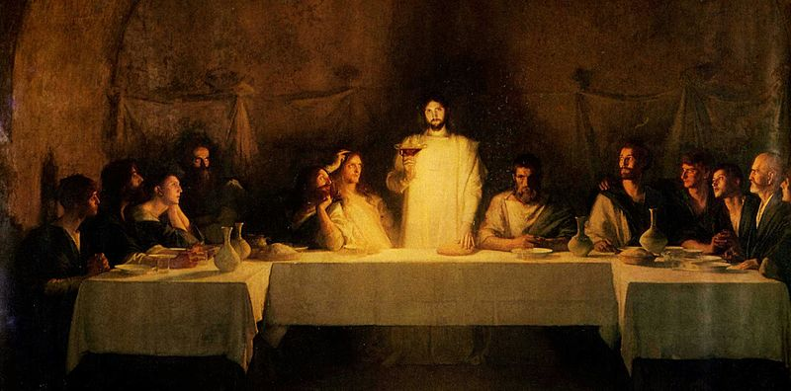
The Last Supper, Pascal Dagnam-Bouveret
https://commons.wikimedia.org/wiki/File:Bouveret_Last_Supper.jpg

Richard: Lin Linaberry will lead our sharing.

SHARING (Lin Linaberry)

We know the wisdom of our community includes both words shared and silent listening. Now, if you’d like, we invite you to share the essence of what is emerging within you from our readings and silence. Let’s begin in silence as we gather our reflections. [Long-ish pause]

Who would like to start our sharing? Remember to unmute yourself to speak and mute yourself again afterwards.

[Sharing]

[If there is extended silence during the sharing:] Is there anyone else who would like to share? [Long-ish pause]

[Stop by about 11:20.]

Thank you. We can continue after the final song, as we often do.

Now Kate Monagan will lead us in prayer.

PRAYERS OF THE COMMUNITY (Kate Monagan)

Let’s pause to notice the prayers that arise in us now. (Pause.) Our response will be: : Holy One, who makes things new, hear our prayer.

God who dwells with us, grant us the humility to accept that we are greatly loved and that we are a people whose feet are washed by Jesus Christ. For this we pray.
All: Holy One, who makes things new, hear our prayer.

God who wipes away every tear, move us to share the overflowing cup of your love with the many in need of consolation. For this we pray.
All: Holy One, who makes things new, hear our prayer.

God of transformation, continue to inspire the Leadership Conference of Women Religious and its member congregations in their sacramental work of self-giving service. For this we pray.
All: Holy One, who makes things new, hear our prayer.

For what else shall we pray? Please unmute yourself to speak, and then mute yourself afterwards.

(Shared prayers)

O You who see us, hear us, and love us more than we can imagine, thank you for receiving our intentions, spoken and unspoken. We entrust all to you. Amen.

OFFERTORY (Kathy Heller)

In this Easter season, we celebrate the Risen One alive among us. Reflect on how your Lenten intention is evolving. How are you bringing it to life this week? [Pause]

Let us pray. You who love us more than we can imagine, we give you our imaginations. Show us how to commit our time, talent, and treasure this week in gratitude for all you give us. Amen.

CELEBRATION OF COMMUNION (Maryann Dolan)

O Great Love, we are humbled and emboldened
to know that you trust us to be your body in this world.
We are part of that body as we let go of all that separates us from you,
and as we embrace one another and your entire creation with merciful love.

We remember the night before Jesus died.
At dinner with friends, Jesus knew all that would soon be asked of them,
and, loving them to the end, Jesus showed them how to care for each other
as they went out into the world.
First Jesus washed their feet
and said, “… as I have done for you, you should also do.”
Then he looked at what was in front of them, the bread and the wine,
gifts of Earth and the work of human hands, and blessed them.
So let us, too, invite God right now into what is front and center in our lives
knowing that God will indeed enter what we offer – and bless it. [Pause.]

Holy One, we entrust ourselves to you and to one another.
Make us your bread of abundance. Make us your wine of joy.
Let even our fragments be plenty to share.
Amen

THE PRAYER OF JESUS (Paula Lake)

Now let us join our hearts as if we could join our hands in harmony with our family throughout the world:

All (muted):

Heavenly Father, heavenly Mother,
Holy and blessed is your true name.
We pray for your reign of peace to come,
We pray that your good will be done,
Let heaven and earth become one.
Give us this day the bread we need,
Give it to those who have none.
Let forgiveness flow like a river between us,
From each one to each one.
Lead us to holy innocence
Beyond the evil of our days —
Come swiftly Mother, Father, come.
For yours is the power and the glory and the mercy:
Forever your name is All in One.
Amen.

FINAL BLESSING (Rose Marie Smith)

As we go forth, let us listen to the words of Sr. Sharlet Wagner: We thank you that “It is not ours to see the future. Our task is not to create a plan for the new to emerge. It is to create a space for the new to emerge. For the young. For the growing diversities. A space where the Holy Spirit is free to work. If we can do this, the future will emerge. And it will be good.” [Pause]

Let us raise our hands in a final blessing for each other:

Broken, we have gathered. Nourished, we reach out.
Now let us now go forth in peace:
in communion with each other
and offering communion to a hungry world. Amen.

Now Reggie Ott will lead us in song.

CLOSING SONG (Reggie Ott)

Sent by our God am I.
My hands are ready now
to make the earth a place
in which your Kin-dom comes.
Sent by our God am I.
My hands are ready now
to make the earth a place
in which your Kin-dom comes.
The angels cannot change
A world of hurt and pain
Into a world of love,
Of justice and of peace.

The task is mine to do,
To set it really free,
So help me to obey,
Help me to do your will!

RESOURCES

- Scripture

https://bible.usccb.org/bible/readings/051522.cfm
- Reflection on Scriptures.

Adapted from Mary M. McGlone, CSJ, “Dream of the Possibilities”, Fifth Sunday of Easter, May 19, 2019.

https://www.ncronline.org/news/spirituality/scripture-life/fifth-sunday-easter-1
- Heavenly Mother; Heavenly Father“Unpacking the Lord’s Prayer-With Parker Palmer April 4, 2020”
https://godspacelight.com/2020/04/04/unpacking-the-lords-prayer-with-parker-palmer/
- Questions
Inspired, in part, by Commentary from https://livingspace.sacredspace.ie/ec051/
- Art
“Shelburne and Primrose.”
Fifth Sunday of Easter – Shelburne and Primrose United Churches
https://images.squarespace-cdn.com/content/v1/5e683c9f64018e48a7328ebc/1619744772637-5DO0X12096QL9P94ZRUY/tr1.jpg
“The New Jerusalem.” illumination from the 14th-century French Cloisters Apocalypse (Metropolitan Museum of Art)
https://www.ncronline.org/sites/default/files/styles/article_full_width/public/DP225750%20New%20Jerusalem%20CROP.jpg?itok=TlCKQfyY
“The Return of the Prodigal Son (detail).” Rembrandt. https://cdn2.picryl.com/photo/2021/12/12/rembrandt-the-return-of-the-prodigal-son-detail-wga19137-36ab9e-1024.jpg
“The Last Supper”, Pascal Dagnam-Bouveret
https://commons.wikimedia.org/wiki/File:Bouveret_Last_Supper.jpg
- Music
Lyrics and Video Option for Opening Song.
Sourced from https://catholichymn.blogspot.com/
Youtube video 16-3.20 seconds
“Prayer of St. Francis (Make Me A Channel of Your Peace)” Sung by Angelina EWTN
- Video option for Closing Song
Sourced from https://www.youtube.com/watch?v=2uN-oeDI7Ag 22-62 seconds
“Sent by the Lord Am I” by Matt Bechingham
https://youtu.be/ZI1Gst7pEqc
- Jerusalem Bible, 1966 edition. Doubleday & Co, New York

