Solidarity with Sisters Communal Prayer for Christmas Eve
December 24, 2021

“The Word became flesh and lives among us.” 1 John

HELLOS AND INTRODUCTIONS (Suzie De Quattro and Betty Thompson)

3:30 – 4:00 PM Extended family welcome to stop by and stay as long (or short) as they want.
4 PM Betty mutes everyone.
WELCOME (Suzie)

- Betty and I had the joy of preparing today’s communal prayer. We will use the old songs and readings that many of us love, despite their traditional male references to God.
- Thanks to Debra Street, Keith Miller, Stu Sklamm and Marilyn and Paul Voigt for our music.
- Thanks to Solidarity with Sisters for being the origin and center of our communal prayer since we began in March 2020. Today’s readers include many from that group. Thanks to Jim De Quattro, Judy Sholes, Lynn Bufka, Ann Jelen, Anne Regan, Bill Fanelli, Richard McGinnis, Sister Marie McCarthy, Jenny Greene, and Terri Butel.

SETTLING IN (Richard McGinnis)

On this joyous Christmas Eve we remember the many years we gathered with family and friends in our churches and our homes. This community is separated by distance but not by common joy. So let’s begin by sharing one collective breath… in and out. With each breath let the Spirit of God settle deeper into you as your exhale tensions from your body and distractions from your mind. In and out. Now let’s take 3 more breaths. One to be together… One to be ourselves… and one to make space for God singing in us.

Now we enter Christmas joy together by singing “Hark, the Herald Angels Sing!” with Debra Street and Keith Miller. Then we will light our Christ candles with Anne Regan and Bill Fanelli.

OPENING SONG: HARK, THE HERALD ANGELS SING! (Debra Street and Keith Miller)

Hark! The herald angels sing,
“Glory to the newborn King!”
Peace on earth and mercy mild,
God and sinners reconciled.”
Joyful, all ye nations rise,
Join the triumph of the skies,
With th’angelic host proclaim:
“Christ is born in Bethlehem.”
Hark! The herald angels sing,
“Glory to the newborn King!”
Hail the heav'n-born Prince of Peace!
Hail the Son of Righteousness!
Light and life to all He brings,
Ris'n with healing in His wings.
Mild He lays His glory by,
Born that we no more may die,
Born to raise us from the earth,
Born to give us second birth.
Hark! The herald angels sing,
“Glory to the newborn King!”

OPENING RITUAL: WELCOMING THE LIGHT OF CHRIST (Isaiah 9:1-6) (Anne Regan & Bill Fanelli)

(Anne and Bill – you can decide whether to light your Christ candle in advance, or for one to light it while the other reads Isaiah.)

All through Advent, we have been aware of the darkness that surrounds this time. And we have been watching for signs of what we know is already here: the presence of God. Today we pray to see holiness anew in Jesus, and to rejoice in this fresh radiance! I invite you to light your Christ candle as I read from Isaiah:

The people who walked in darkness have seen a great light;
upon those who dwelt in the land of gloom
a light has shone.
You have brought them abundant joy
and great rejoicing,
For unto us a child is born, unto us an heir is given;
upon whose shoulder dominion rests.
This One shall be called Wonderful Counselor,
The Strength of God, Eternal Protector, Guardian of Peace.
This dominion is vast
and forever peaceful,
sustained by fair judgment and justice,
from this time onwards and forever.

Let’s stay in the silence of the night and in the light of our candles as we welcome the Guardian of Peace into our hurting world and into our hearts.

MUSICAL MEDITATION: Silent Night instrumental with the London Symphony Orchestra -- https://www.youtube.com/watch?v=nOEH7YRCJbg (Betty)
[Decrease sound to zero between 1:37 - 1:41, when it changes key.] .

CALL TO WORSHIP/ INTRODUCTION TO THEME (Suzie)

Our liturgical year always begins with us watching and waiting in darkness, anticipating the glorious story of God’s coming among us. Each year we circle through the message of repentance from John the Baptist, the faith of Mary’s Yes and vision of angels and shepherds. And tonight, as we have each December, we come full circle to Bethlehem and arrive at the manger.
This Advent, Betty and I have been more aware than ever before that this story moves not in a circle but in a spiral - a spiral that stays centered on the truth of God with us.
Yes, we hear the same ancient story of Emmanuel and Incarnation. But each year this story compels us differently because we are in a new place in the spiral of our own lives. We are different, as is our community and the world. We come to this ancient familiar story and know it for the first time.
Let us listen to tonight’s stories ready to discover something new. The Word is timeless, and fresh, with every turn of the spiral. [Pause.]

In Matthew’s Gospel we see Joseph as the first person living the tension between understanding the Law and the new life that God is bringing in Jesus. Joseph lets go of his previous understanding of the Scriptures to obey the living voice of God. Joseph’s "yes" required Mary’s "yes," but also supported hers. Joseph accepted the promise that Mary saw and affirmed that he would pursue that promise with her. He took part in God’s hope for his life but also relied on the faith of Mary’s hope. Joseph was brave enough to co-mingle his life with hers intimately affecting them both.
Let us listen as Lynn Bufka reads.
READING 1 Mt 1:18-25 (Lynn Bufka)
This is how the birth of Jesus Christ came about.
When Mary was betrothed to Joseph,
but before they lived together,
she was found with child through the Holy Spirit.
Joseph her husband, since he was a righteous man,
yet unwilling to expose her to shame,
decided to divorce her quietly.
Such was his intention when, behold,
the angel of God appeared to him in a dream and said,
“Joseph, son of David,
do not be afraid to take Mary your wife into your home.
For it is through the Holy Spirit
that this child has been conceived in her.
She will bear a son and you are to name him Jesus…
When Joseph awoke,
he did as the angel of God had commanded him
and took his wife into his home.
QUESTIONS 1 [Pause after each question.] (Jim De Quattro)
What tension are you feeling now between law and love? Imagine talking with Joseph.
How does it feel to co-mingle your “Yes” with Mary’s?
On whom do you rely to see what is possible? Whose "yes" impacts your own?
COMMUNAL SILENCE (Betty: Slide 1, time, chime, stop slide)

(Betty) Let’s welcome Jesus! Marilyn Voigt will lead us in singing “Go Tell It on the Mountain,” and Sr. Marie McCarthy will read the Gospel of Luke. Then Jim will lead us into contemplative quiet.

MUSICAL CELEBRATION: GO, TELL IT ON THE MOUNTAIN! (Marilyn and Paul Voigt)

Refrain: Go tell it on the mountain
Over the hills and everywhere,
Go tell it on the mountain
That Jesus Christ is born!
Verse:
While shepherds kept their watching
O'er silent flocks by night
Behold throughout the heavens
There shone a holy light. Refrain
Verse:
The shepherds feared and trembled
When lo, above the Earth,
Rang out the angel chorus
That hailed the Savior’s birth. Refrain
Verse:
They found a lowly manger
Where the humble Christ was born
And God sent our salvation
That blessed Christmas morn. Refrain

READING 2 – Lk 2:1-14 (Sr. Marie McCarthy)

In those days a decree went out from Caesar Augustus
that a census should be made of the whole Roman world.
So all went to be registered, each to their own town.
And Joseph too went up from Galilee from the town of Nazareth
to Judea, to the city of David that is called Bethlehem,
because he was of the house and family of David,
to be enrolled with Mary, his betrothed, who was great with child.
While they were there,
the time came for her to have her child,
and she gave birth to her firstborn son.
She wrapped him in swaddling clothes and laid him in a manger,
because there was no room for them in the inn.

Now there were shepherds in that region living in the fields
and keeping the night watch over their flock.
The angel of the Lord appeared to them
and the glory of the Lord shone around them,
and they were struck with great fear.
The angel said to them,
“Do not be afraid;
for behold, I proclaim to you glad tidings of great joy
that will be for all the people.
For today in the city of David
a savior has been born for you who is Christ, the Messiah.
And this will be a sign for you:
you will find an infant wrapped in swaddling clothes
and lying in a manger.”
And suddenly there was a multitude of the heavenly host with the angel,
praising God and saying:
“Glory to God in the highest
and on earth peace to all, on whom God’s favor rests.”
QUESTIONS 2 [Pause after each question.] (Jim De Quattro)
How are you different from the “you” who heard this story last year?

Who in this story would you like as your companion or guide as you enter 2022?

COMMUNAL SILENCE (Betty: Slide 1 with questions, time, chime, stop slide)

READING 3 / REFLECTION – (Jim De Quattro and Stu Sklamm)
Intro - Jim
Now it is ours to become the story. To let it shine through us in compelling ways. Gather your experiences of this last year. As you listen to Stu Sklamm, ask yourself - How do I live the question of the song? What child IS this?

“What Child Is This?” on sax - Stu

COMMUNAL SILENCE (Betty: Slide 3 with questions, time so total silence is about 3 minutes, chime, stop slide)

SHARING (Ann Jelen)

We invite you to briefly share what emerged in your heart this morning as you listened and as you reflected on these readings. That helps us to glimpse the many ways God is among us. We welcome new voices, and we also know that the wisdom of this community includes both words shared and silent listening. And let’s leave a bridge of silence between speakers.

We begin in silence as we gather our reflections. [Long pause.]

Please unmute yourself to speak, and mute again afterwards. Who would like to begin?

(Sharing)

[Let sharing continue for about 20 minutes.]

Thank you. We have to stop now, and we can continue after the final song, as we often do. Now let us pray, led by Terri Butel.

COMMUNITY PRAYERS (Terri Butel)

This Christmas, ever ancient and ever new, notice what prayer is rising in you. [Pause.]

Now let us pray. Our response will be: God who is with us, hear our prayer.

Emmanuel, God within us, thank you for making your home in us and in our world. Help us notice and honor you. For this we pray. God who is with us, hear our prayer.

Emmanuel, God among us, thank you for all that shines out with your radiance, brightening lives, warming hearts, and illuminating truth. [Pause.] For this we pray. God who is with us, hear our prayer.

Emmanuel, God with us, thank you for this shining community of women religious and other lay people across North America. For this we pray. God who is with us, hear our prayer.

Emmanuel, God for us, turn our gratitude into action for justice and peace, especially for those with no place at the table. For this we pray. God who is with us, hear our prayer.

Emmanuel, God of love, bless and protect women who are giving birth, especially those who are in dangerous places and difficult situations. God who is with us, hear our prayer.

For what else shall we pray?

[Shared prayers]

Thank you. O God, we will do all we can to make our prayers real, and we entrust the outcome to you. Amen.

CELEBRATION OF COMMUNION (Judy Sholes)

At Christmas we are reminded of what is always true.
Ordinary matter is the hiding place for Spirit and thus the very Body of God. And so we pray:

O Great Love, we are humbled and emboldened
to know that you trust us to be your body in this world.
We are part of that body as we let go of all that separates us from you,
and as we embrace one another and your entire creation with merciful love.
We give you thanks for your presence in and among us. [Pause.]

We remember the night before Jesus died.
At dinner with friends, Jesus knew all that would soon be asked of them,
and, loving them to the end, Jesus showed them how to care for each other
as they went out into the world.
First Jesus washed their feet
and said, “… as I have done for you, you should also do.”
Then he looked at what was in front of them, the bread and the cup,
gifts of Earth and the work of human hands, and blessed them.
So let us, too, invite God right now into what is front and center in our lives
knowing that God will indeed enter what we offer – and bless it. [Pause.]

Holy One, you chose to be fully part of humanity.
We now choose to let you be fully part of us.
May we bring your good news into the lives and communities around us. Amen.

OUR FATHER, OUR MOTHER (Jenny Greene)

Let us pray with all who seek justice and peace. We use the words that Jesus gave us interpreted by the Polynesian and Māori people and the New Zealand Anglican community:
Eternal Spirit,
Earth-maker, Pain-bearer, Life-giver,
Source of all that is and that shall be,
Father and Mother of us all,
Loving God, in whom is heaven:
The hallowing of your name echo through the universe;
The way of your justice be followed by the peoples of the world;
Your heavenly will be done by all created beings;
Your commonwealth of peace and freedom
sustain our hope and come on earth.
With the bread we need for today, feed us.
In the hurts we absorb from one another, forgive us.
In times of temptation and test, strengthen us.
From trial too great to endure, spare us.
From the grip of all that is evil, free us.
For you reign in the glory of the power that is love,
now and forever. Amen.

FINAL BLESSING (Betty)

Let us extend our hands over each other in blessing:
…I cannot tell you
how the light comes,
but that it does.
That it will.
That it works its way
into the deepest dark
that enfolds you,
though it may seem
long ages in coming
or arrive in a shape
you did not foresee.
And so
may we this day
turn ourselves toward it.
May we lift our faces
to let it find us.
May we bend our bodies
to follow the arc it makes.
May we open
and open more
and open still
to the blessed light
that comes. Amen.
Now let’s join Debra and Keith in singing our joy to the world!
CLOSING SONG: JOY TO THE WORLD by Isaac Watts/Lowell Mason(Debra Street -Keith Miller)

Joy to the world! the Lord is come;
Let earth receive her King;
Let every heart prepare him room,
And heaven and nature sing,
And heaven and nature sing,
And heaven, and heaven, and nature sing.

Joy to the world! the Savior reigns;
Let all their songs employ;
While fields and floods, rocks, hills, and plains
Repeat the sounding joy,
Repeat the sounding joy,
Repeat, repeat the sounding joy.

He rules the world with truth and grace,
And makes the nations prove
The glories of His righteousness,
And wonders of His love,
And wonders of His love,
And wonders, wonders, of His love.

RESOURCES:

Intro to Matthew’s Gospel: https://www.loyolapress.com/catholic-resources/liturgical-year/advent/inspiration/saying-yes-to-god-josephs-yes/

Communion ending -- sparked by Sr. Mary G. McGlone, CSJ, at https://www.ncronline.org/sunday-resource/dec-25-2021-nativity-lord-christmas-mass-dawn

Blessing: “How the Light Comes” appears in Jan’s new book Circle of Grace: A Book of Blessings for the Seasons

Image of St. Joseph and Baby Jesus by Jason Jenicke, $30 to $110 on canvas or paper in several sizes. https://jasonjenicke.com/product/st-joseph-and-baby-jesus/

Image of Nativity, Jesus Mafa art, https://globalworship.tumblr.com/post/13908904724/pictures-of-the-nativity-story-in-africa-jesus

One more Christmas nativity for you to enjoy – Another image related to our Gospel from Luke, from Sr. Mary M. McGlone at https://www.ncronline.org/sunday-resource/dec-25-2021-nativity-lord-christmas-mass-dawn
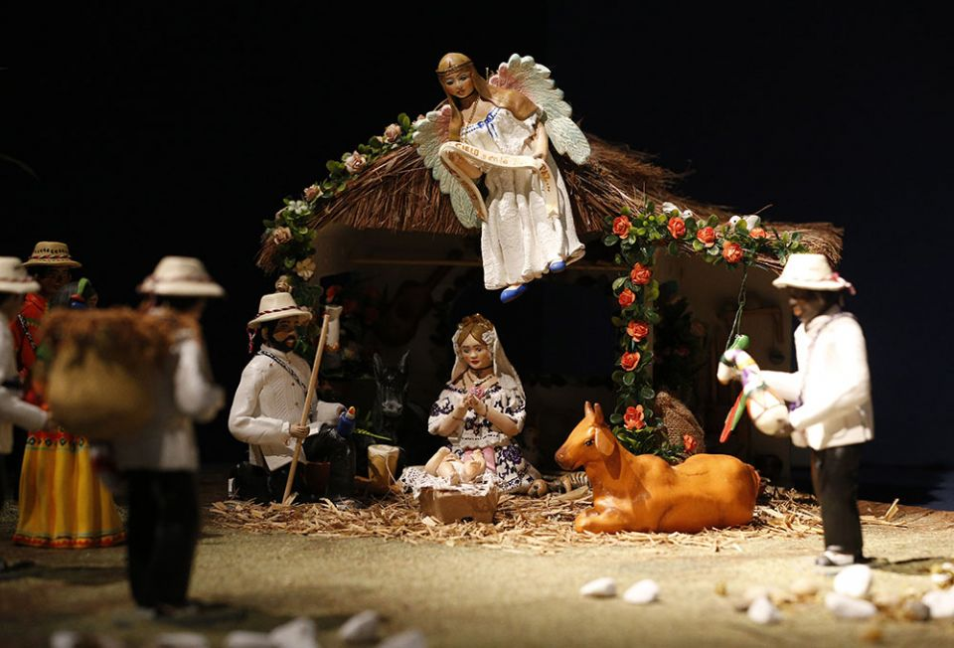

A Nativity scene given by Panama's Embassy to the Holy See is pictured at an exhibition of 100 Nativity scenes at the Vatican Dec. 7, 2018. (CNS/Paul Haring)
“If you happen to be in Rome on Christmas Day, you can visit the Vatican's featured Nativity scene from Peru. It's populated by some 30 characters — people and animals — authentically garbed and posed as contemporary folks from the Andean highlands. The Magi might be mistaken for extra shepherds as they accompany their llamas laden with the fabulous foods people of the area have enjoyed since before the time of the Incas.
“This is a cultural translation or interpretation of the meaning of the Incarnation. The Italian tourism industry expects more than 100 million people to see the display — whether in person or via the world of media communications.
“If we could anthropomorphize a little (When would it be more appropriate than at Christmas?), we might imagine the Trinity taking great pleasure in this and myriad other representations in which people depict the Holy Family and the rest of the cast in their own style of dress and following local customs.
“The people who do that have captured the message of the Incarnation: God decided to be like us to give us faith in our divine potential.”

