Solidarity with Sisters Communal Prayer for February 28 2021
Second Sunday of Lent

“Whoever practices the truth comes to the light.” John 3:21
CHECK-IN and then Betty mutes everyone.

WELCOME (Betty Thompson)
Welcome, everyone!
Introductions – people who haven’t been here before?
Thanks to Mary Ott, who prepared today’s communal prayer.
Thanks to Reggie Ott, Linda Donaldson, Marilyn Voigt, Stu Sklamm, and Pat Campbell for leading our music.
Thanks to the people who will be reading and leading us in prayer today: Richard McGinnis, Jim DeQuattro, Maryann Dolan, Bob Gallagher, Lynn Bufka, Grace Hartzog, Cynthia Norris, Greg Campbell, and Joan Sklamm.
If you’d like to read on future Sundays, please put a note in Chat or email later.

SETTLING IN (Suzie DeQuattro)

We are not all in the same place, but we can still be together by sharing a common breath. So let us begin by slowly taking one collective breath together -- in and out. With each breath let the Spirit of God settle deeper into you. Let your breath carry away tensions from your body and distractions from your mind. In and out. Now let’s take 3 more breaths. One to be here…one to be together…and one to make space for the light of God in you.
Now Mary Ott and Linda Donaldson will lead us into our prayer together.

OPENING RITUAL (Mary Ott and Linda Donaldson)

Mary: Beloved Community, Lent is the call to move from darkness to light.
All: O God, we hear you calling.
Mary: Beloved Community, we begin just where we are.
All: O God, we hear you calling.
Mary: Lord, you have the words of everlasting light.
All: O God, we hear you calling.
Linda (and all, muted): “Hosea” by John Michael Talbot
Come back to me with all your heart,
Don't let fear keep us apart.
Trees do bend, though straight and tall;
So must we to others' call.
Long have I waited for
Your coming home to me
And living deeply our new lives.

(Betty: Start slide 1)
Slide 1
Mary: “Lent is a call to weep for what we could have been and are not. Lent is the grace to grieve for what we should have done and did not. Lent is the opportunity to change what we ought to change but have not. Lent is not about penance. Lent is about becoming, doing and changing whatever it is that is blocking the fullness of life in us right now.” (Joan Chittister, OSB)

Mary: Let’s pause and reflect on what is hindering the light in us right now. [Pause]
Mary: Let us pray together:
All (muted):
I know I have often sinned in my thoughts and in my words, in what I have done and what I have failed to do.
I place my trust in your mercy, O God. And I ask that you, my sisters and brothers, pray for me as I seek to be light. Amen.
(Betty: Stop slide.)
Linda (and all, muted):
The wilderness will lead you
To the place where I will speak.
Integrity and justice
With tenderness
You shall know.
Long have I waited for
Your coming home to me
And living deeply our new lives.

CALL TO WORSHIP / GATHERING PRAYER (Mary Ott)

God of the desert, God of the mountaintop, God of all captives, we are here to walk in your light and to carry your freedom to the world. May we inquire, nudge, and challenge each other to recognize what is ours to do.
Amen. [Brief pause]

INTRODUCTION TO THEME (Mary Ott]

The readings for the second Sunday of Lent lead us from the darkness of human sacrifice to the blinding light of the transfiguration. In the first reading from Genesis we learn that Abraham, who had longed to have a son for many years, was willing to sacrifice his son if that was God’s will. The reading about Abraham and Isaac has at least two messages:
- God wants devotion, not human sacrifice.
- Abraham’s willingness to sacrifice his “beloved son” foreshadows God’s willingness to sacrifice his “Beloved Son.”

We may say that human sacrifice is totally anathema to us, and to modern religions and societies. But is that really true? According to Sr. Joan Chittister, we do go along with human sacrifice when we vent our anger and enforce capital punishment; when we vent our vengeance on the innocent and call it war; when we deny the poor and refugees the basics of life. In all of these ways and others we individually or as part of society sacrifice human lives. Sr. Joan asks us to shift our understanding of human sacrifice.
[Brief pause]
As we enter into our readings, Marilyn Voigt will lead us in song:

ENTRY INTO READINGS (Marilyn Voigt)

Marilyn (and all, muted):
Lead us from darkness to light. Lead us from darkness to light.
Lead us from darkness, lead us from darkness,
Lead us from darkness to light.

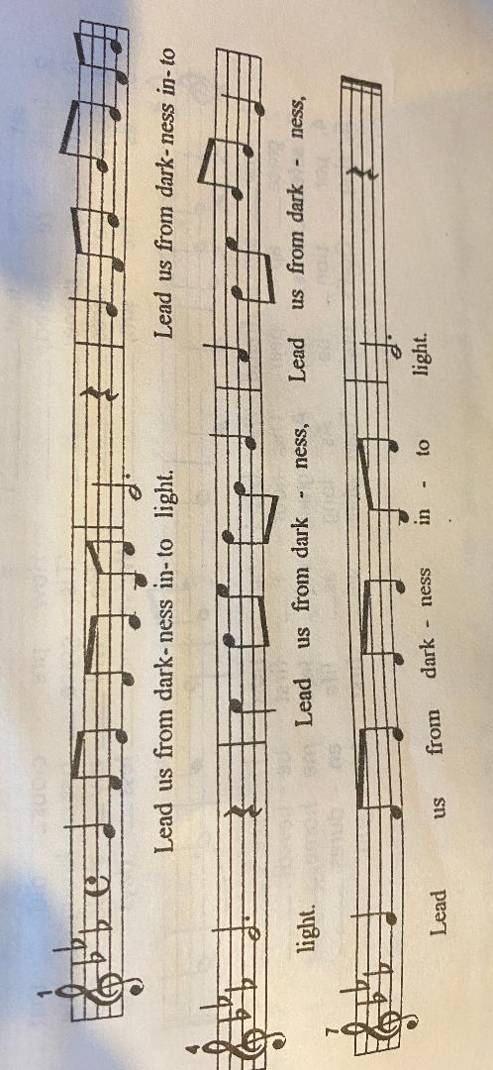

(Mary Ott) Richard McGinnis will read from the 22nd chapter of Genesis, followed by questions and silence for reflection. Feel free to stay with whatever question calls you.

READING 1 (Richard McGinnis)

Gn 22:1-2, 9a, 10-13
God put Abraham to the test.
He called to him, “Abraham!”
“Here I am!” he replied.
Then God said:
“Take your son Isaac, your only one, whom you love,
and go to the land of Moriah.
There you shall offer him up as a holocaust
on a height that I will point out to you.”
When they came to the place of which God had told him,
Abraham built an altar there and arranged the wood on it.
Then he reached out and took the knife to slaughter his son.
But the LORD’s messenger called to him from heaven,
“Abraham, Abraham!”
“Here I am!” he answered.
“Do not lay your hand on the boy,” said the messenger.
“Do not do the least thing to him.
I know now how devoted you are to God,
since you did not withhold from me your own beloved son.”
As Abraham looked about,
he spied a ram caught by its horns in the thicket.
So he went and took the ram
and offered it up as a holocaust in place of his son.
[Slight pause]
REFLECTION QUESTIONS (Jim DeQuattro)

Abraham said “Here I am” when God called to him. How do you hear God speaking to you?
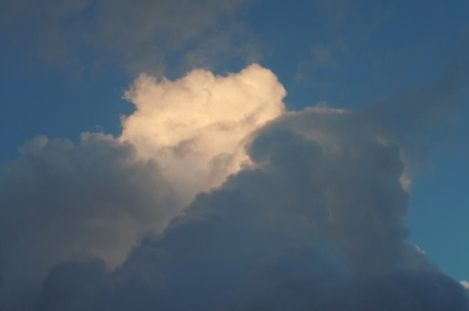
If you recognize the “human sacrifice” of capital punishment, war that kills innocents, and tolerance for the suffering of refugees and poor people, how do you feel, what do you do?

SILENT REFLECTION
(Betty: Slide 2, time 2:00, chime, stop slide,

advance to slide 3)

(Mary Ott) Now Maryann Dolan will read from St. Paul’s letter to the Romans, chapter 8. In this reading we see that what was foreshadowed in the story of Abraham and Isaac has come to fruition in the sacrifice of God’s Beloved Son.

READING 2 (Maryann Dolan)

Rom 8:31b-34, 38-39
Brothers and sisters:
If God is for us, who can be against us?
He who did not spare his own Son
but handed him over for us all,
how will he not also give us everything else along with him?
Who will bring a charge against God’s chosen ones?
It is God who acquits us, who will condemn?
Christ Jesus it is who died—or, rather, was raised—
who also is at the right hand of God,
who indeed intercedes for us.
For I am certain of this:
neither death nor life, nor angels, nor principalities, nothing already in existence and nothing still to come,
will be able to come between us and the love of God,
known to us in Christ Jesus our Lord.
[Slight pause]

REFLECTION QUESTIONS (Jim DeQuattro)

How do you feel about God handing over his Beloved Son for us all?
How does knowing that Jesus intercedes for us always, without our asking, change prayer for you?
SILENT REFLECTION
(Betty: Slide 3, time 2:00, chime, stop slide)

(Mary Ott) Implicit in shifting our understanding of human sacrifice is a shift in our understanding of God, as Sister Mary M. McGlone writes:

“Abraham had conceived of God as one who demanded intercessors and sacrifice to make us acceptable to the divine. The God he met, the God of Jesus, is the God who wants only to draw us into divine life…. This is what the disciples began to comprehend on the mountain of the Transfiguration. For a brief moment, they perceived that Jesus was God's ultimate messenger, the culmination of everything in their tradition: the God who created out of love and wants only love. Like Abraham, they couldn't take it all in. On that mountain they perceived a truth that didn't fit their categories, it couldn't fit into their tents. That is why the divine voice told them to listen and Jesus told them not to speak — at least not yet. …. The God to whom Jesus introduced them blew open their categories and invited them to stop trying to be best or even worthy.”
After that experience, can you imagine the energy that the disciples felt to share God’s love and light?
In this reading we see the full manifestation of Jesus as the Light of the World.

Now Bob Gallagher will read from the 9th chapter of the Gospel of Mark.

READING 3 (Bob Gallagher)

Mk 9:2-10
Jesus took Peter, James, and John
and led them up a high mountain apart by themselves.
And he was transfigured before them,
and his clothes became dazzling white,
such as no fuller on earth could bleach them.
Then Elijah appeared to them along with Moses,
and they were conversing with Jesus.
Then Peter said to Jesus in reply,
“Rabbi, it is good that we are here!
Let us make three tents:
one for you, one for Moses, and one for Elijah.”
He hardly knew what to say, they were so terrified.
Then a cloud came, casting a shadow over them;
from the cloud came a voice,
“This is my beloved Son. Listen to him.”
Suddenly, looking around, they no longer saw anyone
but Jesus alone with them.
As they were coming down from the mountain,
he charged them not to relate what they had seen to anyone,
except when the Son of Man had risen from the dead.
So they kept the matter to themselves,
questioning what rising from the dead meant.
[Slight pause]

REFLECTION QUESTIONS ((Jim DeQuattro)

How can you better listen to Jesus?
What words of Jesus have you questioned or not understood?
SILENT REFLECTION
(Betty: Slide 4, time 2:00, chime, stop slide
--- advance to Slide 5)

SHARING TIME (Lynn Bufka)

We invite you to briefly share what emerged in your heart this morning as you have reflected upon our readings and music. We welcome everyone who wants to speak, and we also know that the wisdom of this community includes both words shared and silent listening.

So let’s begin in silence as we gather our reflections. [Long-ish pause]

Now who would like to start our sharing? Remember to unmute yourself to speak and mute yourself again afterwards.

[Sharing]

[If there is silence more than about 30 seconds before anyone speaks:] Take whatever time you need before you speak.
[If there is extend1ed silence during the sharing:] Is there anyone else who would like to share? [Pause.]

[Stop by about 11:20.] Thank you.

PRAYERS OF THE COMMUNITY (Greg and Pat Campbell)

Greg: We have just listened to God’s word – in scripture, in everyone’s reflections, and in our hearts and minds. Let’s pause in silence to notice what prayer rises in us now.
[Pause]

Our response today will be:
Pat: Hold us in your mercy.
Pat (and all, muted): Hold us in your mercy [sung one time]
How it sounds: https://www.youtube.com/watch?v=r1GKnLS1lFA]

Greg: God of Light, brighten the lives of those who live in darkness, without hope.
For this we pray.
Pat: Hold us in your mercy.
Pat (and all, muted): Hold us in your mercy.

Greg: God of Light, shine in our darkness and make us your light. For this we pray.
Pat: Hold us in your mercy.
Pat (and all, muted): Hold us in your mercy.

Greg: God of Light, thank you for those who welcome your call to a life committed to bringing your Light to people who are poor, marginalized, or unseen. With the Leadership Conference of Women Religious, may we ground our solidarity in your Gospel. For this we pray.
Pat: Hold us in your mercy.
Pat (and all, muted): Hold us in your mercy.

Greg: For what else shall we pray? Please unmute yourself to speak, and mute yourself afterward.

[Shared prayers]

O Great Love, we place all of our prayers, those spoken and those unspoken, into your care, and we entrust the outcome to you. Amen.
Pat: Hold us in your mercy.
Pat (and all, muted): Hold us in your mercy.

OFFERTORY (Joan and Stu Sklamm)
Joan: Loving God, each week we have been offering to you our intent to take a specific action. Week by week, we commit and recommit. Our commitments evolve as we let in more and more light. In musical meditation, we ask you, Holy One: how are we – how am I – to bring your light into the week ahead?
Stu plays: “Take Me As I Am” by John Bell [Repeat as needed for about a minute.]
(Betty: Start slide 5 during Joan’s final sentence above. Stop slide after Stu plays, before Joan speaks. Then advance slide.)

Joan: In thanksgiving for the presence and power of Jesus Christ, and in unity with the Holy Spirit, let us pray. God of abundance, we commit to sharing our time, talents, and treasures so we that we may be a light and a witness to the transforming love of Jesus Christ. Amen.

CELEBRATION OF COMMUNION (Grace Hartzog)

O Great Love, we are humbled and emboldened
to know that you trust us to be your body in this world.
We are part of that body as we let go of all that separates us from you,
and as we embrace one another and your entire creation with merciful love.
We give you thanks for your presence in and among us. [Pause.]

We remember the night before Jesus died.
At dinner with friends, Jesus knew all that would soon be asked of them,
and, loving them to the end, Jesus showed them how to care for each other
as they went out into the world.
First Jesus washed their feet.
Then he looked at what was in front of them, the bread and the cup,
gifts of the earth and work of human hands, and blessed them.
So let us, too, invite God right now into what is front and center in our lives
knowing that God will indeed enter what we offer – and bless it. [Pause.]

Let us invite God into ourselves so that we become God’s living presence in our world. [Pause.]
Holy One, you transform us as you nourish us here.
May we nourish others with your presence.
Amen.

OUR FATHER (Cynthia Norris)

Now let us join our hearts as if we could join our hands to pray in harmony with Christians throughout the world in the words that Jesus gave us:
All (muted): Our Father, who art in heaven, hallowed be thy name.
Your kingdom come. Your will be done on earth as it is in heaven.
Give us this day our daily bread
and forgive us our trespasses as we forgive those who trespass against us,
and do not let us fall into temptation, but deliver us from evil
for the kingdom, the power, and the glory are yours, now and forever. Amen.

FINAL BLESSING (Mary Ott)
(Betty: Slide 6 for duration of the blessing)
Slide 6

“Blessed are you who bear the light “– by Jan Richardson
Blessed are you
who bear the light
in unbearable times,
who testify
to its endurance
amid the unendurable,
who bear witness
to its persistence
when everything seems
in shadow
and grief.
Blessed are you
in whom
the light lives,
in whom
the brightness blazes—
your heart
a chapel,
an altar where
in the deepest night
can be seen
the fire that
shines forth in you
in unaccountable faith,
in stubborn hope,
in love that illumines
every broken thing
it finds. Amen.
CLOSING SONG (Reggie Ott)
“Christ, Be Our Light“-- by Bernadette Farrell
Longing for light, we wait in darkness
Longing for truth, we turn to You.
Make us Your own, Your holy people
Light for the world to see.
Christ, be our light!
Shine in our hearts.
Shine through the darkness.
Christ, be our light!
Shine in Your church gathered today.
Many the gift, many the people
Many the hearts that yearn to belong.
Let us be servants to one another
Making Your kingdom come.

RESOURCES
- Opening Ritual – “Hosea,” by John Michael Talbot.
- Opening Ritual – “Lent is a call…” quote from Benedictine Sister Joan Chittister: http://rosemarieberger.com/2011/03/15/joan-chittister-lent-is-a-chance-to-grieve/
- Readings from the Bible -- https://bible.usccb.org/bible/readings/022821.cfm
- From “Lent 2021: To Live Anew,” by Benedictine Sister Joan Chittister.
- From “Feb. 28, 2021: Second Sunday of Lent” https://www.ncronline.org/sunday-resource/feb-28-2021-second-sunday-lent?site_redirect=1 )by Mary M. McGlone, CSJ.
- “Take me as I am,” by John Bell.
- “Blessed are you who bear the light: – by Jan Richardson: https://adventdoor.com/2014/12/12/advent-3-testify-to-the-light/
- “Christ be our Light,” by Bernadette Farrell.
- Photos by Mary Ott.

