Solidarity with Sisters Communal Prayer for
Ash Wednesday, Wednesday, February 17, 2021

From winter darkness towards the Easter warmth of God’s radiant light
WELCOME (Suzie)
Beloved community – peace be with you!
Response: And also with you.
GATHERING PRAYER / SETTLING IN (Betty)
We gather tonight in darkness as we enter Lent and begin our 40-day walk together into the Christ light of Easter. And so we pray: May we be good companions to one another on this journey. May we let your light shine in us and through us more and more each day. Amen.
I invite you to begin with quiet in your mind and heart. Let’s begin by settling our bodies and our minds. Get comfortable in your chair, feel its support. Take a deep breath and feel your breath flowing all through your body… in and out… carrying away tensions in your body… carrying away distractions… (Pause.) Now let’s settle into this time together, in our different places, by sharing a common breath…. In and out…. One collective breath to be here. And one to be together. And one to let in the light of Christ.
Stu and Linda will now lead us in listening to and then singing Hosea.
OPENING SONG -- Hosea by John Michael Talbot (Stu Sklamm, Linda Donaldson, and all, muted)
Stu plays one chorus:
Come back to me with all your heart,
Don't let fear keep us apart.
Long have I waited for
Your coming home to me
And living deeply our new lives.

Linda sings solo - two verses:
Come back to me with all your heart,
Don't let fear keep us apart.
Trees do bend though straight and tall;
So must we to others' call.
Long have I waited for
Your coming home to me
And living deeply our new lives.

The wilderness will lead you
To the place where I will speak
Integrity and justice
With tenderness
You shall know.
Long have I waited for
Your coming home to me
And living deeply our new lives.

Stu plays one final chorus:
Come back to me with all your heart,
Don't let fear keep us apart.
Long have I waited for
Your coming home to me
And living deeply our new lives.

LENTEN THEME (Betty)
During these 40 days of Lent we seek God and, in doing so, we hope to banish the fear, despair and anger that get in the way of our living deeply this new life in God. We remember what Howard Thurman preached: “The true purpose of all spiritual disciplines is to clear away whatever may block our awareness of that which is God in us.”

And so let us each ask ourselves, What hinders us from coming home to God? What lives inside me that gets in the way of God? And how can I remove those barriers?

Jesus told us that to change we need to identify our own stumbling blocks, “to take the log out of our own eye” first. We get this clearer vision by what Jesus called metanoia. Metanoia which asks us to literally change our mindsets and our hearts to be more like Jesus. We don’t expect to achieve metanoia all at once, but these days of Lent are a start. We can commit to the ongoing struggle to change our hearts. We can face what hinders us, knowing that God is in this with us, loving and encouraging our work. And we can move into the Christ light of Easter transformed and living deeply our new lives.

This Lent, how do you hope to change your mindset and your heart? What hinders you from seeing the light and being the light? What helps you to see that which is God in you?

READING (Marie McCarthy)
A reading from the 2nd chapter of the book of Joel.

Blow the horn in Zion; shout out on this holy mountain! Let all the people of the land tremble, for the day of Yahweh is coming. Yes, it is near.

Now, Yahweh calls, “Come back to me with all your heart, with fasting, weeping, mourning.”

Tear your hearts and not your clothes, and come back to Yahweh your God, who is gracious and compassionate, slow to anger, rich in faithful love, and who relents about inflicting disaster.

Blow the ram's horn in Zion!
Order a fast, proclaim a solemn assembly,
call the people together, summon the community,
assemble the elders, gather the children, even infants at the breast.
Let the ministers of Yahweh stand weeping saying, ‘Spare your people, Yahweh.’”

Then Yahweh showed concern for the land and took pity on the people.

REFLECTION (Suzie)
The reading from Joel takes us back to a time of great danger in Israel. The land has been ravaged by locusts, the crops are failing. The very life of the population is in question. The prophet Joel summons the House of Israel to repent its ways. But, interestingly enough, he does not call them to attend penance services in the synagogue or make animal sacrifices. He does not talk about public displays of remorse, the time-honored tearing of garments to demonstrate grief. No, Joel says instead, “Rend your hearts and not your clothing.”
“Lent is a call to weep for what we could have been and are not. Lent is the grace to grieve for what we should have done and did not. Lent is the opportunity to change what we ought to change but have not. Lent is not about penance. Lent is about becoming, doing and changing whatever it is that is blocking the fullness of life in us right now.”
And Lent is not an individual action for we enter into this season together. It is our communal intention to move forward to do the hard work of being the Body of Christ, to be engaged in the world. Lent is a summons to live anew. To clear out our minds and hearts, not only to let in the light but also to be the light.
Lent has often meant “giving up” in some way. This Lent, maybe we are called instead to give. When we “rend our hearts” we break them open to things we may have been refusing to consider. We start that rending tonight by looking at ourselves with holy curiosity about what we hope to give. In that spirit, you might ask yourself:
- What commitments to happiness have you allowed to get dusty? (Pause ~15 seconds.)
- What fruitful spiritual practices have you let fall aside? (Pause.)
- What fears, hurt, or pain have festered in ways that hold you back? (Pause.)
- How has your anger or harsh judgment closed the doors to your heart and mind? (Pause.)
- When have you let a litany of despair crowd out a litany of prayer? (Pause.)
Today, in these first days of Lent, we invite you to pay attention to your hope for a full and holy life, and to notice what hinders you or helps you in fulfilling that hope. This Lent, day by day and week by week we can explore metanoia – changing our minds and hearts to get rid of some hindrance or create some new good so that we can truly feel the Easter warmth of God’s radiant light.
Then, as Joel promises, God will have pity on us and pour into our hearts the life we know down deep that we are lacking.
(Slight pause.)
We invite you into a slightly longer reflection this evening. Go wherever your heart takes you. This is time for you and God; we won’t be sharing afterwards.
SILENT REFLECTION (Betty: Start slide, time 4 minutes, chime, stop slide.)
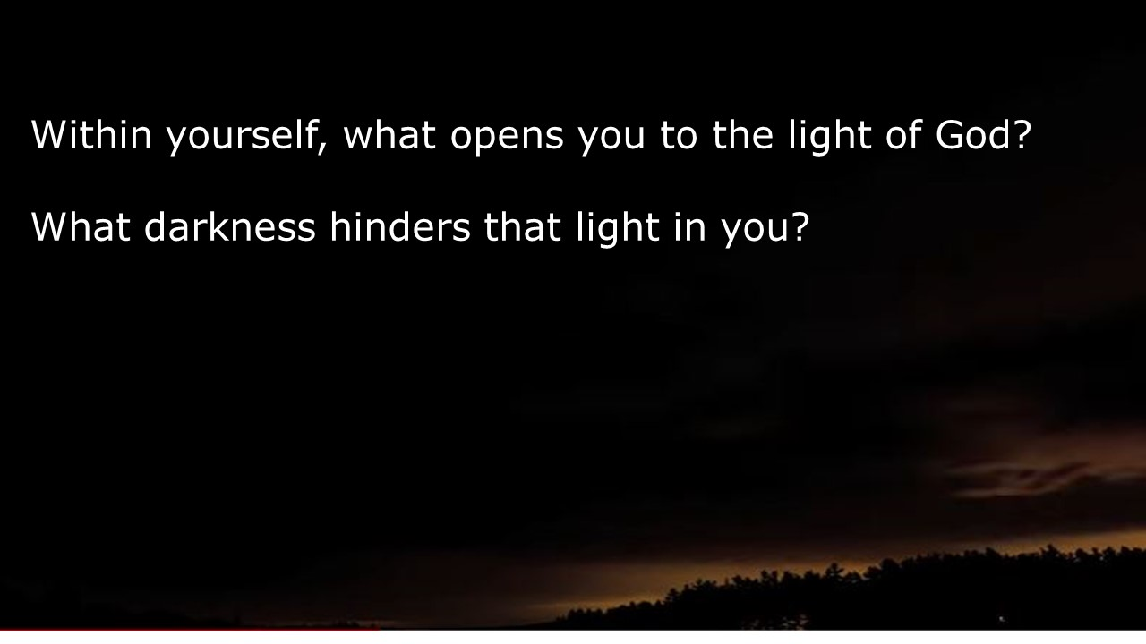
LENTEN INTENTION (Suzie and Betty)
(Betty) We invite you to take what is emerging in your heart right now to form your intention for Lent. [Pause.]

Now we invite you to write or draw your intention on page 14 of your Little Black Book or on your piece of paper. [Pause.]

Now seal your intention by placing your thumb in what you have brought (ashes, oil or water). Mark the shape of a cross in your book or on your paper. [Pause.]

(Suzie) Lent summons us to live anew as a community. As we seek to be light to the world let us seal each other and our community. Raise your thumbs to the camera making the sign of the cross and saying, “Put on the mind of Jesus and believe in the Gospel.”

O God, day by day, week by week, throughout this Lent we ask you to help us open up new spaces in ourselves and in our world – spaces where your holy Spirit has plenty of room to act, spaces where the light of Christ can shine. Amen.

CLOSING BLESSING (Betty)

Let us extend our hands over each other and bless each other.

Blessed are you
who bear the light
in unbearable times,
who testify
to its endurance
amid the unendurable,
who bear witness
to its persistence
when everything seems
in shadow
and grief.
Blessed are you
in whom
the light lives,
in whom
the brightness blazes—
your heart
a chapel,
an altar where
in the deepest night
can be seen
the fire that
shines forth in you
in unaccountable faith,
in stubborn hope,
in love that illumines
every broken thing
it finds. Amen.
CLOSING SONG by John Bell (Reggie Ott and all, muted)
Take, O take me as I am;
Summon out what I shall be;
Set your seal upon my heart
And live in me. Repeat 3 times

RESOURCES
Reflection by Sister Joan Chittister - https://www.huffpost.com/entry/beginning-again-always_b_830218?guccounter=1
Image from “Time-Lapse Dawn Sequence” by John Bannister -
https://www.youtube.com/watch?v=xF49lnywnAE
“Blessed are you who bear the light” by Jan Richardson -https://adventdoor.com/2014/12/12/advent-3-testify-to-the-light/

