Solidarity with Sisters’ Communal Contemplative Prayer – Sept. 29-3, 20020

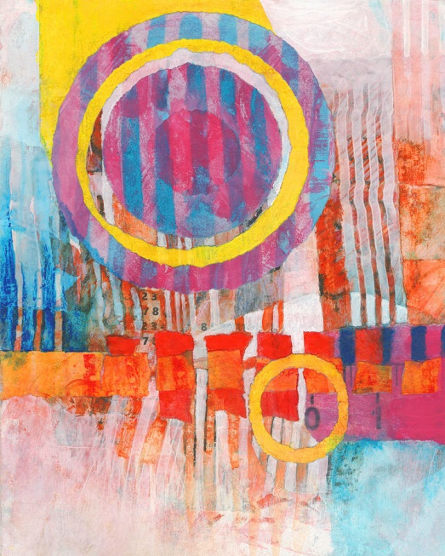
GATHERING

Loving God, we come here now to know you
alive in us.
Help us to let go and to let come.
Help us to live the questions.

Help us to settle into your presence with quiet openness.

We are here to let God transform us. So let’s open ourselves to God. Feel the comfort of your chair and relax into it… and relax into God’s love for you. Let your breath deepen and quiet. Notice your body and any tension you may be carrying. You may want to tighten as you inhale and relax as you exhale—your head and jaw and neck, shoulders arms and hands, stomach, hips, legs and feet. If distractions come, let them slide away. Notice your breath. Take a deep breath, hold for a moment, and slowly exhale. Again. Feel your chest and stomach rise and fall as you gently breathe… Know the Spirit is
Art by David Dasnod
moving in you gently and easily. Again, take 3 gentle breaths.
One to be here… one to be together….and one to carry you into 10 minutes of silence in God.

(10 minutes of silence)

Now let’s listen to words by Meister Eckhart (approx. 1260-1328), and then take them into 20 minutes of silence with God.

Above all else then
Be prepared at all times
for the gifts of God
and be ready always for new ones.

For God is a thousand times
more ready to give than we are to receive.

For the person who has learned to let go
and let be nothing can hinder.
Then each creature points you toward God
and to a new birth and toward seeing
the world as God sees it: Transparently!

Then all things become nothing but God
and we learn to know with God’s
knowledge and to live with God’s love.

When we learn this, we know everything
praises God. Darkness, privations, defects,
evil too praise and bless God,
For all paths lead to God
and God is on them evenly for those who
know with transformed knowledge.

What is best is to take God
and enjoy God in any manner, in any thing.
All my life, this has been my joy.
God does not ask anything else of you
except that you let yourself go
and let God be God in you.”

(20 minutes of silence)

PRAYERS

Let’s come back together… Let us take a moment to let our experience in silence take a shape we can hold onto….. Let us invite each other to share the prayers that arise in us now.

(Shared prayers – “Holy One, hear our prayer.”)

In the Leadership Conference of Women Religious, we see the active fruitfulness of living contemplatively in God. May we all carry quiet within ourselves so that God may be God in us. For this we pray. Holy One, hear our prayer.

CLOSING

O Great Love, we place all of our prayers, those spoken and those unspoken, into your care. We entrust the outcome to you, and we offer you our hearts, our minds, and our wills in service of that outcome, even if it’s not what we had in mind. And so together we pray: Come, Holy Spirit. fill the hearts of your faithful and kindle in us the fire of your love. Send forth your Spirit and we shall be created, and you shall renew the face of the earth. Amen.

SIGN OF PEACE

