Solidarity with Sisters Communal Contemplative Prayer – June 30-July 1
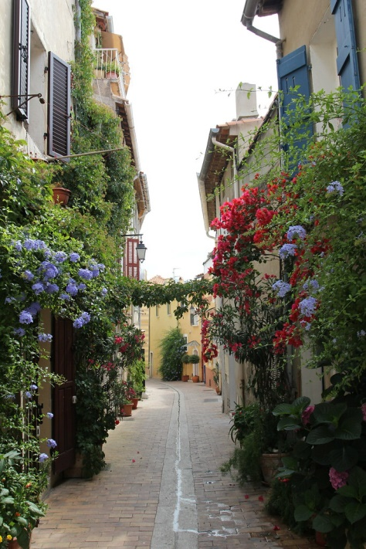
GATHERING
O God who creates and who gives breath,
be with us now as we come to you

with the great longings of our world

and of our selves.

We come together

trusting that the Spirit will be at work in us.

Help us to let go and to let come.

Help us to live the questions

and to move with you, in you, and toward you,

ever open to what is waiting to be born in us.

BEING HERE: Come as you are, in divine presence…

We are moving from getting here to being here. Let your body relax, feeling all the places it is supported. Let your breath slow and deepen. Exhale and release tensions. Inhale and welcome God into you. I invite you to give 10 minutes of silence to knowing God loves you.

(10 minutes of silence)

AWARENESS

Let us listen to the poem “The Appointment” by Mark Nepo from this week’s contemplative resources from the Leadership Conference of Women Religious:

What if, on the first sunny day,
on your way to work, a colorful bird
sweeps in front of you down a
street you’ve never heard of.

You might pause and smile,
a sweet beginning to your day.

Or you might step into that street
and realize there are many ways to work.

You might sense the bird knows some-
thing you don’t and wander after.
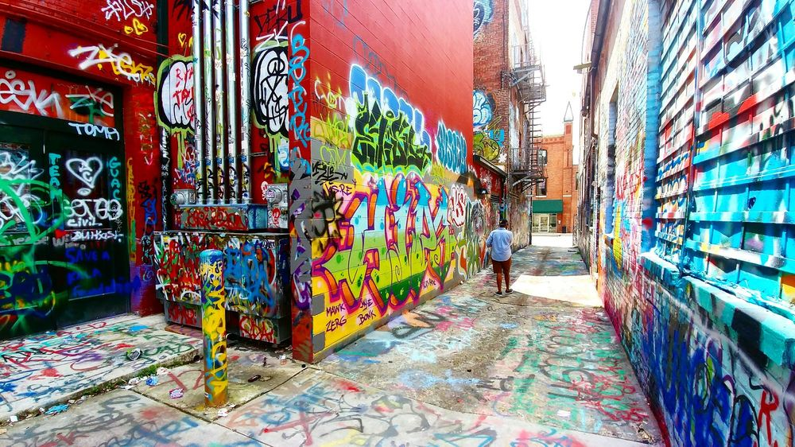
You might hesitate when the bird
turns down an alley. For now
there is a tension: Is what the
bird knows worth being late?

You might go another block or two,
thinking you can have it both ways.
But soon you arrive at the edge
of all your plans.

The bird circles back for you
and you must decide which
appointment you were
born to keep.

You who love us, we give you our silence for 20 minutes. Please open us to your messengers and invitations.

(20 minutes of silence)

INTENTION

Let’s invite each other to share the prayers that arise in us now. Our response will be: You who love us, hear our prayer.

God with us, bless our discernment in this time of detours, uncertainties, and new paths. We ask this for all of us, and in a special way for the Leadership Conference of Women Religious and Catholic sisters. For this we pray. You who love us, hear our prayer.

(Shared prayers)
CLOSING

We place all of our prayers, those spoken and those unspoken, into your loving care, and we entrust the outcome to you. As we do, we use the words of Sister Pat Farrell. “There is so much more going on within and around us than we will ever be able to perceive. The unseen movement of Love is creatively holding everything together in ways infinitely beyond what we could ask or imagine.” We ask the Spirit to “open space in us to flow with what we cannot see, with what is beyond us. Yet the path remains always a walk in the dark. We walk it together, summoning one another to deepening faith in the invisible energy of Love that surrounds and carries us.”

And so together we pray: Come, Holy Spirit. Fill the hearts of your faithful and kindle in us the fire of your love. Send forth your Spirit and we shall be created, and you shall renew the face of the earth. Amen.

SIGN OF PEACE

