Solidarity with Sisters Communal Contemplative Prayer – June 16-17

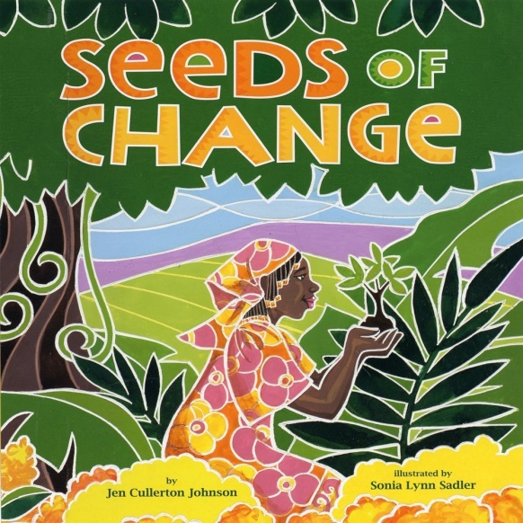
GATHERING
O God who creates and who gives breath,
be with us now as we come to you

with the great longings of our world

and of our selves.

We come together

trusting that the Spirit will be at work in us.

Help us to let go and to let come.

Help us to live the questions

and to move with you, in you, and toward you,

ever open to what is waiting to be born in us.

BEING HERE: Come as you are, in divine presence…

We are moving from getting here to being here. Feel your body, let it relax, supported. Feel your breath. Exhale your tensions. Inhale and welcome God into you. Let’s give 10 minutes of silence to offer our full attention to God and to ask the Holy Spirit to inhabit us.

(10 minutes of silence)

AWARENESS (Reader, please don’t read aloud the parenthetical attributions in a smaller font.)

A prayer by Michael Ray Matthews from Chautauqua’s Interfaith Family.

Here we are yet again,
In our rage, our sorrow, our fear.

We are so angry we are tired.
Between the virus and anti-Blackness,
We are perpetually in grief.
We don’t know what the future holds.

We are a people of unclean lips.
We live in and accept the Logic of Empire
Its Impulse and Imagination course in our very flesh.
Daily we manifest dehumanization, exclusion, and isolation.

And yet again we are here
In faith, hope, and love.

We seek the wisdom and courage
To sustain and deepen the Solidarity
We see in the Tweets and in the streets.

May the Spirit of Revolutionary
Love Be present among us,
Fall fresh upon us,
And breathe again on each of us.

Transform us Within
So that Black Lives Matter in our hearts and minds.

Transform us Between
So that Black Lives Matter in our relationships.

Transform us Among
So that Black Lives Matter in our institutions and systems.

Transform us Around
So that we may grow a culture where All Black Lives Matter.

May our work today
Not only cultivate Beloved Community,
But help to rebuild the Soul of the World.

Ase. Amı ̆n. Blessed Be. Amen.

Holy One, in these 20 minutes of silence, please lead us from these words to wherever you are waiting for us.

INTENTION

Let’s invite each other to share the prayers that arise in us now.

Response: Holy One, hear our prayer.

The Leadership Conference of Women Religious and Catholic sisters work to root out racism in themselves and their communities as they cultivate Beloved Community in society. May we support them, and do the same. For this we pray. Holy One, hear our prayer.

(Shared prayers)

CLOSING

We place all of our prayers, those spoken and those unspoken, into your loving care, and we entrust the outcome to you. We thank you, God, that “It is not ours to see the future. Our task is not to create a plan for the new to emerge. It is to create a space for the new to emerge. For the young. For the growing diversities. A space where the Holy Spirit is free to work. If we can do this, the future will emerge. And it will be good.” And so together we pray: Come, Holy Spirit. Fill the hearts of your faithful and kindle in us the fire of your love. Send forth your Spirit and we shall be created, and you shall renew the face of the earth. Amen.
SIGN OF PEACE

