Solidarity with Sisters’ Communal Contemplative Prayer – August 18-19, 2020

GATHERING

O God who creates and who gives breath,
be with us now as we come to you

with the great longings of our world

and of our selves.

We come together

trusting that the Spirit will be at work in us.

Help us to let go and to let come.

Help us to live the questions

and to move with you, in you, and toward you,

ever open to what is waiting to be born.

BEING HERE: Come as you are, in divine presence…

Let’s make space in ourselves for God. Let your body soften and relax…. Feel the support of your chair and of the floor…. Notice your breath and let it slow and deepen…. Let the Spirit flow into you with every breath…. Let’s take one deep breath to be here… one to be together… and one to create space for peace. I invite you to welcome the Spirit during 10 minutes of silence.

(10 minutes of silence)

AWARENESS

On Sunday we gave our attention to readings and reflections about faith and prayer. You may want to spend time with the image above, of reaching hands, that Anne and Bill shared the prior Sunday and the images of the night sky, the Canaanite woman, and St. Teresa of Avila that Lynn and Norb shared this past Sunday. The poem The Avowal by Denise Levertov will give us another entry point into contemplative silence.
As swimmers dare
to lie face to the sky
and water bears them,
as hawks rest upon air
and air sustains them,
so would I learn to attain
freefall, and float
into Creator Spirit’s deep embrace,
knowing no effort earns
that all-surrounding grace.

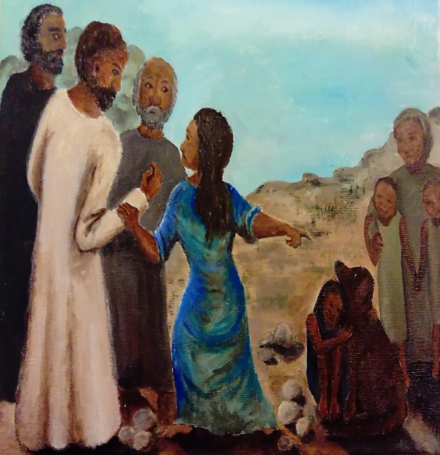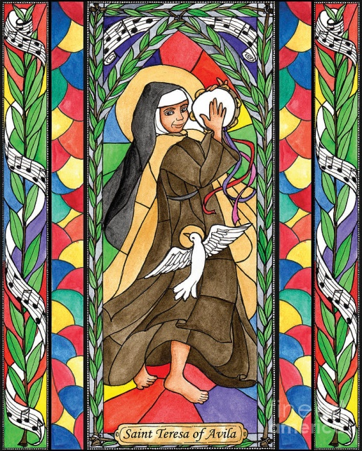

Let us take these words and images into 20 minutes of silence with God.

(20 minutes of silence)

INTENTION

Let’s invite each other to share the prayers that arise in us now. Our response will be: Holy One, hear our prayer.
At last week’s Assembly of the Leadership Conference of Women Religious, Sister Jean Marie Fernandez used the words “I can’t breathe” to reflect that “Our society is suffocating from systemic injustice…. I work with people from all faith traditions who recognize breath as the life force of the universe….. I believe God’s breath is healing our universe, navigating through our diverse charisms, strengthening us in new ways, so a greater good can emerge.” Spirit of life, may we breathe with you for the healing of all. For this we pray. Holy One, hear our prayer.

(Shared prayers)
CLOSING

O Great Love, we place all of our prayers, those spoken and those unspoken, into your care, and we entrust the outcome to you. As we close, we are inspired by the words of Sister Eloise Garcia:
What would happen if Catholic sisters [and other lay people]
were to unleash the power of their lifetimes of prayer and contemplative practice
to hold the safety and protection of all peoples across the world as a sacred intention?
And so together we pray: Come, Holy Spirit. Fill the hearts of your faithful and kindle in us the fire of your love. Send forth your Spirit and we shall be created, and you shall renew the face of the earth. Amen.
SIGN OF PEACE

