Solidarity with Sisters’ Communal Contemplative Prayer – August 11-12, 2020

GATHERING

O God who creates and who gives breath,
be with us now as we come to you

with the great longings of our world

and of our selves.

We come together

trusting that the Spirit will be at work in us.

Help us to let go and to let come.

Help us to live the questions

and to move with you, in you, and toward you,

ever open to what is waiting to be born.

BEING HERE: Come as you are, in divine presence…

Let’s make space in ourselves for God. Let your body soften and relax…. Feel the support of your chair and of the floor…. Notice your breath and let it slow and deepen…. Let the Spirit flow into you with every breath…. Let’s take one deep breath to be here… one to be together… and one to create space for peace. I invite you to welcome the Spirit during 10 minutes of silence.

(10 minutes of silence)

AWARENESS

On Wednesday through Friday of this week, the Leadership Conference of Women Religious will be holding their annual Assembly, online. The theme is “God’s Infinite Vision: Our Journey to the Borders and Beyond.” With the sisters, let’s look with God’s vision beyond the borders of our current ways.
I invite you to return to yesterday’s two images of what it’s like to experience divine presence, and where that leads. Remember Elijah leaving the cave and heading back to Damascus. Remember Peter leaving the boat and walking on water. [Pause.]
As we did on Sunday, we draw on Dr. Margaret Wheatley’s address to the 2016 LCWR Assembly. It is titled “Finding Ground in the Age of Groundlessness.” She said:
“We need to be the presence of peace wherever we are, wherever we are. In the midst of terrifying circumstances, we need to be the presence of peace.
“We are eating the future by our unwillingness to use our great human capacities for thought and reflection and contemplation, and for working with Mystery which then does provide us with solutions [and] right action…. Some people think that when we get contemplative and reflective it means we’re withdrawing from the world, but that is not my experience at all. It means we’re getting wiser because we’re not reacting in the moment; and we’re also not working from ego, we are working with Mystery, and Mystery is not really mysterious. Our willingness to enter into Mystery, to surrender to Mystery, means we are abandoning our egos, we are abandoning our personality, we are abandoning the tight ways we hold ourselves. But once you surrender the experience, if you go back to any of the beautiful women Christian mystics in the church, their experience is one of rapture, ecstasy, clarity, clear-seeing, and complete confidence. That’s not based on achievement, it just is.
“I would love you to contemplate about when you have surrendered and when you have felt you were working not as you, but in full relationship with the Divine.”

Let us take these words into 20 minutes of silence with our God of infinite vision who leads us to the borders and beyond.

(20 minutes of silence)

INTENTION

Let’s invite each other to share the prayers that arise in us now. Our response will be: Holy One, hear our prayer.
God of Infinite Vision, along with LCWR, we pray for the ability to see beyond the borders we are used to, in full relationship with you. For this we pray. Holy One, hear our prayer.

(Shared prayers)
CLOSING

O Great Love, we place all of our prayers, those spoken and those unspoken, into your care, and we entrust the outcome to you. As we close, we are inspired by the words of Sister Eloise Garcia:
How might our prayers and intentions be joined across [communities]
for the common good of the whole Earth community
to help lift the spirits of a people, especially
in the wake of closed churches, synagogues, mosques, and other places of worship?
What would happen if Catholic sisters [and other lay people]
were to unleash the power of their lifetimes of prayer and contemplative practice
to hold the safety and protection of all peoples across the world as a sacred intention?
And so together we pray: Come, Holy Spirit. Fill the hearts of your faithful and kindle in us the fire of your love. Send forth your Spirit and we shall be created, and you shall renew the face of the earth. Amen.
SIGN OF PEACE

Because we refer to the readings and reflections from our Sunday communal prayer, here they are, with thanks to Anne Regan and Bill Fanelli, who planned Sunday.

INTRODUCTION TO THEME (Anne)
We are living in times of unanticipated chaos, where old forms are giving way and the new forms are not yet clear. Our faith tells us that in times of chaos, divine presence draws near.
In today’s readings, we are invited to consider the ways in which God’s presence becomes known. In Kings, we look at the prophet Elijah hiding in a cave on Mount Sinai, having had enough of having his hopes dashed for how God’s work should be done - in his humble opinion. Queen Jezebel was slaughtering the Lord’s prophets, so Elijah challenged her to have four hundred and fifty of her own prophets call upon Ba’al to consume an offering. When they failed, Elijah called upon the God of Israel, and immediately, Elijah’s offering was devoured. Elijah then seized the prophets of Ba’al, and slaughtered them. Elijah thought this demonstration would certainly result in the conversion of Queen Jezebel and King Ahab.
Instead, Jezebel told Elijah he will meet the same end as her prophets. Elijah fled for his life, and we find him full of despair, hiding in a cave.
In Matthew, we pick up with the disciples right after the loaves and the fishes of last week, and Jesus and Peter walk on the water. Jewish people of the time would hear the echoes of Psalms where God “stretches forth thy hand from on high and rescues me and delivers me out of great waters.” The storm is a symbol of the presence of God. In moments of great need, we recognize the presence of the Lord. Both readings inform us about what becomes possible when God’s presence makes itself known.
In our third reflection, we will consider what Meg Wheatley and John Lewis suggest about the connection between the still quiet voice, being led to the edge, and living the gospel.
After each reading, we will offer questions before we pause for silent reflection. Don’t feel you have to answer all questions. To stay with only one of them might lead you into a deeper place.

Now Donna Ellerman will read from KINGS. Then Jim De Quattro will offer questions for our reflection.

READING 1: 1 Kings 19:9-15a (Donna)
At the mountain of God, Horeb, Elijah came to a cave where he took shelter. [But the word of the LORD came to him: Why are you here, Elijah?
He answered: “I have been most zealous for the LORD, the God of hosts, but the Israelites have forsaken your covenant. They have destroyed your altars and murdered your prophets by the sword. I alone remain, and they seek to take my life.”]
Then the LORD said to him,
“Go outside and stand on the mountain before the LORD;
the LORD will be passing by.”
A strong and heavy wind was rending the mountains
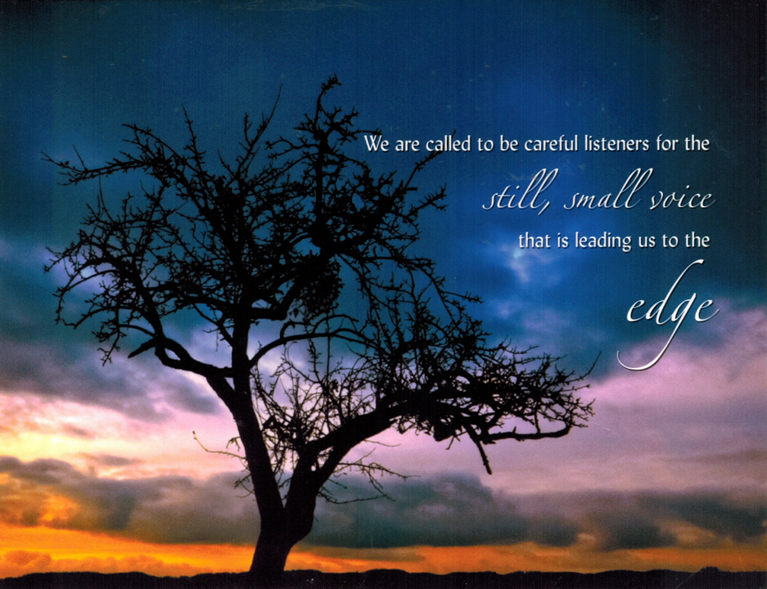
and crushing rocks before the LORD—
but the LORD was not in the wind.
After the wind there was an earthquake—
but the LORD was not in the earthquake.
After the earthquake there was fire—
but the LORD was not in the fire.
After the fire there was a tiny whispering sound.
When he heard this,
Elijah hid his face in his cloak
and went and stood at the entrance of the cave.
[A voice said to him, Why are you here, Elijah?
He replied, “I have been most zealous for the LORD, the God of hosts, but the Israelites have forsaken your covenant. They have destroyed your altars and murdered your prophets by the sword. I alone remain, and they seek to take my life.”
The Lord said to him: Go back! Take the desert road to Damascus.]
REFLECTION QUESTIONS (Jim De Quattro)
What helps you hear the still, small voice?
What sends you to a cave to hide out, and, should God inquire, what is your lament?
When have you felt called to go back, and “take the desert road” to a situation you wanted to leave behind?
SILENCE (Sound a chime after 2 minutes.) (Anne)
Anne: Now Bill Ellerman will read from the 14th chapter of Matthew.
READING 2: Matthew 14:22-33 (Bill E.)
After he had fed the people, Jesus made the disciples get into a boat
and precede him to the other side,
while he dismissed the crowds.
After doing so, he went up on the mountain by himself to pray.
When it was evening he was there alone.
Meanwhile the boat, already a few miles offshore,
was being tossed about by the waves, for the wind was against it.
During the fourth watch of the night,
he came toward them walking on the sea.
When the disciples saw him walking on the sea they were terrified.
“It is a ghost,” they said, and they cried out in fear.
At once Jesus spoke to them, “Take courage, it is I; do not be afraid.”
Peter said to him in reply,
“Lord, if it is you, command me to come to you on the water.”
He said, “Come.”
Peter got out of the boat and began to walk on the water toward Jesus.
But when he saw how strong the wind was he became frightened;
and, beginning to sink, he cried out, “Lord, save me!”
Immediately Jesus stretched out his hand and caught Peter,
and said to him, “O you of little faith, why did you doubt?”
After they got into the boat, the wind died down.
Those who were in the boat did him homage, saying,
“Truly, you are the Son of God.”

REFLECTION QUESTIONS (Jim)

When do you cry out "Lord, save me"?
In what way do you hear Jesus say "take heart, it is I; have no fear?"

When do you find yourself stepping out of the boat into the chaos?

SILENCE (Sound a chime after 2 minutes.) (Anne)

Anne: Now Betty Thompson and Bill Fanelli will read a reflection on the themes of these scriptures.

REFLECTION: Excerpted from Meg Wheatley and John Lewis (Betty & Bill)
Betty: Addressing the Leadership Conference of Women Religious at the 2016 Assembly, Dr. Margaret Wheatley gave a talk titled “Finding Ground in the Age of Groundlessness.” She said:
We are called to be careful listeners to the still, small voice that is leading us to the edge. A long time ago I was told that the voice of God, the voice of the Holy Spirit, speaks as loudly as we are willing to listen, and that has been a great source of guidance to me. If I couldn’t hear the voice of Spirit, I knew that it was my problem. It wasn’t that the Holy Spirit had turned away from me, it’s just that I had moved in the position of thinking, “I know what to do, I’m in charge here. Thank you, I got the inspiration now. I’m just running off with it.”
But this still, small voice is not small, and I think part of our resistance, certainly my resistance, was where it leads us. ... When we listen to Spirit, when we really listen and tune in, we are led to the edge. Not a comfortable place to be. So there is enormous risk involved in being willing to be used by God. There is enormous possibility, but there is also enormous risk.
Bill: Over the last few weeks, we have had the opportunity to reflect on the life and faith of the Honorable John Lewis. His life is witness to what it means to be led to the edge and be willing to return, over and over again. In his actions, we see the embodiment of the African proverb “When you pray, move your feet.” John Lewis described his experience in these words
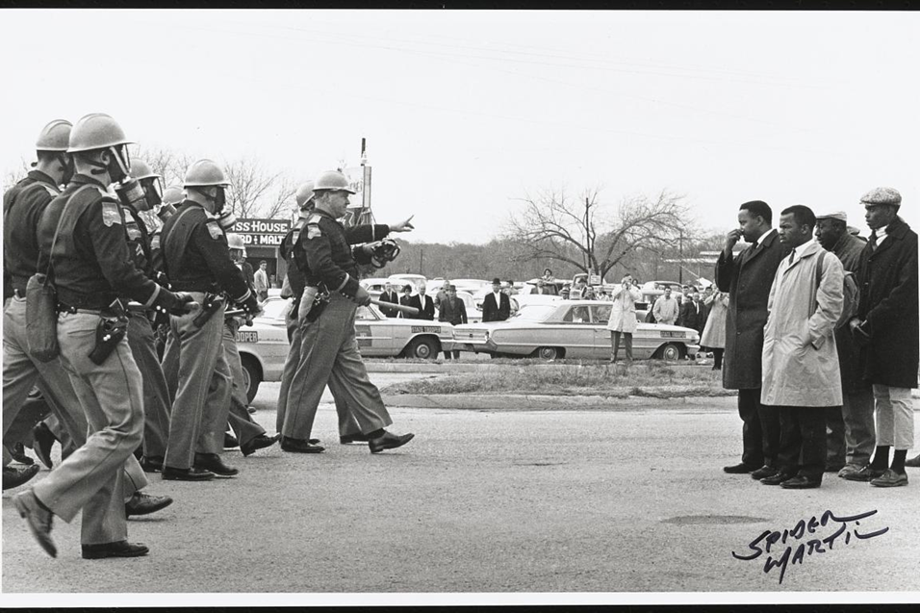
When we were sitting in, it was love in action.
When we went on the freedom ride, it was love in action.
The march from Selma to Montgomery was love in action.
We do it not simply because it’s the right thing to do, but it’s love in action. That we love our country, we love a democratic society, and so we have to move our feet.
Rep. John Lewis
REFLECTION QUESTIONS (Jim)

What is the difference between what you think God wants you to do and what comes to you in the silence?

What risks does heeding the deep still voice bring up?

