We gather in solidarity with women religious for
Communal Contemplative Prayer – Date, 202x

Settle into the immense Love in which we live and move and have our being....
As I sit here, the beating of my heart,
the ebb and flow of my breathing, the movements of my mind
are all signs of God's ongoing creation of me.
I pause for a moment, and become aware
of this presence of God within me….
Notice if something here leads you to the Holy One. Follow that path, or
just follow the Spirit.

“Living Peacefully with Complex, Unanswerable Questions”
Excerpt 3, by Sister Ellis McCulloh

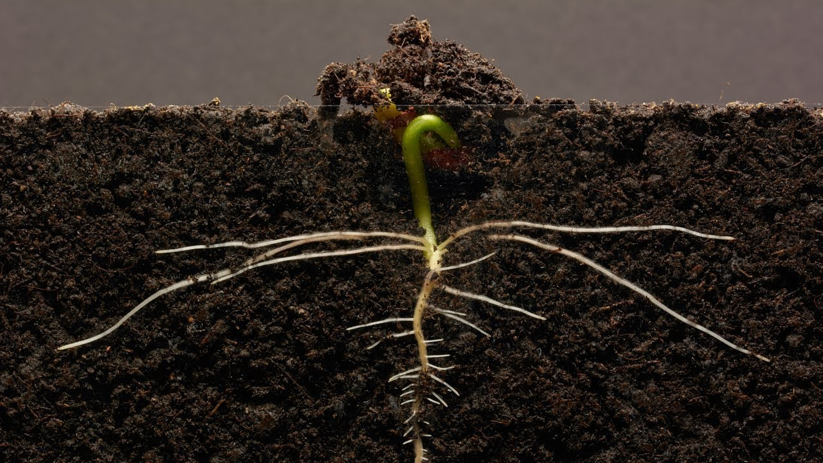
For a long time, my constant prayer mantras have been, “Be where your feet are” and “When you pray, move your feet.” I am most inclined to live 100 steps ahead of the present moment – dreaming about ways to respond, planning events well into the future, thinking about my next ministry, etc. Regular spiritual direction, prayer, and time with friends and community help me stay grounded in the present moment. They remind me that the future isn’t mine to plan, but mine (ours) to live into. Our next step isn’t a giant hurdle to be leapt, but a constant moving forward and listening, learning, and being challenged by all the voices around me.

For me, the larger questions are about what is at the heart of life. What continues to propel us on the spiritual journey? For me, there is freedom and joy in embracing the questions and allowing them to inform our lives and our future

30 minutes of silence

We welcome one another’s reflections and prayers.

Closing: Dear God, may we never forget how much we need each other. After all, we are connected through your creation. Let us not be afraid to talk, to laugh, to cry, and to share stories and our lives with each other. Amen.

Or: Come, Holy Spirit. Fill the hearts of your faithful and kindle in us the fire of your love. Send forth your Spirit and we shall be created, and You shall renew the face of Earth. Amen.

Settling in: modified from Sacred Space, a website of the Irish Jesuits

Reading: from the Winter 2022 Occasional Papers of the Leadership Conference of Women Religious, on the theme “The Unknown: A Place of Potential and Possibility.” This excerpt is from the article whose title is cited above, in which Sister Annmarie Sanders interviews four younger women religious: Felician Sister Grace Marie Del Priore, Humility of Mary Sister Ellis McCulloh, Marianist Sister Nicole Trahan, and Jane Aseltytine, a Sister of the Immaculate Heart of Mary of Monroe, Michigan.
Image: “Bean time lapse: 25 days, Soil Cross Section” – by GPhase https://www.youtube.com/watch?v=w77zPAtVTuI
First Closing prayer option: Maria Shriver’s Sunday Paper https://www.mariashriversundaypaper.com/

