Solidarity with Sisters’ Communal Contemplative Prayer, Dates, 20xx

Gathering - Most gracious Love, we gladly come to your endless embrace. We are here to attune to your movement, so that our growth and our actions may always be in you.

So let us settle into your presence, Beloved One.
May I quiet my words and listen…. May I calm my thoughts and be….
May I soften my heart and open…. May I still my soul and receive….
(Pause) Our breath says we are here…. We are together…. we are in God.

Psalm 139

Yahweh, you gaze on me and you know me, you know if I am standing or sitting.

The word is not even on my tongue, Yahweh, before you know all about it;

close behind and close in front you fence me round, shielding me with your hand.

Such knowledge is beyond my understanding, a height to which my mind cannot attain.

Where could I go to escape your spirit? Where could I flee from your presence?

If I flew to the point of sunrise, or westward across the sea,

your hand would still be guiding me, your right hand holding me.

It was you who created my inmost self and put me together in my mother’s womb;

for all these mysteries I thank you: for the wonder of myself, for the wonder of your works.

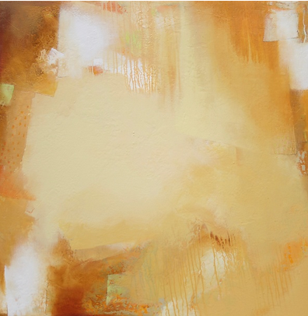
You know me through and through,

from having watched my bones take shape

when I was being formed in secret,

knitted together in the limbo of the womb.

I could no more count your thoughts

than I could the sand;

And suppose I could, you would still be more.

Beloved, examine me and know my heart;

probe me and know my thoughts;

make sure I do not follow pernicious ways,

and guide me in the way that is everlasting.

(30 minutes of silence)

(Sharing, if you would like)

Closing – Holy One, we entrust ourselves to you in peace and in hope. “Make us now your living sign. Recreate us for your purpose in this place and in this time.” Amen.

Translation: The Jerusalem Bible, abridged and lightly adapted

Image: “Sunny with a Chance of Sand” by Jan Jahnke at https://www.artfulhome.com/product/Acrylic-Paintings/Sunny-with-a-Chance-of-Sand/117030?refid=73426&gclid=CjwKCAiA5sieBhBnEiwAR9oh2t6Og8asl_zuMUzwQFHsnWdo8B_efIfG3QTEPKM9o5uEUuoGEg5Q6xoCeAsQAvD_BwE

