Solidarity with Sisters’ Communal Contemplative Prayer, Dates, 20xx

Gathering - Most gracious Love, we gladly come to your endless embrace. We are here to attune to your movement, so that our growth and our actions may always be in you.

So let us settle into your presence, Beloved One.
May I quiet my words and listen…. May I calm my thoughts and be….
May I soften my heart and open…. May I still my soul and receive….
(Pause) Our breath says we are here…. We are together…. we are in God.

Lyrics and music based on Psalm 139 by Bernadette Farrell
https://www.youtube.com/watch?v=mEGc3_D19Vo
O God, you search me and you know me.
All my ways lie open to your gaze.
When I walk or lie down, you go before me:
Ever the maker and keeper of my days.
You know my resting and my rising.
You discern my purpose from afar,
and with love everlasting you besiege me:
In ev’ry moment of life or death, you are.
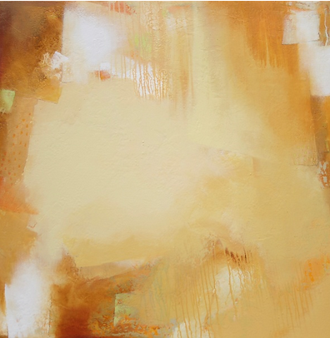
Before a word is on my tongue, Lord,
you have known its meaning through and through.
You are with me beyond my understanding:
God of my present, my past and future too.
Although your Spirit is upon me,
still I search for shelter from your light.
There is nowhere on earth I can escape you:
Even the darkness is radiant in your sight.
For you created me and shaped me,
gave me life within my mother’s womb.
For the wonder of who I am, I praise you:
Safe in your hands, all creation is made new.

(30 minutes of silence)

(Sharing, if you would like)

Closing – Holy One, we entrust ourselves to you in peace and in hope. “Make us now your living sign. Recreate us for your purpose in this place and in this time.” Amen.

Translation: The Jerusalem Bible, abridged and lightly adapted

Image: “Sunny with a Chance of Sand” by Jan Jahnke at https://www.artfulhome.com/product/Acrylic-Paintings/Sunny-with-a-Chance-of-Sand/117030?refid=73426&gclid=CjwKCAiA5sieBhBnEiwAR9oh2t6Og8asl_zuMUzwQFHsnWdo8B_efIfG3QTEPKM9o5uEUuoGEg5Q6xoCeAsQAvD_BwE

