Solidarity with Sisters
Stations of the Cross – Good Friday, April 15, 2022

WELCOME Suzie
Welcome to this time of reflective silence together with Jesus. You may want to have a crucifix, and a pen and paper.
INTRODUCTION Suzie
Thank you to Sr. Vera Ruotolo, who prepared our prayer tonight, and to Cheryl Dowden and Jim De Quattro for leading us in these Stations of the Cross.

Tonight, at every station, we will go deeper into the Henri Nouwen poem that you received on Wednesday. At every station, we enter into compassion he describes: “Compassion asks us to go where it hurts, to enter into the places of pain…. Compassion means full immersion into the condition of being human.”

Now let us pause and remember those in our lives whom we want to hold in our collective compassion. (Pause.) We invite you to name them aloud. (People speak.)

Betty will now mute everyone. (Pause. Suzie unmutes.)

At each station tonight, we will hear a reflection and then pause in sacred silence. Open your hearts for any words or phrases that speak to you personally. Jot them down. Take your notes into our longer silences after the 4th, 12th, and 14th Stations.

If longer silence has not been part of your usual life, here is one of many ways to let the silence be fruitful. Notice what has resonated for you – words or images, or the feelings you are experiencing. Talk with God about them. Let it be a conversation, with pauses when you listen for God speaking to you. Pay attention to new feelings and insights that arise as God moves in you.

After the last station, we will pray together and end in silence, with subdued singing, and finally we will leave in darkness. We will end the gathering without conversation. What unites us tonight is not what we express aloud but rather our shared experience of the compassion of Jesus.

So let us settle into this holy time.

SETTLING IN Betty
We are not all in the same physical space, but we can be together by sharing a common breath. We begin by slowly taking one collective breath together. In and out. With each breath, allow the Spirit of God to settle deeper into your being … and ground you in the moment. Allow your body to relax … your head and shoulders … arms and chest … abdomen and legs. Now let’s take 3 more breaths together. One to be here … one to be united in prayer … and one to make space for the gifts of this blessed time together.

CALL TO WORSHIP Suzie
On February 24th the peaceful lives of the Ukrainian people were fiercely invaded by an enemy of democracy. Their president, Volodymyr Zelensky, responded with determination and courage. He called Ukrainian men to defend their country. Immediately these courageous men took leave of their loved ones and prepared to bravely defend their homeland, their democracy, their freedom. And thus began an exodus. Ten million people have fled their homes, of which five million are children. Over four million Ukrainian women, children, and elders, have sought refuge in neighboring countries, who welcomed them with kindness and generosity.

During these past Lenten forty days in the desert, suddenly we were thrust into the reality of a merciless attack on the people of Ukraine, the Body of Christ was viciously attacked at the hands of Evil.

Reader #1: Jim De Quattro
Though He was harshly treated, He submitted and opened not His mouth. He was led like a lamb to the slaughter, and like a sheep before its shearers, … is silent. –Isaiah 53:7
This solemn Good Friday calls us to a deeper compassionate knowing of Jesus in the weakest moments of his humanity … his humiliation of being abandoned, of being scourged, mocked, and spit upon … then condemned to death.
During this time together the Spirit invites each of us to consciously be the living Body of Christ by experiencing a deeper compassionate knowing of the passion and death of Jesus, as painfully experienced today in our suffering people of Ukraine.

Reader #2: Cheryl Dowden
Together let us walk the Way of the Cross with Jesus and Mother Mary through the merciless destructive shelling of the streets of Ukraine, as we carry our own crosses with hope for peace … and new life.
Jesus, we desire to humbly face our own inner poverty, and carry our crosses with acceptance and courage, as we follow your way of the cross.
Let us pause for quiet reflection.

(Pause.)

Reader #1: Jim De Quattro (Begin when this slide appears.) – Slide 1

The First Station: Jesus Is Condemned to Death.

Jim: We adore You, O Christ, and we praise you.
All/Cheryl: Because by Your holy cross, You have redeemed the world.
Jim: Compassion asks us to go where it hurts, where the lives of Ukrainians are attacked, their home life is disrupted, and where their streets and towns are reduced to rubble. Suddenly millions of innocent families face displacement, and as their courageous men take up arms to bravely defend their homeland.
In silence Jesus accepts his unjust condemnation of crucifixion.
Jim: We pause for a moment of reflection.

Reader #2: Cheryl Dowden (Begin when this slide appears.) – Slide 2

The Second Station: Jesus Is Given His Cross.

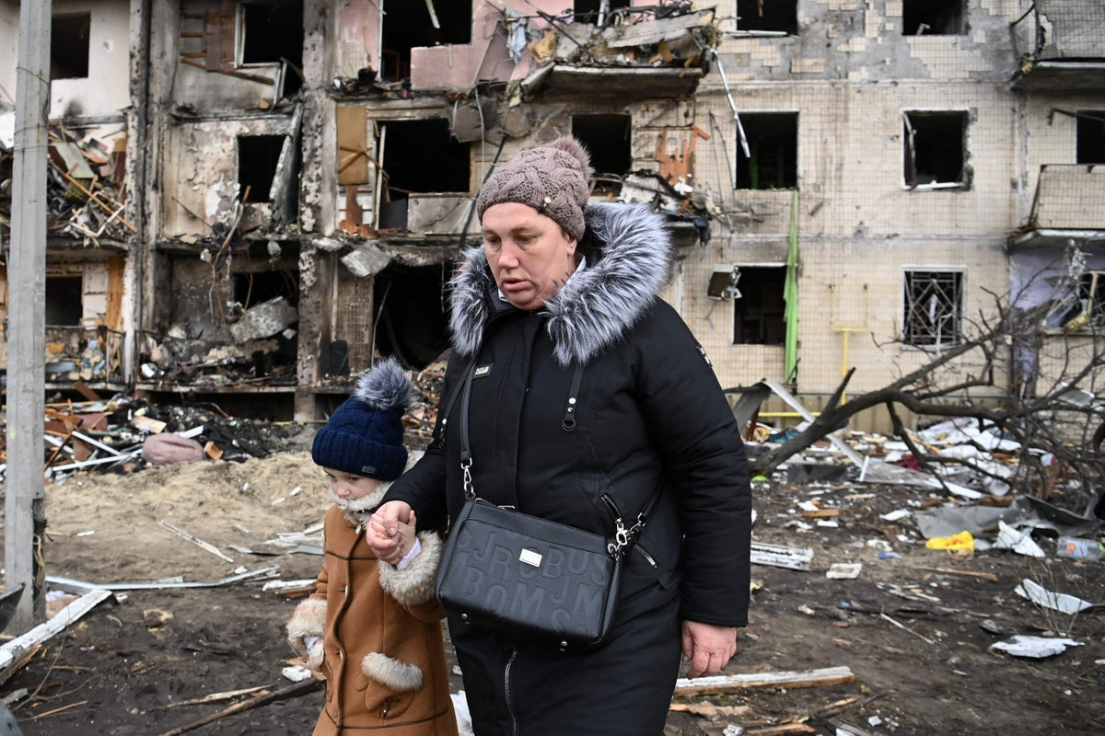

Cheryl: We adore You, O Christ, and we praise you.
All/Jim: Because by Your holy cross, You have redeemed the world.
Cheryl: Compassion takes us into places of pain…into the pain of anxiety, fear, and uncertainty. This woman must be strong for her child even as she asks, why this imposed suffering? Why us good families?
Jesus did not choose his cross, it was given to him.

Reader #1: Jim De Quattro (Begin when this slide appears.) - Slide 3

The Third Station: Jesus Falls the First Time.

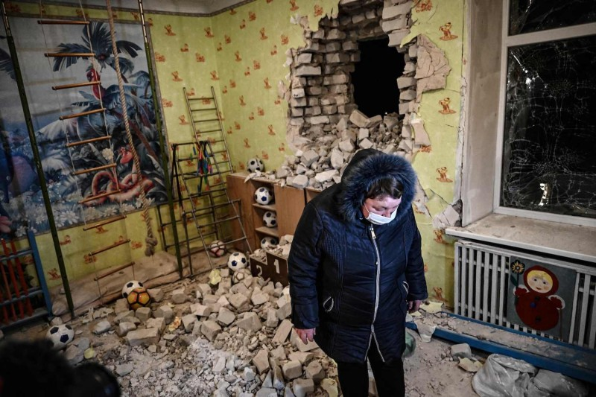

Jim: We adore You, O Christ, and we praise you.
All/Cheryl: Because by Your holy cross, You have redeemed the world.
Jim: Compassion calls us to share in brokenness, confusion, and anguish. At times we cry, “Merciful God, this burden is too heavy to carry. Please give us strength to stand strong. We pray.”
Jesus suffered humiliation, but he sanctified this moment by rising … and he continued to carry his cross.

Reader #2: Cheryl Dowden (Begin when this slide appears.) - Slide 4

The Fourth Station: Jesus Meets His Mother.

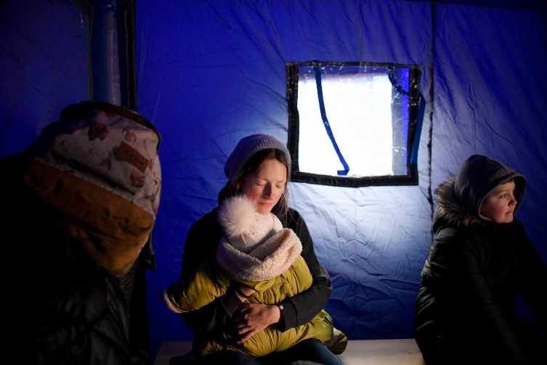

Cheryl: We adore You, O Christ, and we praise you.
All/Jim: Because by Your holy cross, You have redeemed the world.
Cheryl: Compassion causes a mother to reach out and console the child of her womb.
“Holy Mary, your love and comfort is needed for the displaced mothers of Ukraine, and their precious children.”
Betty: Slide 5 - Play video
John Williams: Theme from Schindler's List (violin Solo) Ellen Klodova (5:00) - https://www.youtube.com/watch?v=1h0yEysiYHw

Reader #1: Jim De Quattro (Begin when this slide appears.) - Slide 6

The Fifth Station: Simon of Cyrene Helps Jesus Carry His Cross.

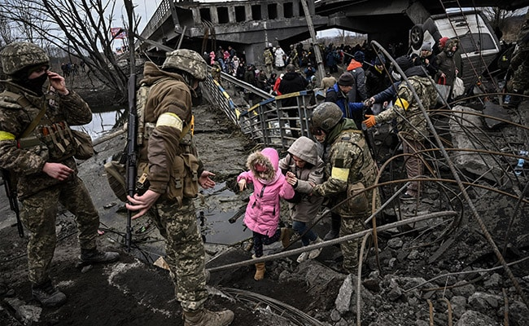

Jim: We adore You, O Christ, and we praise you.
All/Cheryl: Because by Your holy cross, You have redeemed the world.
Jim: Compassion inspires us to reach out to those in need.
“During these days of displacement, we meet people embracing and welcoming us. They offer food, shelter, and safety.”
“Jesus, bless the strangers who help us with their kindness and goodness.”

Reader #2: Cheryl Dowden (Begin when this slide appears.) - Slide 7

The Sixth Station: Veronica Wipes the Face of Jesus.

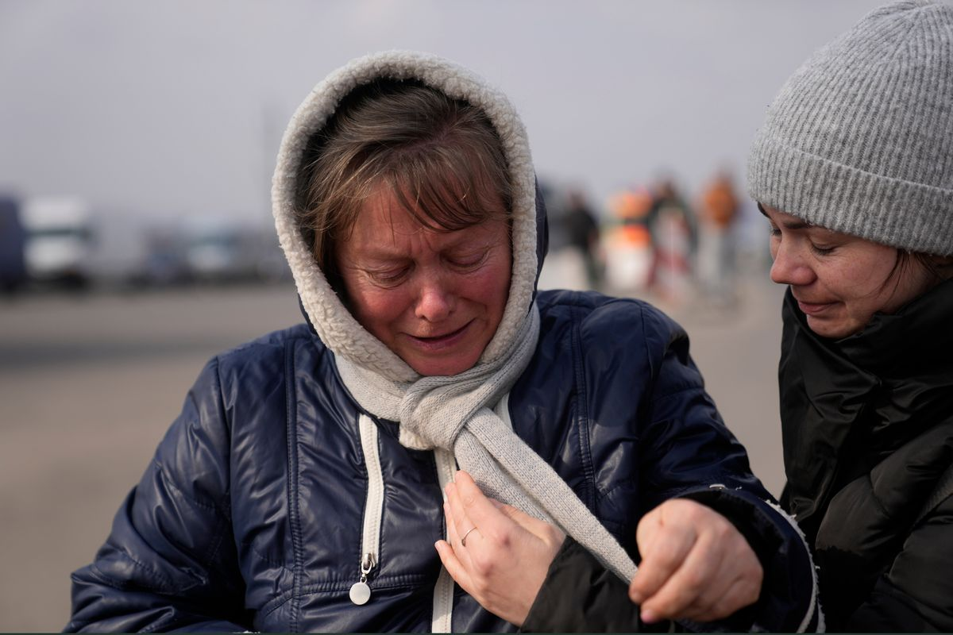

Cheryl: We adore You, O Christ, and we praise you.
All/Jim: Because by Your holy cross, You have redeemed the world.
Cheryl: Compassion asks me to forget myself and to see the need of the person who suffers.
A woman steps up and offers a cloth to wipe the bleeding face of Jesus. Unexpectedly, she is rewarded.
“Jesus, how many times I have been upset, because the person to whom I gave a kindness, did not express gratitude. I ask for forgiveness.”

Reader #1: Jim De Quattro (Begin when this slide appears.) - Slide 8

The Seventh Station: Jesus Falls for the Second Time.

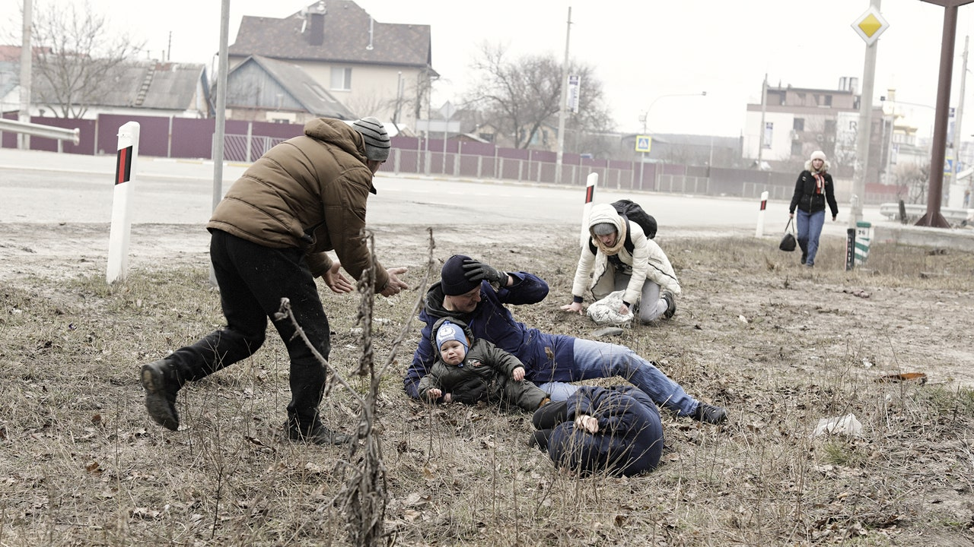

Jim: We adore You, O Christ, and we praise you.
All/Cheryl: Because by Your holy cross, You have redeemed the world.
Jim: Compassion requires us to be weak with the weak, to mourn, and be vulnerable with the vulnerable.
“There is something holy about being human, about drawing on inner strength and not giving up.”
Jesus, you have shown us the way to fall a second time, by courageously standing up and carrying your cross, no matter the pain and humiliation. I ask for courage to do the same.

Reader #2: Cheryl Dowden (Begin when this slide appears.) - Slide 9

The Eighth Station: Jesus Meets the Women of Jerusalem.

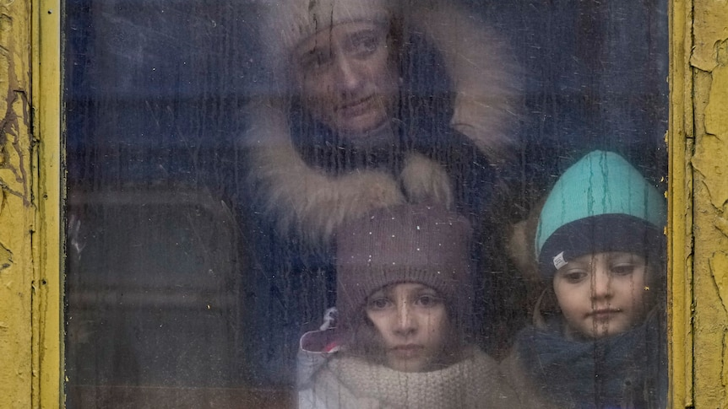

Cheryl: We adore You, O Christ, and we praise you.
All/Jim: Because by Your holy cross, You have redeemed the world.
Cheryl: Compassion challenges us to weep with those in tears.
“We all are sharing a great loss. It is not shameful to cry about the destructive loss of our homes and belongings. Our brave husbands are risking their lives to save our country. Our children are confused and frightened. One day soon may this weeping and sadness end in joyful song and dancing. We hopefully pray.”

Reader #1: Jim De Quattro (Begin when this slide appears.) - Slide 10

The Ninth Station: Jesus Falls for the Third Time.

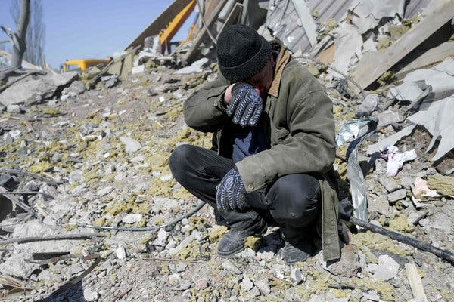

Jim: We adore You, O Christ, and we praise you.
All/Cheryl: Because by Your holy cross, You have redeemed the world.
Jim: Compassion challenges us to stand up for what we believe.
“Jesus, because of your passion and death, you give us the courage and strength to defend our beloved country and our displaced families. Jesus, be with us until the end of this horrific assault. We know we are strong because of your unconditional love for us.”

Reader #2: Cheryl Dowden (Begin when this slide appears.) - Slide 11

The Tenth Station: Jesus Is Stripped Naked.

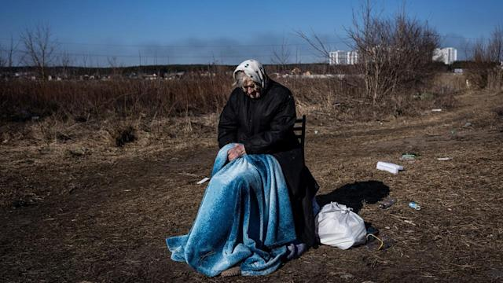

Cheryl: We adore You, O Christ, and we praise you.
All/Jim: Because by Your holy cross, You have redeemed the world.
Cheryl: Compassion calls us to be vulnerable with the vulnerable.
“We are being stripped of everything we hold dear. Our family life, our cities, our beautiful homeland. We are surrounded by devastation and rubble. In you, dear Jesus, and holy Mother Mary, we place our lives and homeland.”

Reader #1: Jim De Quattro (Begin when this slide appears.) - Slide 12

The Eleventh Station: Jesus Is Nailed to the Cross.

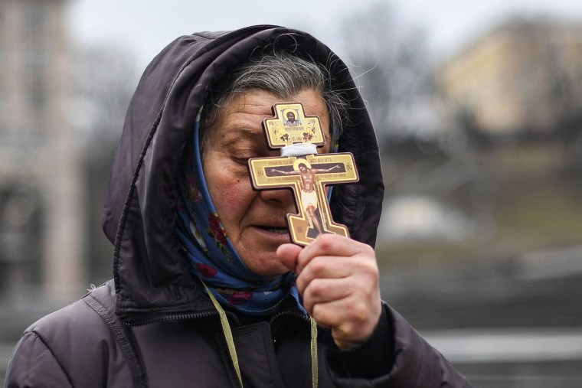

Jim: We adore You, O Christ, and we praise you.
All/Cheryl: Because by Your holy cross, You have redeemed the world.
Jim: Compassion requires us to look upon the suffering son of God and to embrace our cross -- this excruciating cross that has been imposed on us.
Holy Mother Mary, as we suffer so many losses, be with us now, and at the hour of our death, we pray.

Reader #2: Cheryl Dowden (Begin when this slide appears.) - Slide 13

The Twelfth Station: Jesus Dies on the Cross.

Cheryl: We adore You, O Christ, and we praise you.
All/Jim: Because by Your holy cross, You have redeemed the world.
Cheryl: We pause to reflect as we listen and mourn the wounded, the assaulted, the raped, the dying, and the dead of Ukraine and Russia.
“Jesus, and Mother Mary, bring them home to you. We pray.”
Slide 14 - Play Video
Adagio for Strings by Samuel Barber (London Philharmonic Orchestra & David Parry)
https://www.youtube.com/watch?v=03shhXSwRrA

Reader #1: Jim De Quattro (Begin when this slide appears.) - Slide 15

The Thirteenth Station: Jesus Is Taken Down from the Cross.

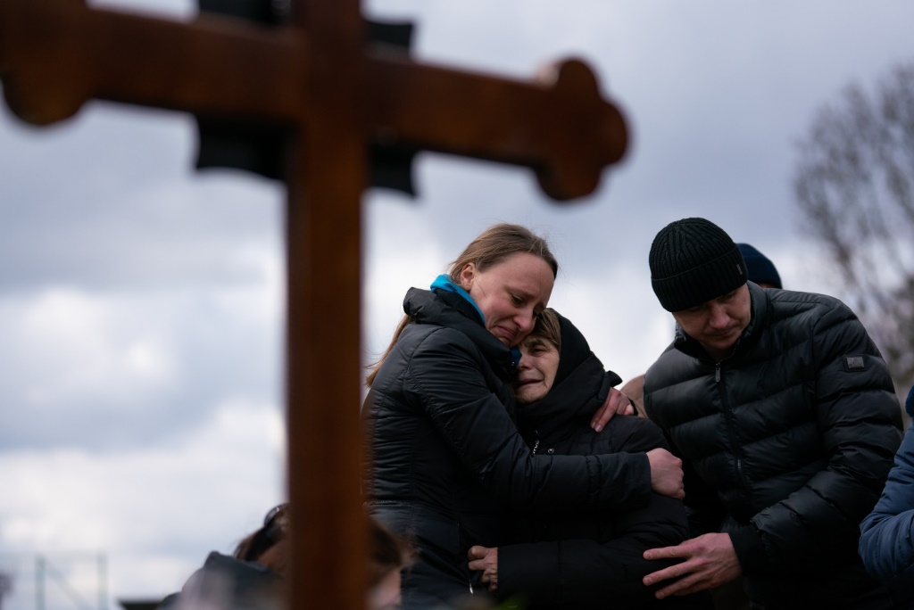

Jim: We adore You, O Christ, and we praise you.
All/Cheryl: Because by Your holy cross, You have redeemed the world.
Jim: Compassion means full immersion in the condition of being human.
“Jesus, you comfort and console us knowing that because of your passion and death, you are with us at all times,
especially when we suffer, die, and rise to new life.
For this we are deeply grateful.”

Reader #2: Cheryl Dowden (Begin when this slide appears.) - Slide 16

The Fourteenth Station: Jesus Is Placed in the Tomb.

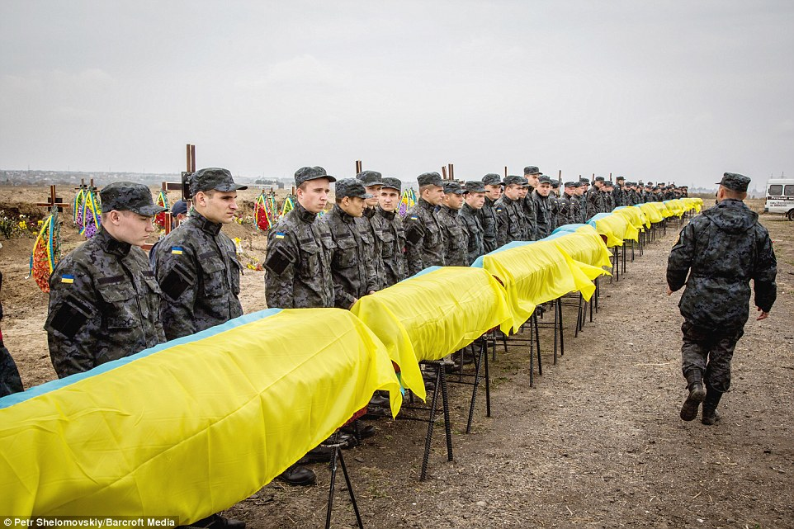

Cheryl: We adore You, O Christ, and we praise you.
All/Jim: Because by Your holy cross, You have redeemed the world.

Cheryl: Jesus, unjustly condemned, abandoned and alone, you took upon yourself the guilt of humanity.
Let us pause to remember the thousands who died bravely and courageously defending their homeland and loved ones, as well as those victims who were killed randomly and without mercy.
Let us sing with the music of Taizé as we remember the dead and dying this day.
Slide 17 - Play Video
“Jesus, Remember Me” by the Taize Community - https://www.youtube.com/watch?v=r6tVReXsioM

Conclusion
Reader #1: Jim De Quattro Betty: Slide 18
“Every human act,
every Christian act, is an act of hope.
But that means we must be women and men of the present,
we must live this moment --- really live it, not just endure it --- because this very moment, for all its imperfection and frustration, because of its imperfection and frustration,
is pregnant with all sorts of possibilities,
is pregnant with the future, is pregnant with love,
is pregnant with Christ.”
-- Walter Burghardt, S.J.
(Pause a few moments.)

Reader #2: Cheryl Dowden (Begin with Burghardt slide still on screen.)
On this solemn day of Holy Week let us continue to pray for the people of Ukraine as Good Friday continues for them … until a peaceful resolution.
Betty: Slide 19
Together we pray: Jesus, our brother, and holy Mother Mary, we place our trust in you, and beg for the conversion of the Russian people, and their leader – and for our own conversion as well. We hopefully pray.
Betty: Betty: Slide 20
You may want to spend some time now or tomorrow simply looking at your cross or crucifix, paying attention to its meaning for you, in honor of the traditional Good Friday practice of Adoration of the Cross. You will also find all of these words and images in your email at the end of this time together.
As you are able, continue in contemplative quiet into Holy Saturday as we anticipate the beauty of the Easter vigil and the joy of Easter Sunday!!
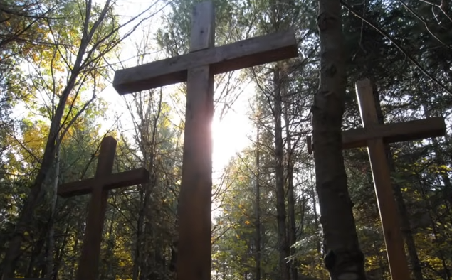

“Jesus, Remember Me” by the Taize Community - https://www.youtube.com/watch?v=r6tVReXsioM
Adagio for Strings by Samuel Barber (London Philharmonic Orchestra & David Parry)
https://www.youtube.com/watch?v=03shhXSwRrA
John Williams: Theme from Schindler's List (violin Solo) Ellen Klodova (5:00) - https://www.youtube.com/watch?v=1h0yEysiYHw

