Solidarity with Sisters’ Communal Contemplative Prayer, Dates, 20xx

Gathering - Most gracious Love, we gladly come to your endless embrace. We are here (this evening) (this afternoon) to attune to your movement, so that our growth may always be in you.

So let us settle into your presence, Beloved One.
May I quiet my words and listen…. May I calm my thoughts and be….
May I soften my heart and open…. May I still my soul and receive….
(Pause) Our breath says we are here…. We are together…. we are in God.

“One winter afternoon” by e. e. cummings
One winter afternoon
( at the magical hour
when is becomes if )
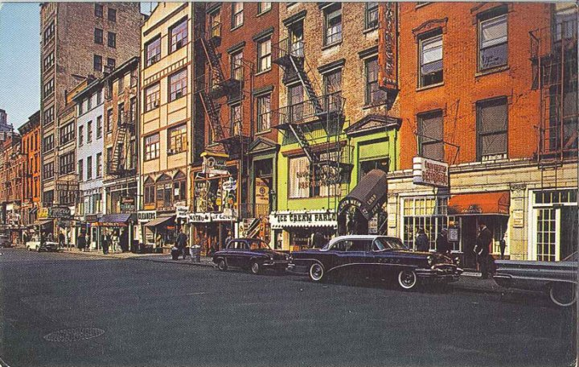
a bespangled clown
standing on eighth street
handed me a flower.
Nobody, it’s safe
to say, observed him but
myself; and why? because
without any doubt he was
whatever (first and last)
most people fear most:
a mystery for which i’ve
no word except alive
— that is, completely alert
and miraculously whole ;
with not merely a mind and a heart
but unquestionably a soul –
by no means funereally hilarious
(or otherwise democratic)
but essentially poetic
or etherally serious :
a fine not a coarse clown
(no mob, but a person)
and while never saying a word
who was anything but dumb;
since the silence of him
self sang like a bird.
Most people have been heard
screaming for international
measures that render hell rational
— i thank heaven somebody’s crazy
enough to give me a daisy

(30 minutes of silence)

(Sharing, if you would like)

Closing – Holy One, step by step may our journeys bring us ever deeper into your Divine delight, in solidarity with one another and with women religious. We give you this prayer and all our prayers, spoken and unspoken, entrusting the outcomes to you. “Make us now your living sign. Recreate us for your purpose in this place and in this time.” Amen.

Image: West Eighth Street ca. the early 1960’s, around the time of the publication of ‘One winter afternoon.’ Found at https://www.villagepreservation.org/2012/01/03/my-favorite-things-poets-edition/

