A Contemplative Reconciliation Time
Solidarity with Sisters, March 28-29, 2023

Please bring a candle to be lighted during the prayer.
This man eats with sinners and welcomes them. Luke 15:2
SETTLING IN Maryann
I invite you to begin with quiet in your mind and heart. Get comfortable in your chair, feel its support. Take a deep breath and feel your breath flowing all through your body… in and out… deeper… in and out… softening you… carrying you into quiet…. (Pause.) Now let’s settle into this time together, in our different places, by sharing a collective breath, to be here…. And another breath, to be together…. And another breath, to open us to holy presence….
May music open us to the Spirit’s movement.
OPENING SONG: Come, Ye Disconsolate by Roberta Flack and Donnie Hathaway
(Betty – Jim De Quattro clip of https://www.youtube.com/watch?v=VmnnMHGvVJc to 2:10.)

Come, ye disconsolate, where’er ye languish,
Come to the mercy seat, fervently kneel.
Here bring your wounded hearts, here tell your anguish;
Earth has no sorrow that heav’n cannot heal.
REFLECTION Betty
On Ash Wednesday we began with our awareness of pain and sorrow in the world. We entered Lent in solidarity with those affected by war and violence… hunger… racism… climate upheaval.… We also opened our hearts to all that needs forgiveness in this world…, in ourselves…, and in our relationships…. We feel grief and sorrow as we notice patterns in our own lives that damage others -- things we keep doing, or failing to do. We long to somehow disrupt our harmful patterns and make space for grace to grow.
Our Ash Wednesday prayer reminded us that the Holy One forgives us before we even ask. Tonight we will enter into this generous grace. We will let it become our own offering of reconciliation and healing.
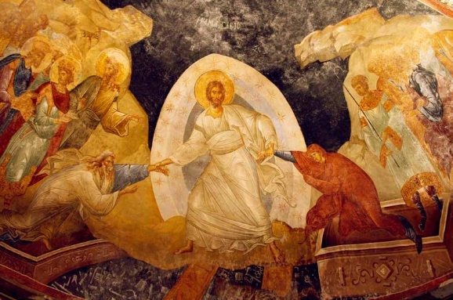
Recall that on Ash Wednesday we gazed at a typical image of the Eastern church that expresses this complete divine forgiveness and grace (show slide). It is an icon of Easter that shows Christ rising with both arms reaching down to tug everyone else up, too – the greatest saints, the worst sinners, and each of us.
This is the Way of Jesus. This is the Way of abundant welcome. During this time together, let us renew our commitment to the Way of Jesus, and to the Light we receive for the next steps.
Jesus’s Way was extravagant largesse – he poured himself out in love. He banqueted, drank, healed on the Sabbath, kept company with women and disreputable people. The Pharisees were appalled: “He eats with sinners and welcomes them!” they said. Formal boundaries meant nothing to him; he walked right through them. He walked with prayerful dignity through the way of the cross, into death, and beyond death. He did not hoard his love, he squandered it. What opened the gates to the Reign of the Holy One was not love stored up but love utterly poured out.
Tonight let us unite with the Way who is Jesus, the Light who is Christ. Let us trust that a united outpouring of light and love shares in the power of Jesus to bring about reconciliation and resurrection.
So here and now let us pour out light and love. We can move toward resurrection with Jesus by offering reconciling light and love wherever each of us feels the strongest need right now. What begs for your light? What are you aware of that aches to become more whole?
- You might be aware of loved ones and strangers in need and in pain….
- You might be aware of patterns in your life that are harmful to you or to others or to Earth…
- You might be aware of hurts and fears you hold, that keep your love from flowing with the extravagant freedom of the Way of Jesus….
- You might be aware of your own aching heart….
LIGHTING OF CANDLES/CONTEMPLATIVE MUSIC AND SILENCE
Maryann
Let us light our candles now, affirming our intention to unite with the light and love of God, however each of us is called. (Pause as we all light our candles.) As we pray with the words “I am sending you light...” let the word “you” have any meaning you wish.
30 minutes of contemplative time
beginning with musical background:
“I am sending you light” by Melanie DeMore

I am sending you light
to heal you, to hold you.
I am sending you light
to hold you in love.
Betty: Fade after first ending https://www.youtube.com/watch?v=4ISWFxMexMQ

CLOSING: Maryann
Let us close in quiet.
Let us settle into the blessings of this moment.
Holy One, you bless us with shared confidence that
you unite with our love in the work of reconciliation.
You hold our hopes for healing
in provident love
that is greater than anything we can ask or imagine.
We entrust ourselves and our intentions to you
in this immense, trustworthy, and beautiful Holy Mystery.
May it be so.
Let us listen to music that expresses this prayer. Feel free to stay here in quiet as long as you’d like, and to go in peace at any time.
(Betty – Jim De Quattro clip of https://www.youtube.com/watch?v=VmnnMHGvVJc from 2:12.)
Joy of the desolate, light of the straying,
Hope of the penitent, fadeless and pure!
Here speaks the Comforter, tenderly saying,
“Earth has no sorrow that heav’n cannot cure.”

RESOURCES
The reflection was shaped by:
- “A Time to Weep” – Sr. Joan Chittister’s Vision and Viewpoint for Feb.27, 2023 at https://mailchi.mp/benetvision.org/a-time-to-weep?e=68c49189cd
- Resurrecting Easter: How the West Lost and the East Kept the Original Easter Vision by John Dominic Crossan and Susan Crossan, 2018. https://www.amazon.com/Resurrecting-Easter-West-Original-Vision/dp/0062434187/ref=sr_1_7?qid=1673717994&refinements=p_27%3AJohn+Dominic+Crossan&s=books&sr=1-7
- Theologian Cynthia Bourgeault, quoted by Fr. Richard Rohr at https://cac.org/daily-meditations/self-emptying-love-2023-02-22/
- Candle light print at https://www.art.com/products/p52835104079-sa-i11447398/candle-light-fire-lamp-nearby-abstract-background-river-during-sunset-or-sunrise-in-countryside-me.htm?ProductTarget=52835104079&RFID=217825&gclid=CjwKCAiAxvGfBhB-EiwAMPakqgiqxNKudqHCS6T9GdbsG9qLgjS037u7HSBlnJr8fIvJ87kbK1OIwhoCwuAQAvD_BwE&utm_campaign=PLA&utm_medium=cpc&utm_source=google
“Come, ye disconsolate” https://www.youtube.com/watch?v=VmnnMHGvVJc

Come, ye disconsolate, where’er ye languish,
Come to the mercy seat, fervently kneel.
Here bring your wounded hearts, here tell your anguish;
Earth has no sorrow that heav’n cannot heal.
Joy of the desolate, light of the straying,
Hope of the penitent, fadeless and pure!
Here speaks the Comforter, tenderly saying,
“Earth has no sorrow that heav’n cannot cure.”
Here see the bread of life, see waters flowing
Forth from the throne of God, pure from above.
Come to the feast of love; come, ever knowing
Earth has no sorrow but heav’n can remove.

