Solidarity with Sisters’ Communal Prayer, August 13, 2023
The Audacity of Faith: We were made for these times.
(Clarissa Pinkola Estes)

Please bring bread and wine/special drink.

WELCOME (Suzie De Quattro and Betty Thompson)
Welcome back, everyone!
- We are pleased to be able to plan our prayer for today and thanks to Anne and Bill for providing us with a wonderful starting point from 3 years ago.
- Introductions – people who haven’t been here before?
- Thanks to the people who will be reading and leading us in prayer and song today: Jo’Ann De Quattro, Jennie Lechtenberg, and Jacqueline Quinn, who are all Sisters of the Holy Names; Kate Finan, Cecilia Estrada, Mary Dolmage, Jim De Quattro, Kathleen Cross, Ann Masters, Peggy Thompson, Norb Bufka, Pat Campbell, and Peg Duchesne, and those who accepted our invitation to begin sharing reflections.
- Planners would be delighted to know if you would read on coming dates. For Aug. 20 contact Terri Butel; for Kathy Cavanaugh for Aug. 27.
- Now Kate Finan will lead us in Settling In.

SETTLING IN (Kate Finan)
We are here to let God transform us. Pay attention to the restful and rejuvenating quiet space within you…. We can focus on the beautiful gift of our breathing and listen…. In these quiet moments, we make ourselves available and totally open to the presence and action of God’s love and spirit within and among us…. Let’s breathe in God’s love for each and for all, and breath that love back out again into our troubled and wounded world. (Pause for 2 long breaths.)
Now Peg Duchesne will lead us into our celebration.

OPENING – HERE I AM by John Michael Talbot (Peg D.)

I, the God of sea and sky,
I have heard my people cry.
All who dwell in dark and sin
My hand will save.
I who made the stars of night,
I will make their darkness bright.
Who will bear my light to them?
Whom shall I send?

Refrain: Here I am, God.
Is it I, God?
I have heard You calling in the night.
I will go, God,
If You lead me.
I will hold Your people in my heart.

I, the God of wind and flame,
I will tend the poor and lame.
I will set a feast for them.
My hand will save.
Finest bread I will provide
'Til their hearts be satisfied.
I will give my life to them.
Whom shall I send? Refrain

GREETING / CALL TO WORSHIP (Jo’Ann)
Beloved community, welcome back to our Sundays together! We hope each of you, like us, has found some refreshment in the past two weeks, and we rejoice to be together again.
Vacations can be time for quiet appreciation of ordinary sacraments in which we experience divine presence, like listening to waves and trees, or gazing at distant vistas, or enjoying conversations. May we gather now in that spirit, aware of how we have met God during the past two weeks and attentive for the divine word that is waiting for us to hear this morning.
Let us pray.
O gracious Mystery that we name God,
we come together trusting that the Spirit will be at work in us.
Help us to let go and to let come.
Help us to live the questions that you place in our hearts.
Blessed Be.

INTRODUCTION TO THEME (Jennie)
Today we will reflect together on audacious faith that impels us to do what seems impossible.
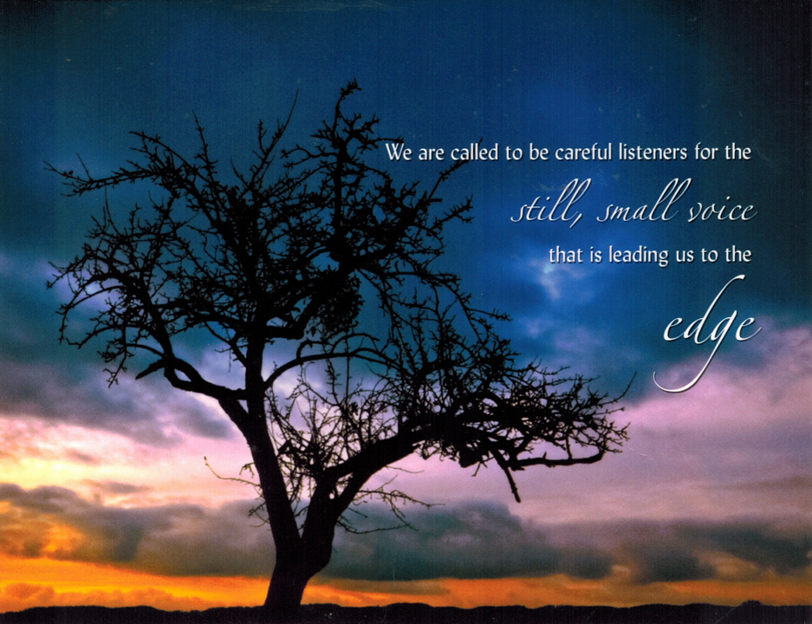
Our readings show us two people hearing God’s call. In what ways are they like you? Elijah heard a very quiet call, a whisper – and it told him to turn his life upside down. Peter heard a loving invitation – and it asked him to do the impossible. Both had to be ready for the unexpected voice.
Hearing God is one thing. Acting is another. Pierre Teilhard de Chardin, the Jesuit scientist and mystic, said, "What paralyzes life is lack of faith and lack of audacity." Faith is an audacious way to live. A bit like Peter deciding to walk on water, half-measures simply won't do.
Today on the lake with the apostles, let’s look together over the edge of our accustomed boat. We may see something for which we are willing to risk walking on water. Fears can make us sink, like Peter. But audacious faith lets us believe that “in times of chaos, divine presence draws near.” (Pause)
Now Jim De Quattro will tell us how the prophet Elijah experienced what can happen when God’s presence draws near. Then Peggy Thompson will offer questions; reflect on one that calls you.
READING 1: 1 Kings 19:9-15a (Jim DQ)
In this reading, we meet Elijah full of despair and hiding in a cave. He believed that he had converted Queen Jezebel with a demonstration of Yahweh’s power of Ba’al, and so he then had the prophets of Ba’al slaughtered. Jezebel, furious, told Elijah she would have him killed. Elijah fled to the cave where we now find him.
A reading from the First Book of Kings:
At the mountain of God, Horeb, Elijah came to a cave where he took shelter. But the word of the Yahweh came to him: “Why are you here, Elijah?”
He answered: “I have been most zealous for Yahweh, the God of hosts, but the Israelites have forsaken your covenant. They have destroyed your altars and murdered your prophets by the sword. I alone remain, and all seek to take my life.”
Then Elijah was told,
“Go outside and stand on the mountain before Yahweh;
and Yahweh will be passing by.”
A strong and heavy wind was rending the mountains
and crushing rocks before Yahweh —
but Yahweh was not in the whirlwind.
After the wind there was an earthquake—
but Yahweh was not in the earthquake.
After the earthquake there was fire—
but Yahweh was not in the fire.
After the fire there was gentle whisper.
When Elijah heard this,
he hid his face in his cloak
and went and stood at the entrance of the cave.
Then the voice of Yahweh spoke to him: “Why are you here, Elijah? Go back the way you came! Take the desert road.” [Then Yahweh instructed Elijah about what he was to do and who would help him.]
REFLECTION QUESTIONS 1 (Peggy T.)
What helps you hear the still, small voice amid the noise?
What is your cave of refuge? What comes to you when you are there?
What words or images from this reading speak to you right now?
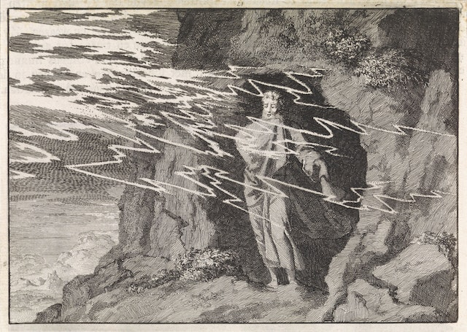

“Elijah in the Cave” by Jan Luyken, public domain

COMMUNAL SILENCE (Sound a chime after 2 minutes.) (Betty)
Now Kathleen Cross will pick up Matthew’s Gospel just after Jesus has shared 5 loaves and 2 fishes with 5000 people – and all were well fed.
READING 2: Matthew 14:22-33 (Kathleen Cross)
After Jesus fed the people, he sent the disciples off in their boat.
Then Jesus went up on the mountain alone to pray.
Meanwhile the boat, already a few miles offshore,
was being tossed about by the waves, for the wind was strong.

Later in the night,
Jesus came toward the disciples, walking on the sea.
Seeing him, they were terrified and cried out in fear,
“It is a ghost.”
At once Jesus spoke to them, “Take courage, it is I; do not be afraid.”

Peter replied,
“Rabbi, if it is you, command me to come to you on the water.”
Jesus said, “Come.”
Peter got out of the boat and began to walk on the water toward Jesus.
But when Peter saw how strong the wind was, he became frightened;
and, beginning to sink, he cried out, “Rabbi, save me!”
Immediately Jesus stretched out his hand and caught Peter,
and said, “O you of little faith, why did you doubt?”
They got into the boat and the wind died down.

REFLECTION QUESTIONS 2 (Peggy T.)

Who or what has called you to step with confidence out of your boat?
When have you called, “Jesus, save me!” expecting his hand, and received something else?

“

“Onto the Water…” - St. Luke’s Episcopal Church, Lebanon, PA

COMMUNAL SILENCE (Sound a chime after 2 minutes.) (Betty)
Now Ann Masters will read a reflection adapted from Clarissa Pinkola Estes and Pierre Teilhard de Chardin:
READING 3: (Ann M.)
Almost every day we may feel astonished and outraged by the latest degradations of truth, justice, and peace. “Our world is in desperate need of witnesses to the possibility of living Gospel values. We aren’t being asked to walk on water, but to act like we believe that God’s love for us and in us is more powerful than chaos, evil and apathy.” “Faith is an audacious way to live.”
We live with audacious faith when we listen for the quiet divine voice. We have audacious faith when we resist weakly bewailing these times or worrying over what is beyond our reach. Instead, we audaciously remember who made us and why we are here. We audaciously draw on what we have been learning and practicing for many years, becoming ready for this exact moment. We were made for these times.
“One of the most calming and powerful actions you can do to intervene in a stormy world is to stand up and show your soul. Soul on deck shines like gold in dark times. “
We know how to show our souls. We do small, calm things that come from deep within and reach toward other suffering souls. Then we do it again. “What is needed for dramatic change is an accumulation of acts – adding, adding more, continuing.”
Look around and notice others who also shine, quietly or brightly. There are millions! ~ And so many ways to shine out! Kindness shines. Justice shines. Joy shines. Creative daring shines. Each can be an audacious act of faith.
We were made for these times.

REFLECTION QUESTIONS 3 (Peggy T.)

What in your life has prepared you so you are made for this time?
When have you admired an act of audacious faith? How might that influence your own next actions?
COMMUNAL SILENCE (Sound a chime after 2 minutes.) (Betty)

Now Peg Duchesne will lead us in sharing.
SHARING (Peg D.)
Take a moment to look at all of us gathered here this morning – usually at least 50 people. In our Sharing, we offer each other unique glimpses of God. Let us honor this like an offertory procession of personal words and of quiet listening. We have invited a few people to begin. After them, we welcome any of you to share one awareness or feeling from your reflections. We ask that you allow a bridge of respectful silence after each speaker to receive the gift they offer – enough time to take two slow, deep breaths.
So let’s begin in silence to gather our reflections and prepare our hearts to listen deeply.
Arlene, please unmute yourself…
[two slow, deep breaths before introducing next person]
Judith, please unmute yourself…
[two slow, deep breaths before introducing next person]
Jim, please unmute yourself…
[two slow breaths after each reflection]
[People share brief personal reflections. Take two slow, deep breaths between speakers so we receive each gift that is offered.]

[Stop by 20 minutes after the hour.]

Thank you to each of you who shared and to all who listened. If there was not time for you to share or speak fully, we can continue after the final song as we often do, or send your reflection to Judy Sholes for our follow-up email.

COMMUNITY PRAYERS (Pat C.)
We have just listened to God’s word – in scripture, in everyone’s reflections, in our quiet pauses, and in our hearts and minds. We have made ourselves ready to come to God in prayer.
Our response will be: Audacious Love, walk with us
God within us, give us inner stillness and patience to await the still, small voice. For this we pray. Audacious Love, walk with us.
God among us, form our souls in faith. Give us the courage to shine out for Gospel values. For this we pray. Audacious Love, walk with us.
God beyond us, keep calling “Come!” to the Leadership Conference of Women Religious. Guide them as they end their annual Assembly ready to follow you into unknown waters. For this we pray. Audacious Love, walk with us.
God beside us, show us our next step into deeper solidarity with people who need us to use our privilege in their initiatives. For this we pray. Audacious Love, walk with us.
God who holds out a hand to us in our doubt, beckon us beyond our fears and losses. For this we pray. Audacious Love, walk with us.
For what else shall we pray? Carolyn H surgery Thursday;
(People speak.) Response: Audacious Love, walk with us.
Thank you.
We place all of our prayers, those spoken and those unspoken, into your loving care. With audacious faith, we entrust the outcome to you. Give us ears and hearts attentive to hear you say to us, ”Do not fear, it is I.” Amen.
CELEBRATION OF COMMUNION & SHARING OF BREAD (Mary & Cecilia)
In Ordinary Time, we are reminded of what is always true.
The ordinary matter of creation is full of holiness and is one way we know the very Body of God. And so we pray:

O Great Love, we are humbled and emboldened
to know that you trust us to be your body in this world.
We are part of that body
as we embrace one another and your entire creation with merciful love.
We give you thanks for your presence in us.
We remember the night before Jesus died.
At dinner with friends, Jesus knew all that would soon be asked of them,
and, loving them to the end, Jesus showed them how to care for each other
as they went out into the world.
First Jesus washed their feet.
Then he looked at what was in front of them, the bread and the cup,
gifts of Earth and work of human hands, and blessed them,
and offered them to the people who shared his life.

We, too, share Jesus’ life, so let us lift our bread and cup
in celebration of our communion in divine mystery. We pray:
O You beyond all names, as we eat and drink together,
make us your bread of abundance. Make us your wine of joy.
May even our fragments be plenty to share.

(All eat and drink.)

Holy One, you chose to be fully part of humanity.
We choose to be your living presence.
May it be so.

To extend our communion to all people and all creation, (Norb Bufka) will lead us in the Prayer of Jesus.

PRAYER OF JESUS (Norb)

Our Father, Our Mother, holy is your name.
Your kingdom come. Your will be done on earth as it is in heaven.
Give us this day our daily bread
and forgive us our trespasses as we forgive those who trespass against us.
Do not let us fall into temptation, and deliver us from evil
for the kingdom, the power, and the glory are yours, now and forever. Amen.

FINAL BLESSING (Jacqueline)

Broken, we have gathered. Nourished, we reach out.
Now let us now go forth in peace:
in communion with each other
and offering communion to a hungry world. Blessed Be.

Now let us close with the call to “Be A Light” by Thomas Rhett.

CLOSING SONG: BE A LIGHT by Thomas Rhett
Sung with Reba McEntire and others at https://www.youtube.com/watch?v=oaU5h9FTcfc (stop at 1’40”)
In a time full of war, be peace.
In a time full of doubt, just believe.
Yeah, there ain't that much difference between you and me.
In a time full of war, be peace.

In a world full of hate, be a light.
When you do somebody wrong, make it right.
Don't hide in the dark, you were born to shine.
In a world full of hate, be a light.
La-la-la, la, la, la, la

In a place that needs change, make a difference.
In a time full of noise, just listen.
'Cause life is but a breeze, better live it.
In a place that needs a change, make a difference.

In a world full of hate, be a light.
When you do somebody wrong, make it right.
Oh, don't hide in the dark, you were born to shine.
In a world full of hate, be a light.

La-la-la, la, la, la, la……

RESOURCES

Settling In – adapted from Emily R. John, Ph.D., at Catholic Women Preach for the 19th Sunday of Ordinary Time 2020, Aug. 9, 2020 - https://www.catholicwomenpreach.org/preaching/08092020
Intro to Theme, prayers and Reading 3 adapted from
- Sr. Mary M. McGlone, CSJ, at NCR’s Sunday Resources:
  - For Sunday, Aug. 13, 1916 - https://www.ncronline.org/spirituality/scripture-life/scripture-life/nineteenth-sunday-ordinary-time-0
  - For the 19th Sunday of Orindary Time 2020 - https://www.ncronline.org/aug-9-2020-nineteenth-sunday-ordinary-time
- (Esp. Reading 3): Clarissa Pinkola Estes, “We Were Made for These Times” - https://www.awakin.org/v2/read/view.php?tid=2195

McCarthys – house guests
Voigts and Carolyn – at Fr. Andrew’s installation

