Solidarity with Sisters’ Communal Prayer
EASTER
April 9, 2023

HELLOs and then Betty mutes everyone. (Betty)
(Please begin by saying: “Christ is risen, Alleluia!”)

WELCOME (George)
Welcome, everyone as we celebrate our Easter joy!
- Introductions – people who haven’t been here before?
- We have prepared our Easter celebration! There was major help from last year’s script!
- Thanks to the people who will be reading and leading us in prayer and song today: Debra Street, Kathy Linabery, Maria Desjardins, Charlotte Cook, Carolyn Henrich, and Tim and Mia Brown.
- To help us stay attentive to each other, let’s refrain from Zoom chat until after our closing song. Please remember to unmute yourself before speaking and mute again afterwards.
- Planners would be glad to know if you can read. For April 16, tell Cecilia Estrada and Mary Dolmage. For April 23, Terri Butel. For April 30, Suzie De Quattro or Betty Thompson.

SETTLING IN (Debra Street)

Take some time to be still and relax. … Be aware of the gift of your breathing. … Be aware of the depth of God’s love deep within your being. …Take a deep breath again to celebrate our being in God and with each other. ... Finally, breathe together and reflect on God’s gift that calls us to be here to celebrate Christ’s Resurrection this morning. Close your eyes and continue reflecting on the Resurrection. (Pause)

Now we will sing our opening song!

OPENING SONG: “Christ the Lord is Risen today” (Debra Street)

1. Jesus Christ is ris’n today, Alleluia!
All the Earth and angels say, Alleluia!
Raise your joys and triumphs high, Alleluia!
Sing, ye heav’ns, and earth reply, Alleluia!

2. Love’s redeeming work is done, Alleluia!
Fought the fight, the vict’ry won, Alleluia!
Jesus’ agony is o’er, Alleluia!
Darkness veils the earth no more, Alleluia!

George Urban will read our Call to Worship. (Alicia Urban)

CALL TO WORSHIP (George Urban)

Come, celebrate! Come, celebrate!
Jesus Christ has risen!
Oh, yes, Christ is risen!
Christ is with us.
Christ is around us.
Christ, the anointed, is in love with us.
Come, celebrate! Come, celebrate!

Kathy Linabery will gather us in prayer.

GATHERING PRAYER (Kathy Linabury)

Speak, Mary, declaring
What you saw, wayfaring.
“The tomb of Christ, who is living,
The glory of Jesus’ resurrection;
bright angels attesting,
The shroud and napkin resting.
Yes, Christ my hope is arisen;
to Galilee he goes before you.”
Christ indeed from death is risen, our new life obtaining.
Have mercy, victorious one, ever with us!
Amen. Alleluia

Alicia will introduce the Theme.

INTRODUCTION OF THE THEME (Alicia)

“The old news about Easter is that it is about resurrection. The new news may be that it is not so much about the resurrection of Jesus as it is about our own. Unfortunately, we so often miss it. Can we go beyond what we learned as children and become adult witnesses? -- people who have met and walked with Jesus, full of joy and called by name.”

Our 1st reading from Acts announces joy for what Jesus did and calls us to proclaim the story throughout the countryside!

The Gospel of John leads us to the moments following Jesus’ resurrection. Drawing on the insights of distinguished scripture scholar Fr. Raymond Brown, we hear the story in two parts. The set-up is Mary finding the empty tomb and returning to tell the disciples. In our first scene, Peter and John run to the tomb. In the second scene, Mary returns to the tomb and encounters Jesus. Notice what it takes to bring each person to belief. Fr. Brown notes that Peter goes into the tomb first, but the beloved disciple John is the first full believer, when he himself enters the tomb. Mary believes only when she hears her name – an echo of the Good Shepherd parable, when “he calls his own by name, and they know his voice.” Jesus sends Mary to proclaim his resurrection to the other disciples. Together, they find ways to leave the tomb behind and become the new creation that we meet at Pentecost.

When will we believe? What will we say?

[Pause.] (Alicia Urban) Now Maria Desjardins will read an edited section of the first reading from the 10th chapter of the Acts of the Apostles.

READING 1 (Acts 10:34, 26, 39-43) (Maria Desjardins)

Then Peter addressed them, “I now really understand that God has no favorites.
This is the message God has sent to the people of Israel: the good news of peace, proclaimed through Jesus Christ who is savior of all.
Now we are witnesses to the good Jesus did throughout the countryside; and they killed him, hanging him on a tree. Yet on the third day God raised him to life.
We again are witnesses, having eaten and drunk with him after his resurrection.
We have been commissioned to proclaim to the people that Jesus Christ is the One set apart by God to judge the living and the dead, and that all who believe in Jesus will have their sins forgiven through his name.”

REFLECTIVE QUESTIONS (Charlotte Cook)

Choose the question that fits best for your reflection:

- If you were announcing the wonder of Jesus’ being raised to life, what would you say? What feelings do you have as you proclaim this good news?

- If you were able to speak right now to the people of Russia or other countries waging war, how would you proclaim “the message of peace” from Acts?

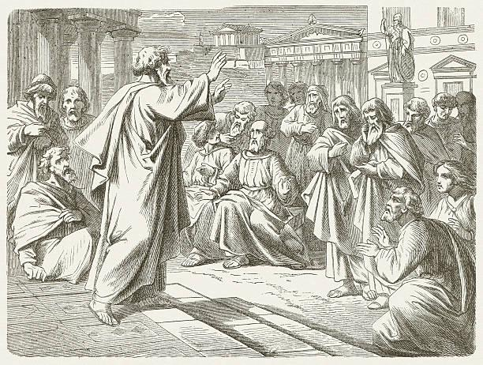

COMMUNAL SILENCE (Betty: Share slide 1, time 2:00, chime, stop slide.)

Betty: Now George Urban and Carolyn Henrich will read from the Gospel of John 20:1-18.

READING 2 John 20:1-18 (George Urban and Carolyn Henrich)

Reader 1 (George)

It was very early on the first day of the week and still dark, when Mary of Magdala came to the tomb. She saw that the stone had been moved away from the tomb and came running to Simon Peter and the other disciple, the one whom Jesus loved. “They have taken the Rabbi out of the tomb,” she said, “and we don't know where they have put Jesus.”

So Peter set out with the other disciple to go to the tomb.

They ran together, but the other disciple, running faster than Peter, reached the tomb first; he bent down and saw the linen cloths lying on the ground, but did not go in.
Simon Peter, following him, also came up, went into the tomb, saw the linen cloths lying on the ground and also the cloth that had been over his head; this was not with the linen cloths but rolled up in a place by itself.

Then the other disciple who had reached the tomb first also went in; he saw and he believed.
Till this moment they had still not understood the scripture, that Jesus must rise from the dead.

Reader 2 (Carolyn)

But Mary stayed outside the tomb weeping. And as she wept, she bent over into the tomb and saw two angels in white sitting there. One was seated at the head and one at the foot of where the body of Jesus had lain. And they asked her, “Woman, why are you weeping?” She said to them, “They have taken my Teacher, and I don’t know where they laid him.” When she had said this, she turned around and saw Jesus there, but did not know it was Jesus.

Jesus said to her, “Woman, why are you weeping? Whom are you looking for?” She thought it was the gardener and said, “Please, if you are the one who carried him away, tell me where you laid him, and I will take him.”

Jesus said to her, “Mary!” She turned and said to him in Hebrew, “Rabbouni” (which means Teacher.)

Jesus said to her, “Stop holding on to me, for I have not yet ascended to my Abba. But go to my sisters and brothers and tell them, ‘I am going to my Abba and your Abba.” Mary of Magdala went and announced to the disciples, “I have seen our teacher, and she reported what the Savior said to her.

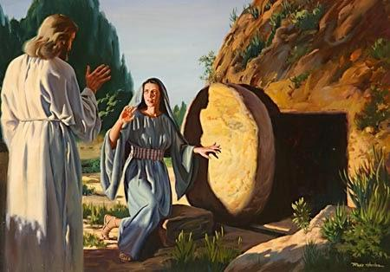

REFLECTIVE QUESTIONS (Charlotte Cook)
(Choose the one that fits best for your reflection.)

  - Put yourself in the scene. Recall Mary saying, “They have taken our Teacher!” How do you feel?

  - How does it feel to be Peter or the Beloved Disciple, who runs hard, stumbling and sweating, and then entering the tomb?

  - Imagine you are Mary. What is it like as you hear Jesus’ saying your name?

COMMUNAL SILENCE (Betty: Share slide 2, time 2:00, chime, stop slide.)

Betty: Alicia will read the 3rd reading.

READING 3: (Alicia)

An edited reading from a lecture giving a didactic call to the action of discipleship by Sr. Joan Chittister: “Easter calls us to resurrection–our own.”

The old news about Easter is that it is about resurrection. The new news may be that it is not as much about the resurrection of Jesus as it is about our own. Jesus, you see, is already gone from one tomb. The only question now is whether we are willing to abandon our own, leave the old trappings behind and live in the light of the Jesus, the Christ, whom the religious establishment persecuted, and politicians condemned. It is the greatest question in a world that practices religion as an act of private devotion and sees law and government as an arm of God. It’s at the tomb that we discover things about ourselves.

After six weeks of Lent are we prepared to answer this last, most momentous question: Will we ourselves, touched by Jesus, now rise and do life differently?

Similarly to the women at the tomb, many have looked for the fullness of life in the wrong places: in things, in systems, in social approval, in money, in status. Like the women who went to the tomb expecting to find the grave blocked, we have allowed our fear of resistance to silence our hearts and color our sense of possibility. We have failed to hear the Word of God from strange quarters. We have lived through racism and sexism and prejudice and taken it all for granted. We have taken as truth the half-truths of every system that preaches only itself. We have hugged God to ourselves and made the Creator a prisoner of our smallness of mind and hardness of heart. Like Peter and John who run to the tomb “to see for themselves” because they will not believe a woman, we have failed to realize that the voice of the church is one. We have missed the whole point of the tomb: that to cut anyone off from the proclamation of the word of God is to shrink our own experience of God. We miss the messages. We reject the messengers. We make ourselves the measure of our God and call it faith.

REFLECTIVE QUESTIONS (Charlotte Cook)
(Choose the one that fits best for your reflection.)
  - What reaction sparks in your innermost self in hearing: “We have hugged God to ourselves and made the Creator, a prisoner of our smallness of mind and hardness of heart.”

  - How do you feel if you were trapped in your own tomb? What would it take for you to abandon it?

  - What feelings rise in you if you consider Sr. Joan’s words in relationship to the horrors of the war in Ukraine and elsewhere, even our streets?

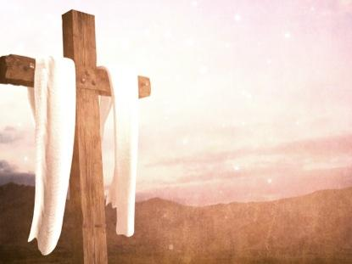
COMMUNAL SILENCE (Betty: Share slide 3, time 2 min., stop slide.)

Betty: Now Tim Brown will lead us in our sharing.

SHARING (Tim Brown)

We invite you to briefly share what emerged in your heart this morning as you listened and as you reflected on these readings that help us to glimpse the many ways God is among us. We welcome new voices, and we also know that the wisdom of this community includes both words shared and silent listening. And let’s leave a bridge of silence between speakers.

We begin in silence as we gather our reflections. [Long pause.]

Please unmute yourself to speak, and mute again afterwards.

Who would like to begin?
……….
(Ask when closer to the time limit:) “Would anyone else like to share?”
(Let sharing continue for a total of about 20 minutes, ending about 20 min. after the hour.)

Thank you for your insights and thoughts. We must stop now, but we can continue after the final song, as we often do.

Now let us pray together our intensions with Mia Brown.

PRAYERS OF THE COMMUNITY (Mia Brown)

“We have been preparing for six weeks to answer the question: Will we ourselves, touched by Jesus, now rise, and do life differently?” Is there a prayer that comes to you as you reflect on this question? [Long pause.]
Our response is: Risen Christ, hear our prayer.

Praying with joy, let us celebrate ourselves, our families, relatives, and friends as we raise our voices: “Alleluia, Christ is Risen!”
Let us pray: Risen Christ, hear our prayer.

Praying for peace and survival, let us hold in our hearts those in war-ravaged Ukraine and other nations warring or struggling to survive. May there be peace and reconstruction and adequate food and shelter.
Let us pray: Risen Christ, hear our prayer.

Praying with compassion, let us remember those who are in the midst of suffering: illness, hunger, poverty, homelessness, alienation, isolation, persecution, loss of everything in war or natural disasters, especially those in the path of the recent, vicious tornados.
Let us pray: Risen Christ, hear our prayer.

Praying with hope, let us remember all religious and the leaders of Catholic Sisters who continue to speak for peace and justice, and acceptance of all God’s people,
Let us pray: Risen Christ, hear our prayer.

Praying with thanksgiving, let us celebrate the grace, wisdom, and joy of what we have received from our God.
Let us pray: Risen Christ, hear our prayer.

For what else shall we pray? Please unmute and then mute yourself after your intention.

(People offer their intentions. Respond to each: ) Risen Christ, hear our prayer.

(End with: ) Thank you.

CELEBRATION OF COMMUNION (George)

O Great Love, we are humbled and emboldened
to know that you trust us to be your body in this world.
We are part of that body as we let go of all that separates us from you,
and as we embrace one another and your entire creation with merciful love.
We give you thanks for your presence in and among us. [Pause.]

We remember the night before Jesus died.
At dinner with friends, Jesus knew all that would soon be asked of them,
and, loving them to the end, Jesus showed them how to care for each other
as they went out into the world.
First Jesus washed their feet
and said, “… as I have done for you, you should also do.”
Then he looked at what was in front of them, the bread and the cup,
gifts of the earth and work of human hands, and blessed them.
So let us, too, invite God right now into what is front and center in our lives
knowing that God will indeed enter what we offer – and bless it. [Pause.]

Holy One, make us your bread of abundance. Make us your wine of joy.
Let even our fragments be plenty to share.
Amen.

OUR FATHER, OUR MOTHER (Betty) ALL MUTED
Now let us join our hearts with all who seek the coming of God, using the words that Jesus gave us written by the Polynesian and Māori people and the New Zealand Anglican community:
Eternal Spirit,
Earth-maker, Pain-bearer, Life-giver,
Source of all that is and that shall be,
Father and Mother of us all,
Loving God, in whom is heaven:
The hallowing of your name echo through the universe;
The way of your justice be followed by the peoples of the world;
Your heavenly will be done by all created beings;
Your commonwealth of peace and freedom
sustain our hope and come on earth.
With the bread we need for today, feed us.
In the hurts we absorb from one another, forgive us.
In times of temptation and test, strengthen us.
From trial too great to endure, spare us.
From the grip of all that is evil, free us.
For you reign in the glory of the power that is love,
now and forever. Amen.

FINAL BLESSING (Alicia)
“A Resurrection Prayer” by Kathy Galloway

Christ our life,
You are alive - in the beauty of the earth,
in the rhythm of the seasons,
in the mystery of time and space.
Alleluia!

Christ our life,
You are alive - in the tenderness of touch,
in the heartbeat of intimacy,
in the insights of solitude.
Alleluia!

Christ our life,
You are alive - in the creative possibility
of the dullest conversation,
of the dreariest task,
the most threatening event.
Alleluia!

Christ our life,
You are alive - to offer re-creation
to every unhealed hurt,
to every deadened place,
to every damaged heart.
Alleluia!

You set before us a great choice.
Therefore we choose life.
The dance of resurrection soars and
surges through the whole creation.
This is grace, dying we live.
So let us live.

CLOSING SONG: “Alleluia! Alleluia! Let the Holy Anthem Rise” (Debra Street)

1.Alleluia! Alleluia!
Let the holy anthem rise,
And the choirs of heaven chant it
In the temple of the skies;
Let the mountains skip with gladness,
And the joyful valleys ring
With hosannas in the highest
To our Savior and our King!

2.Alleluia! Alleluia!
Like the sun from out the wave,
Christ has risen up in triumph
From the darkness of the grave.
In the splendor of the nations,
And the lamp of endless day,
Christ, the very Lord of glory,
Christ is risen up today!

4. Alleluia! Alleluia!
Blessed Jesus, make us rise
From the life of this corruption
To the life that never dies.
May your glory be our portion,
When the days of time are past,
And the dead shall be awakened
By the trumpet’s mighty blast!

RESOURCES
USCCB: readings for Apr. 1, 2023, Easter

“Christ the Lord is Risen today” (Text: Chares Wesley, 1707-1788; Tune: LLANFAIR, 7 77 with alleluias: Robert Williams, 1781-1821) https://www.youtube.com/watch?v=XveIGmAUdkQ

Paul Preaching on Mars' Hill | ClipArt ETC etc.usf.edu“Alleluia! Alleluia! Let the Holy Anthem Rise” “Gather” Hymnal #440 https://globalworship.tumblr.com/post/143458443735/resurrection-art-india-sr-claire

Reading 3: https://joanchittister.org/articles/easter-calls-us-resurrection-our-own National Catholic Reporter April 6, 2001 (Reprinted in Trefoil, 2005)

“A Resurrection Prayer” by Kathy Galloway, “25+ Prayers for Easter Dinner to Give Thanks to Christ”
Closing hymn: “Alleluia! Alleluia! Let the Holy Anthem” lyrics:

