Solidarity with Sisters’ Communal Prayer
Fifth Sunday of Lent

march 26, 2023

“Authentic Christianity is not so much a belief system as a life-and-death system that shows us how to give away our life, how to give away our love, and eventually how to give away our death. Basically, how to give away—and in doing so, to connect with the world, with all other creatures, and with God.” Richard Rohr

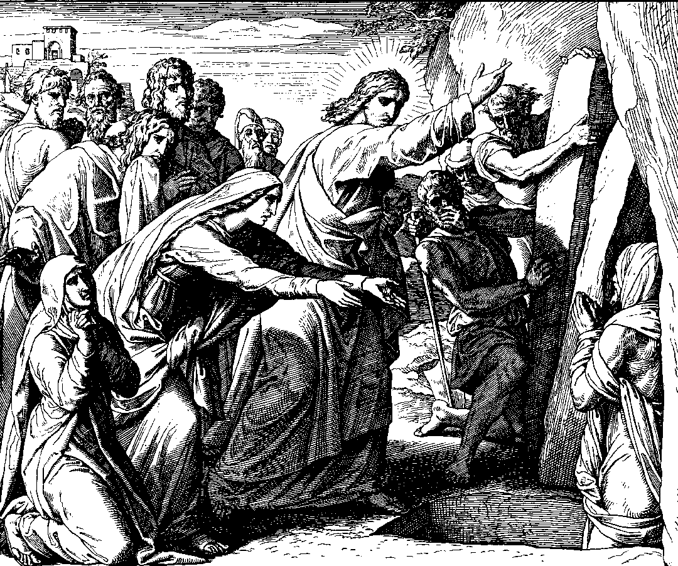
Rising Lazarus from the Dead, Die Bibel in Bildern, Julius Schnorr Von Carolsfeld (1794-1872,) Wikimedia.

HELLOs, then Zoom host mutes everyone. (Suzie De Quattro & Betty Thompson)

WELCOME (Richard McGinnis)
Welcome, everyone!
- I am Richard McGinnis and I prepared our prayer for today.
- Introductions – people who haven’t been here before?
- Thanks to Debra Street for leading our music.
- Thanks to the people who will be reading and leading us in prayer today: Sister Jacqueline Quinn, Paula Lake, Kathy Heller, Anne Regan, Maryann Dolan, Kate Monagan, Rose Marie Smith, Bill Fanelli, Dan McCarthy, Nancy Sushinsky, and Karen McCarthy.
- We are grateful for all readers and welcome new readers. To read in the next few weeks, contact Jo’Ann De Quattro for Good Friday, and Alicia Urban for Easter, and Cecilia and Mary for the Sunday after Easter. Leave a message in Chat or email the planners.

SETTLING IN (Richard McGinnis)

Let’s begin. Be still and relax. Let your breath carry away tensions from your body and distractions from your mind. Settle into the quiet center of yourself. Breathe deeply—in and out. Notice your breathing as it moves in you. Let it slow and deepen—filling you with the Peace of Christ. Now, let us take three more breaths collectively. One to be here…one to be together…and one to surrender to the Spirit who never leaves us.

Now Sister Jacqueline Quinn will lead us into our prayer together.

OPENING RITUAL (Sr. Jacqueline Quinn)

God of our deserts, God of our transformation, God of our fruitfulness, God of all who forget you and all who return to you, God of all who hope for new life, we are here to listen to you.

Leader: Beloved Community, Lent calls us to return to Yahweh with all our heart
All: O God, we hear you calling.
Leader: Beloved Community, we begin just where we are.
All: O God, we hear you calling.
Leader: Holy One, you appeal to us for justice, peace, and communion for all creation!
All: O God, we hear you calling.
Leader: “Lent is a call to weep for what we could have been and are not. Lent is the grace to grieve for what we should have done and did not. Lent is the opportunity to change what we ought to change but have not…. Lent is about becoming, doing and changing whatever it is that is blocking the fullness of life in us right now.”
Let us pause and reflect on what is blocking us, or maybe even protecting us, from being tugged into the unknown magnificence of resurrection.
[Pause about 15 seconds – about 3 slow deep breaths.]
Leader: Let us pray together:
All (muted):

I ask you, my sisters and brothers, to pray for me to our God.

Holy One, accept my deep sorrow for ways in which I participate in the brokenness of your world -- in my thoughts and in my words, in what I have done and what I have failed to do.
Thank you for your endless love for me, and for your forgiveness that comes even before I ask.
Help me to forgive myself.
Strengthen me to take an active part in bringing your grace to the world, in the company of all your children, all the saints, and all the Earth. Amen.

Leader: Richard McGinnis will now introduce us to today’s theme.

INTRODUCTION TO THEME (Richard McGinnis)

When our youngest daughter was in elementary school, one of her close friends confided to her that she was a spirit. It made my wife and me chuckle, but it also made me wonder. What did it mean for this child to be a spirit?
Today, it is you and I who are invited by the Scriptures to reflect on that question – what does it mean for each of us to be a spirit.
Scripture tells us that, as believers, the Spirit of God dwells within us--a God who is loving and who will faithfully restore us from the worst of life’s burdens. A God who not only listens to our prayers, but also hears every one of those prayers. A God who always loves us, not distantly or mildly, but intimately and extravagantly--to the point of tears. A God, who promises that the spirit within us, when animated by a love of our own, will be more powerful than illness, will be more powerful than death. And who promises that the Spirit within us will remake a mundane life constrained by practical concerns into a holy life--a life of impossible blessing.
“I am the resurrection and the life,” Jesus says to Martha--and to you and to me as well. “Believe in me.’
(Slight pause)

Kathy Heller will read from the Prophet Ezekiel and the Letter of Paul to the Romans. Paula Lake will offer questions for your reflection, followed by silence. Feel free to stay with whatever question calls you.

READING 1 (Kathy Heller)

1A Ez 37:13-14
O my people, I will open your graves
and have you rise from them,
and bring you back to the land of Israel.
I will put my spirit in you that you may live,
and I will settle you upon your land;
thus you shall know that I am your God.
I have promised, and I will do it.
1B Rom 8:8, 10-11
Those who are in the flesh cannot please God.
But if Christ is in you,
although the body is dead because of sin,
the spirit is alive because of righteousness.
If the Spirit of the one who raised Jesus from the dead dwells in you,
the one who raised Christ from the dead
will give life to your mortal bodies also,
through the Spirit dwelling in you.
[Slight pause]
REFLECTIVE QUESTIONS [Take a full breath after each question.] (Paula Lake)
When have you witnessed someone in distress being led by the provident hand of God to renewed life?
Where have you felt the truth of God’s words “I will put my spirit in you so that you may live”?
How does the divine promise of eternal life shape your attitude toward your experience of earthly life?
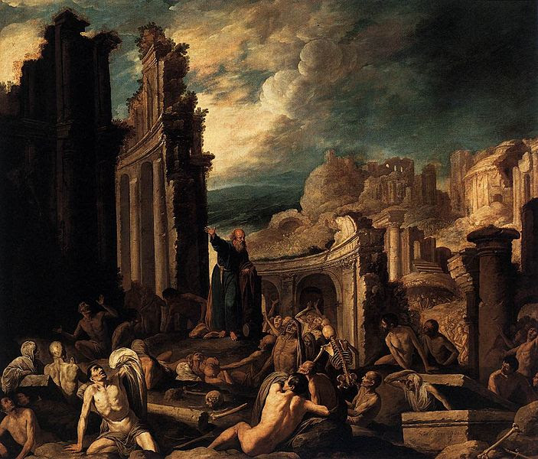
The Vision of Ezekiel, Francisco Collantes (1599-1656, Wikimedia)

COMMUNAL REFLECTION (Betty: Slide, time 2:00, chime, stop slide)

(Richard): Next, Anne Regan will read to us from the Gospel of John.

READING 2 (Anne Regan)

Jn 11:3-7, 14- 17, 20-23, 25-27, 33b-44

There was a man named Lazarus who was sick.
His sisters Mary and Martha sent word to Jesus, saying,
“Rabbi, the one you love is ill.”
When Jesus heard this he said,
“This illness is not to end in death,
but is for the glory of God,
that God’s beloved one may be glorified through it.”
Now Jesus loved Martha and her sister and Lazarus.
So when he heard that Lazarus was ill,
he said to his disciples,
"Let us go back to our friend Lazarus in Judea,”
which was where the Jews had tried to stone him.

Thomas said to his fellow disciples,
“Let us go with Jesus and we can die with him.”
When Jesus arrived, Martha said to Jesus,
“If you had been here,
my brother would not have died.
But even now I know that whatever you ask of God,
God will give you.”
Jesus said to her,
“Your brother will rise.”
Jesus told her,
“I am the resurrection and the life;
whoever believes in me, even if they die, will live,
and everyone who lives and believes in me will never die.
Do you believe this?”
She said to him, “Yes, I believe.”
Jesus became perturbed and deeply troubled, and said,
“Where have you laid him?”
They said to him, “Sir, come and see.”
And Jesus wept.
So the Jews said, “See how Jesus loved Lazarus.”
But some of them said,
“Could not the one who opened the eyes of the blind man
have done something so that Lazarus would not have died?”
So Jesus, perturbed again, came to the tomb.
Jesus said, “Take away the stone.”
Martha, the dead man’s sister, said to him,
“Rabbi, by now there will be a stench;
Lazarus has been dead for four days.”
Jesus said to her,
“Did I not tell you that if you believe
you will see the glory of God?”
So they took away the stone.
And Jesus raised his eyes and said,
“Abba, I thank you for hearing me.
I know that you always hear me;
but because of the crowd here I have said this,
that they may believe that you sent me.”
And when he had said this,
He cried out in a loud voice,
“Lazarus, come out!”
The dead man came out.

[Slight pause]

REFLECTIVE QUESTIONS [Take a full breath after each question.] (Paula Lake)

When have you felt God weeping with you?
When have you experienced the reality of divine presence through an expression of love?
Where have you seen undaunted faith lead to an outcome that seemed practically impossible?

COMMUNAL REFLECTION (Betty or other: Slide, time 2:00, chime, stop slide)

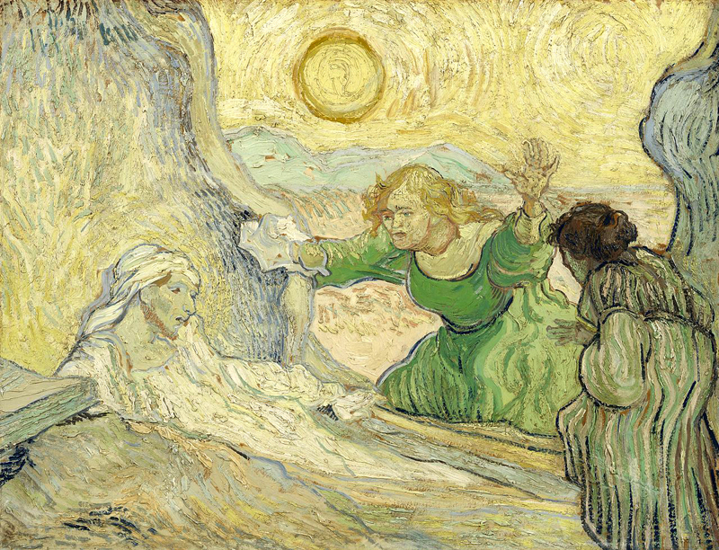
Raising of Lazarus, Vincent van Gogh (1853-1890). From Art in the Christian Tradition, a project of the Vanderbilt Divinity Library, Nashville, TN.

(Richard): Now Maryann Dolan will read an adaptation of a reflection on the Scriptures by Mary M. McGlone, CSJ.

READING 3 (Maryann Dolan)

Scripture scholar Jesuit Fr. Silvano Fausti says John's entire Gospel is an unfolding Epiphany. It gradually reveals Jesus' glory, God's presence in human flesh and history.

From that perspective, we see Jesus constantly confronting evil: the natural evil of sickness and death and the human-caused evil of betraying or thwarting the human vocation to love. In each case, Jesus' response is life-giving. Jesus reveals that the essence of God's being and glory is life-giving love.
Using this perspective on today’s Liturgy of the Word ushers us into an experience of epiphany, into scenes of God's self-revelation.
Our selection from Ezekiel comforts the people who consider themselves as good as dead. Ezekiel speaks in the name of God who wants to bring them back to life, give them a new heart and allow them to be enlivened by the divine spirit.
This promise of the divine spirit leads us directly to our selection from Romans about two orientations in life – flesh and spirit. One in the “flesh” is caught up in fear and avoidance of vulnerability that makes self-protection the primary priority. In contrast, people who live in the spirit are neither alone nor self-sufficient. They live with the courage-generating assurance that life is a gift and a promise.
Probably the least-noticed words in today's Gospel come from Thomas, who says, “Let us go with Jesus and we can die with him.” With those words, Thomas proclaimed the very same faith that Mary and Martha professed about Jesus as the resurrection and the life. Thomas was telling his companions that living in fear, living in the “flesh,” was truly a dead end.
That awareness opened them to new dimensions of life, to the Spirit of Christ who would lead them beyond their greatest imaginings.
Today's Scriptures urge us to practice living faith, to allow the Spirit of Christ to free us from any fear that focuses us on our own well-being as if it could be separated from the well-being of others. Being caught up in the dynamic of loving, we can witness to the glory of our life-giving God who does not send suffering but accompanies us in it through one another.
Let us strive to be with Thomas and keep saying, "Let us go with him."
[Slight pause]

REFLECTIVE QUESTIONS [Take a full breath after each question.] (Paula Lake)

When have you realized that you were not self-sufficient, but then proved not to be alone?
What do you want to say to God about “accompanying us through each other” instead of God ending suffering?

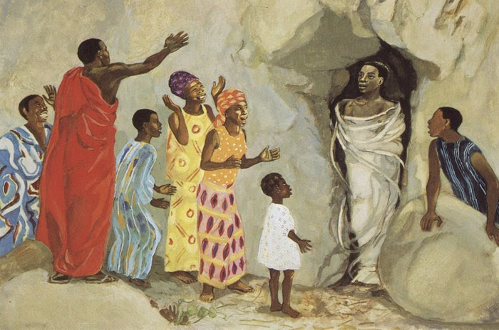
Jesus Raises Lazarus to Life, Jesus MAFA project, http://diglib.library.vanderbilt.edu/act-imagelink.pl?RC=48269.

COMMUNAL REFLECTION (Betty: Slide, time 2:00, chime, stop slide)

Richard. As we prepare for Sharing, listen in silence to the second and third verses from the hymn “Hosea” with which we started the season of Lent in our communal service on Ash Wednesday.

SONG--“Hosea” by Gregory Norbert https://www.youtube.com/watch?v=32YSYJiCJEI (Verses 2 and 3, commencing at 0.51 and fading about 2:17 at end of chorus after “faithfulness” and stop about 2:21.)

The wilderness will lead you to your heart, where I will speak.
Integrity and justice with tenderness, you shall know.

Long have I waited for your coming home to me and living deeply our new life!

You shall sleep secure with peace; faithfulness shall be your joy.

Long have I waited for your coming home to me and living deeply our new life!

SHARING (Kate Monagan)

We invite you to share the essence what emerged in your heart this morning as you have reflected upon our readings and music. We welcome everyone who wants to speak, and we also know that the wisdom of this community includes both words shared and silent listening.

So let’s begin in silence as we gather our reflections. [Long-ish pause]

Now who would like to start our sharing? Remember to unmute yourself to speak and mute yourself again afterwards.

[Sharing]

[If there is silence more than about 30 seconds before anyone speaks:] Take whatever quiet you need before you speak.

[If there is extended silence during the sharing:] Is there anyone else who would like to share? [Pause for a slow, deep breath.]

[Stop by about 20 minutes after the hour.]

Thank you. Let us pause for a minute of silence to hold all that has been said, and to notice what is rising in us in response. [Long pause.] We can continue after the final song, as we often do.

Holding onto what the Holy One is saying, we turn to God in prayer.

PRAYERS OF THE COMMUNITY (Bill Fanelli)

Our response today will be: “God of love, hear our prayer.”
For the unfolding of divine love in the hearts of the Leadership Conference of Women Religious and in the hearts of all women religious to empower them to continue their tender works of mercy and the pursuit of justice;
ALL: “God of love, hear our prayer.”
For all who may find hope difficult: refugees, immigrants, the unemployed, the homeless, LGBTQ persons, minorities and, at times--ourselves, that all of us may surrender to the power of God that promises new life beyond our struggles;
ALL: “God of love, hear our prayer.”
For a deepening sense of the love that God has for each one of us, and confidence in the never-failing responsiveness of God to hear our every prayer and to lift us up--even in the worst of times;
ALL: “God of love, hear our prayer.”
For the softening of our hearts with compassion and empathy so that we may be empowered to be agents of blessing.
ALL: “God of love, hear our prayer.”

For what else shall we pray? Please unmute yourself to speak, and mute yourself afterwards.

(After a person shares their prayer: ) ALL: “God of love, hear our prayer.”
O You who love us more than we can imagine, we are grateful for this chance to give you our prayers, spoken and unspoken. We entrust the outcome to you. Amen.

OFFERTORY (Dan McCarthy)

Holy One, we bring you ourselves knowing you accept us just as we are and forgive us before we forgive ourselves.

We pause in silence to reflect on our Lenten intention – how did I live it this last week? (Long pause)
We turn again to you and ask - In what specific way am I hearing your call to me for this coming week? (Long pause)
Holy One, we offer our whole selves to you, all that we have and all that we are. We pray that you will help us to be bold in our mission and in our witness. May we who have been given so much, give to others in need, support those who suffer or mourn, give peace to those in trouble, work for unity in our world and love our neighbor as Jesus taught us. Blessed Be!
CELEBRATION OF COMMUNION (Karen McCarthy)

O Great Love, we are humbled and emboldened
to know that you trust us to be your body in this world.
We are part of that body as we let go of all that separates us from you,
and as we embrace one another and your entire creation with merciful love.
We give you thanks for your presence in and among us. [Pause.]

We remember the night before Jesus died.
At dinner with friends, Jesus knew all that would soon be asked of them,
and, loving them to the end, Jesus showed them how to care for each other
as they went out into the world.
First Jesus washed their feet
and said, “… as I have done for you, you should also do.”
Then he looked at what was in front of them, the bread and the wine,
gifts of Earth and the work of human hands, and blessed them.
So let us, too, invite God right now into what is front and center in our lives
knowing that God will indeed enter what we offer – and bless it. [Pause.]

Let us know God within ourselves so that we become God’s living presence in our world. (Pause.)

Holy One, we entrust ourselves to you and to one another.
Make us your bread of abundance. Make us your wine of joy.
Let even our fragments be plenty to share.
Blessed be.

To extend our communion Rose Marie Smith will lead us in the Prayer of Jesus.

THE PRAYER OF JESUS (Rose Marie Smith)

Now let us join our hearts as if we could join our hands in harmony with our family throughout the world:

All (muted):

Heavenly Father, heavenly Mother,
Holy and blessed is your true name.
We pray for your reign of peace to come,
We pray that your good will be done,
Let heaven and earth become one.
Give us this day the bread we need,
Give it to those who have none.
Let forgiveness flow like a river between us,
From each one to each one.
Lead us to holy innocence
Beyond the evil of our days —
Come swiftly Mother, Father, come.
For yours is the power and the glory and the mercy:
Forever.
Amen.

FINAL BLESSING (Nancy Sushinsky)
Let us extend our hands in blessing of one another with the following words:
May God grant us the joy promised by Christ! –
Not by shielding us from all sorrows and pain,
But by strengthening us to bear it, as it comes;
Not by making our path easy,
But by making us sturdy to travel any path;
Not by taking hardships from us,
But by taking fear from our heart;
Not by granting us unbroken sunshine,
But by keeping our face bright, even in the shadows;
Not by making our life always pleasant,
But by showing us when people and their causes need us most,
and by making us anxious to be there to help.
God’s love, peace, hope and joy be with you.
– Author Unknown
CLOSING SONG—"Sing of the Lord’s Goodness” by Ernest Sands (Debra Street)
Sing of the Lord's goodness, author of all wisdom, come to the Lord and bless God’s name.
Mercy God has shown us, God’s love is forever, faithful to the end of days.
Come, then, all you nations, sing of your Lord's goodness, melodies of praise and thanks to God.
Ring out the Lord's glory, praise God with your music, worship the Lord and bless God’s name.
Power he has wielded, honor is his garment, risen from the snares of death.
His word he has spoken, one bread he has broken, new life he now gives to all.
Come, then, all you nations, sing of your Lord's goodness, melodies of praise and thanks to God.
Ring out the Lord's glory, praise God with your music, worship the Lord and bless God’s name.
Courage in our darkness, comfort in our sorrow, Spirit of our God most high;
solace for the weary, pardon for the sinner, splendor of the living God.
Come, then, all you nations, sing of your Lord's goodness, melodies of praise and thanks to God.
Ring out the Lord's glory, praise God with your music, worship the Lord and bless God’s name.
RESOURCES

Introductory Quotation.
Richard Rohr’s Daily Meditation from the Center for Action and Contemplation, February 24, 2023, citing Rohr, Universal Christ, pp. 213-214. Meditations@cac.org
Scriptures.
Adapted from https://bible.usccb.org/bible/readings/032623.cfm
Reflection on Scriptures.
Adapted from Mary M. McGlone, CSJ, “Fifth Sunday of Lent,” March 26, 2023. https://www.ncronline.org/march-26-2023-fifth-sunday-lent
Prayers, in part.
L. Mick, “Planning: 5th Sunday of Lent.” https://www.ncronline.org/spirituality/scripture-life/scripture-life/fifth-sunday-lent
Art.

Rising Lazurus from the Dead, Die Bibel in Bildern, Julius Schnorr Von Carolsfeld (1794-1872,) Wikimedia. https://3.bp.blogspot.com/-OPlis3zHtHs/WMBjoGiOvWI/AAAAAAAAD_k/NNJWbuM5YkAA46HptZG3AVxTh6uo-SP1wCPcB/s1600/Luca_Giordano_-_Raising_of_Lazarus.jpg

The Vision of Ezekiel, Francisco Collantes (1599-1656,) Wikimedia. https://3.bp.blogspot.com/-KZA8a5CgvJw/WMBjoKrbw6I/AAAAAAAAD_k/ZT-mO6MIwsoDhYFZz6x9i75qxY0dloiXgCPcB/s1600/Francisco_Collantes_-_The_Vision_of_Ezekiel.jpg

Raising of Lazarus, Vincent van Gogh (1853-1890). From Art in the Christian Tradition, a project of the Vanderbilt Divinity Library, Nashville, TN. https://diglib.library.vanderbilt.edu/cdri/jpeg/laznmcxdjfuiygtr8y75.jpg

Jesus Raises Lazarus to Life, Jesus MAFA project, http://diglib.library.vanderbilt.edu/act-imagelink.pl?RC=48269. https://2.bp.blogspot.com/-GCP89t5I26M/WMBjoHZB85I/AAAAAAAAD_k/5G3_CLOVPZMCreLsQWdb22lWdpMo4Ys6gCPcB/s1600/Mafa-jesus-raises-lazarus-to-life.jpg

Music.

Song--“Hosea” by Gregory Norbert
https://www.youtube.com/watch?v=32YSYJiCJEI
Closing Song--"Sing of the Lord’s Goodness” by Ernest Sands https://catholichymn.blogspot.com/2015/06/sing-of-the-lords-goodness.html
Video option--https://www.youtube.com/watch?v=xLMDEN8Y5f0 (12 seconds to 2:56)

