Solidarity with Sisters Communal Contemplative Prayer
February 21-22, 2023
Settling in: Let us move into presence together by becoming aware of our
breathing – taking in the oxygen with which the plants gift us, and releasing our
carbon dioxide to feed and nourish the plants in a mutual exchange of gift. Let
your breath deepen and slow as you settle into presence. And let’s take three deep
breaths: one to be here, one to be together, and one to be open to the movement and gifts of the Spirit.

Poem for Lent
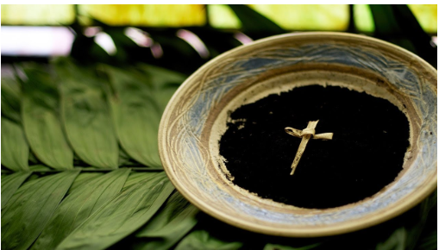
The cosmos dreams in me
while I wait in stillness,
ready to lean a little further
into the heart of the Holy.
I, a little blip of life,
a wisp of unassuming
love,
a quickly passing breeze,
come once more into Lent.
No need to sign me
with the black bleeding ash
of palms, fried and baked.
I know my humus place.
This Lent I will sail
on the graced wings of
desire,
yearning to go deeper
to the place where
I am one in the One.
Oh, may I go there soon,
in the same breath
that takes me to the stars
when the cosmos dreams in me.
—JOYCE RUPP

30 minutes of silence
We welcome one another's reflections and prayers.
Prayers: Take a moment to gather what is rising in you from the silence. At
your own pace, come back together. If you'd like to share a prayer or
reflection, unmute anytime.
Closing: Jesus waits silent and unseen to come into my heart. I will
respond to His call. He comes with His infinite power and love, may I be
filled with joy in His presence. Amen.

Settling in: modified from Sacred Space, a website of the Irish Jesuits
Closing prayer: Daily Prayer for February 22, 2023 from Sacred Space

