Solidarity with Sisters’ Communal Prayer
Sunday, Feb. 5, 2023
Fifth Sunday in Ordinary Time
“What is to be done?”
“You shall not withhold yourself!” - Martin Buber

HELLOs and then Zoom host mutes everyone. (Betty/Bill)
WELCOME (Bill Fanelli)
Welcome, everyone!
- Introductions – people who haven’t been here before?
- Anne and I are pleased to share today’s communal prayer with you today.
- Thanks to the people who will be reading and leading us in prayer today: Norb Bufka, Bill Cavanaugh, Kathy Cavanaugh, Kathleen Cross, Sr. Jo’Ann De Quattro, Sr. Grace Hartzog, Sr. Jennie Lechtenberg, Sr. Marie McCarthy, Kathy Heller, and Judy Sholes.
- Our gathering this morning will conclude with a special blessing of accompaniment, spoken and sung, for Betty Thompson.
- We are always looking for new readers. If you’d like to read on February 12, please contact Terri Butel and on February 19, Maryann Dolan and Judy Sholes. Their email addresses will be in Chat. This really helps planners. Thank you!
- We want to remind you that you will receive your invitation and script for this coming Sunday from Jim De Quattro. The Zoom address will be the same through Pentecost.
- Pray with us using this year's Little Black Book. These come to us from Saginaw, Michigan. Bishop Ken Untener began this tradition 30 years ago and it has continued.
- Thanks to Joan and Stu Sklamm, Anne Regan and Bill Fanelli, you can get a copy wherever you are.
  - For those nearby: Email Joan Sklamm at jmsklamm@msn.com using the subject “Lenten books,” with your name, address and telephone number and if you are able to pick up your book at SJB Parish Office.
  - For those who need your copy mailed: Email Anne Regan aregan@verizon.net with your address, using the subject “Lenten books.”
SETTLING IN (Anne Regan)
To be with God and each other, we need to first be with ourselves. Let your breath slow and deepen and carry ease into your body and your mind in this present moment. As you continue to breathe, breathe in knowing we are here now together. Breathe out knowing that we are surrounded by light. Breathe as we pray:
May I quiet my words and listen….
May I calm my thoughts and be….
May I soften my heart and open….
[Pause]

Anne: Now we enter our celebration, singing, “Gather Us In” by Marty Haugen.
OPENING SONG – “Gather Us In” by Marty Haugen (Bill F. start video)
https://www.youtube.com/watch?v=IbNXqjwh8is (Start at 0:05, and end at 1:43)

Here in this place new light is streaming
Now is the darkness vanished away
See in this space our fears and our dreamings
Brought here to you in the light of this day
Gather us in, the lost and forsaken
Gather us in, the blind and the lame
Call to us now and we shall awaken
We shall arise at the sound of our name

We are the young, our lives are a mystery
We are the old who yearn for your face
We have been sung throughout all of history
Called to be light to the whole human race
Gather us in, the rich and the haughty
Gather us in, the proud and the strong
Give us a heart so meek and so lowly
Give us the courage to enter the song
GREETING and GATHERING PRAYER (Kathy Cavanaugh)
Beloved Community, rejoice! The light of love is within us, surrounds us and always seeks to meet us, embracing our heartfelt pleadings with compassion and love.
All: Thanks be to God!
Help us settle in this morning and together create a space in which we can “exceed the limits of our imaginations” and more fully enter our calling as co-creators of a new world order. God of Relationship, God of the Both/And, turn our self-sufficiency into a deep desire to be about this mission together. Make us pliable in your hands, and unrestricted in our readiness to be reshaped and refashioned as a light receiving, light reflecting and light multiplying community, wherever you lead us.
All: May it be so.
INTRODUCTION TO THEME (Bill Fanelli)
Today we will explore and affirm the presence of light in our lives. We're here, to be light for each other, connected in an entire cosmos of light. And together we continue to learn what it means to uncover our own inner light and join together in the spiritual work of creating a new consciousness.
This morning, we are reminded in no uncertain terms that it is ours to feed the poor, clothe the naked and to dismantle oppressive systems. Isaiah addresses the recently returned exiles who lament the failure of their fasting to bring about change. We are told that if we act justly, we will be in the light of love.
In Matthew, Jesus speaks to fishermen, farmers, laborers and spiritual outcasts. Extending Isaiah, Jesus tells this community that they are the light. We are all uniquely created in God’s image, and called to bring our highest selves as gifts to the world. Jesus saw people as we truly are - whole and perfect expressions of the divine light. Matthew suggests that our limited human natures are like the proverbial bushel basket - coverings that allow us to hide the light within so completely that we ourselves may forget that it’s there.
Our third reading conveys Thomas Merton’s experience of realizing what is deepest and truest in all of us. On a street corner in Louisville, Kentucky, Merton saw this truth and also saw the difficulty we face in imagining the truth. And we wonder together, can I know this for myself? Can I know it for all of creation?
Bill Fanelli: Now Bill Cavanaugh will read from Isaiah, Chapter 58:7-10, followed by questions and silence for reflection. Stay with whatever question calls you.
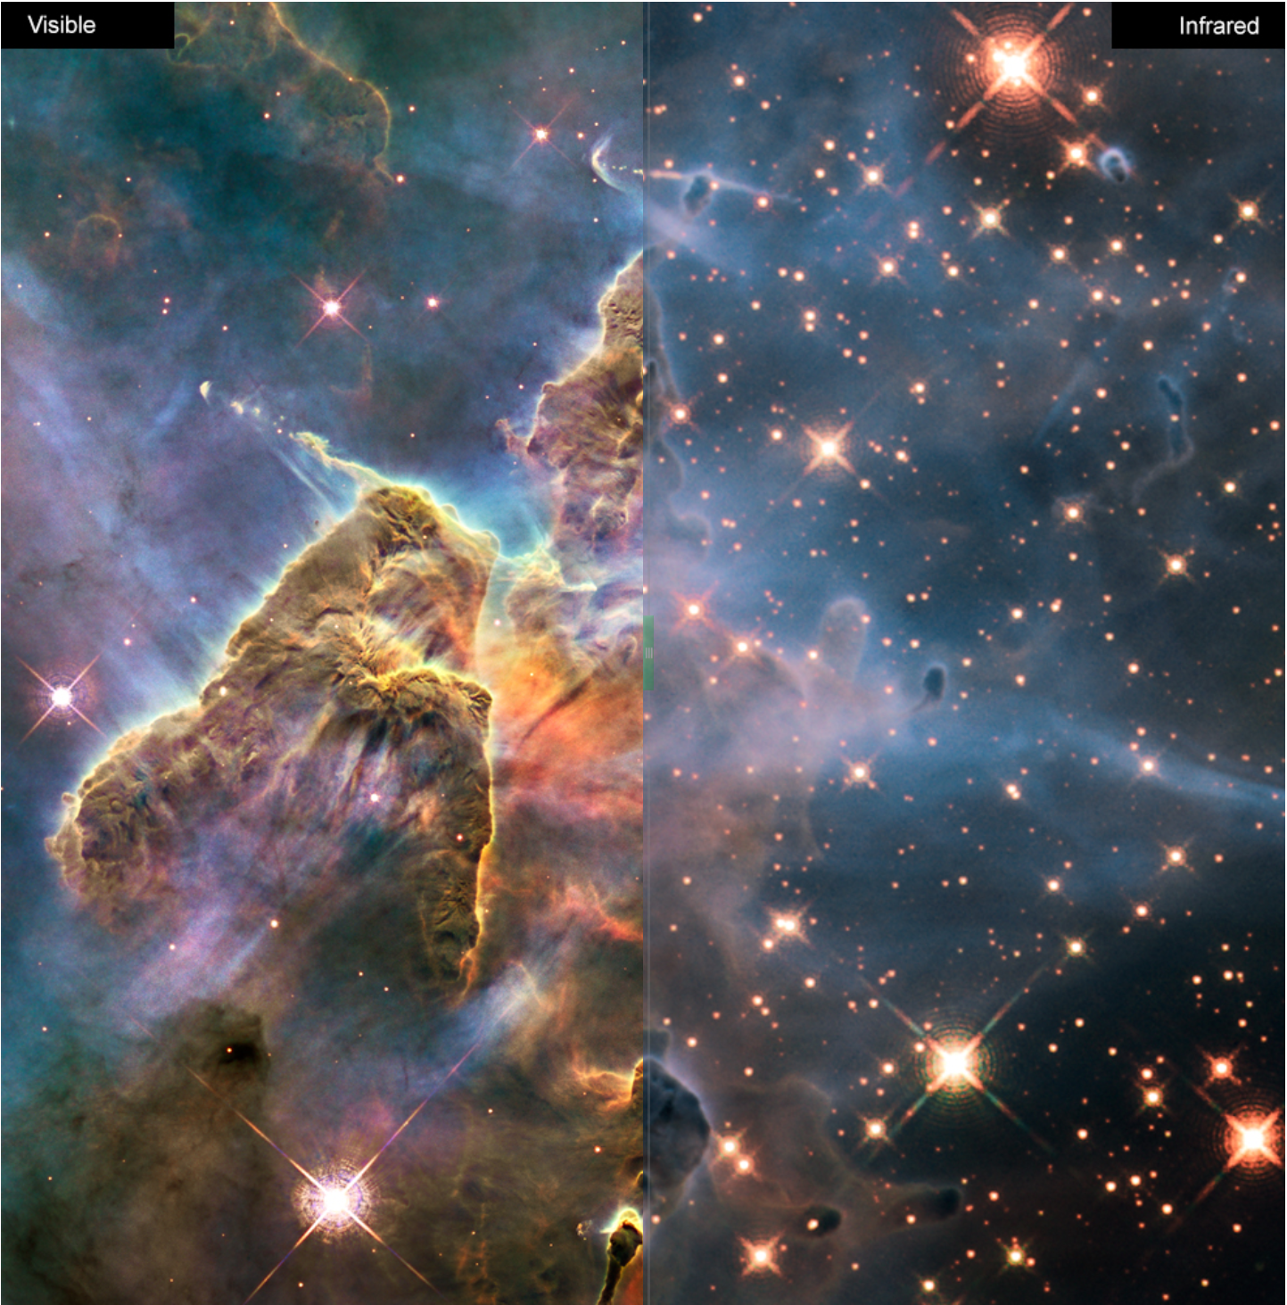
READING 1 (Bill Cavanaugh)
Thus says our God:
Share your bread with the hungry,
shelter the oppressed and the homeless;
clothe the naked when you see them,
and do not turn your back on your own.
Then your light shall break forth like the dawn,
and your wound shall quickly be healed;
your vindication shall go before you,
and the glory of Yahweh will be your rear guard.
Cry, and Yahweh will answer;
Call, and Yahweh will say “Here I am!”
If you remove from your midst
oppression, false accusation and malicious speech;
If you give your bread on the hungry
and satisfy the needs of the afflicted;
then light will rise for you in the darkness,
and the gloom shall become for you like midday.

REFLECTION QUESTIONS 1 (Kathleen Cross)
- What helps you see the hungry, oppressed, and homeless in our midst? What clouds your vision?
- How can you clothe the naked when you see them?
- How do you experience light rising for you in the darkness?
COMMUNAL SILENCE (Bill: Share slide 1 with “Explore - Light | Inside the Image” time 2:00, chime, stop slide.)
Bill Fanelli: Sister Grace Hartzog will now read from Matthew’s Gospel 5:14-16.
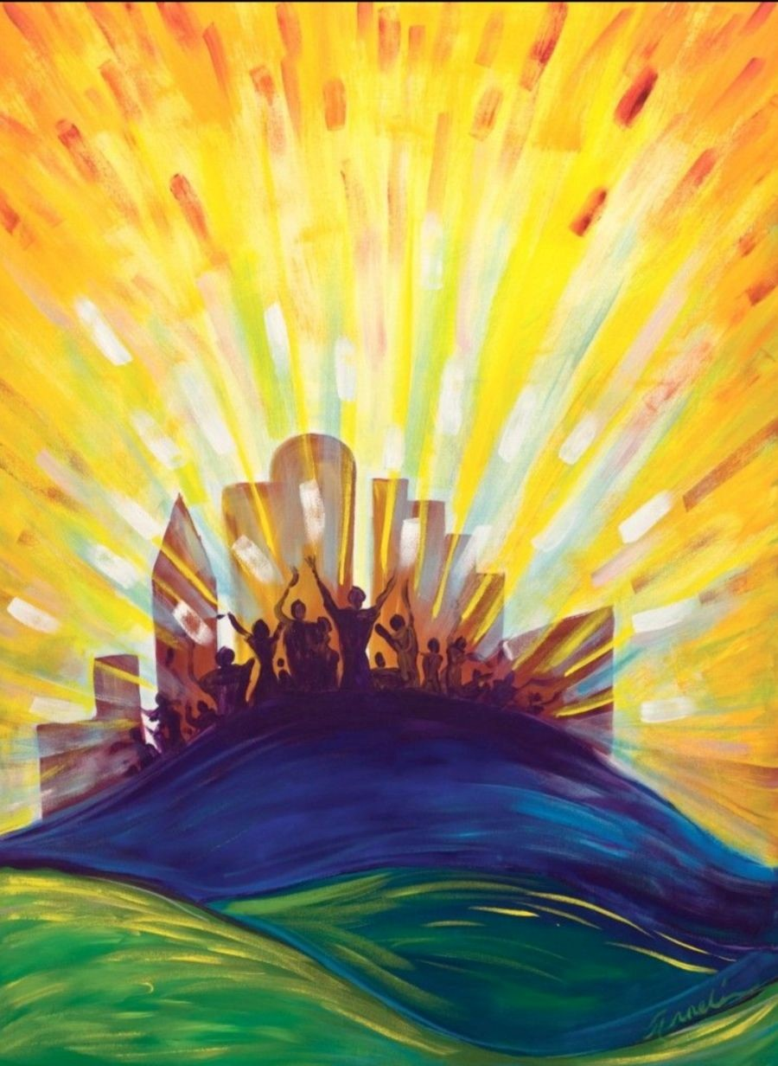
READING 2 (Grace Hartzog)
Jesus said to his disciples:
“You are the light of the world.
A city set on a mountain cannot be hidden.
Nor do they light a lamp and then put it under a bushel basket;
it is set on a lampstand,
where it gives light to all in the house.
In the same way, your light must shine before others,
that they may see your good deeds
and give praise to your God in heaven”

REFLECTION QUESTIONS 2 (Kathleen Cross)
- Reflect on what is truly your nature to bring into the world. How clear are you about that?
- What do you have to give up by not hiding your light?
- Where or when does your light illuminate the needs of the poor and marginalized?
COMMUNAL SILENCE (Bill: Share slide 2 with city on a hill, time 2:00, chime, stop slide2.)

Anne: Now Sister Marie McCarthy will read reflections from Thomas Merton on what it means to be divine light.

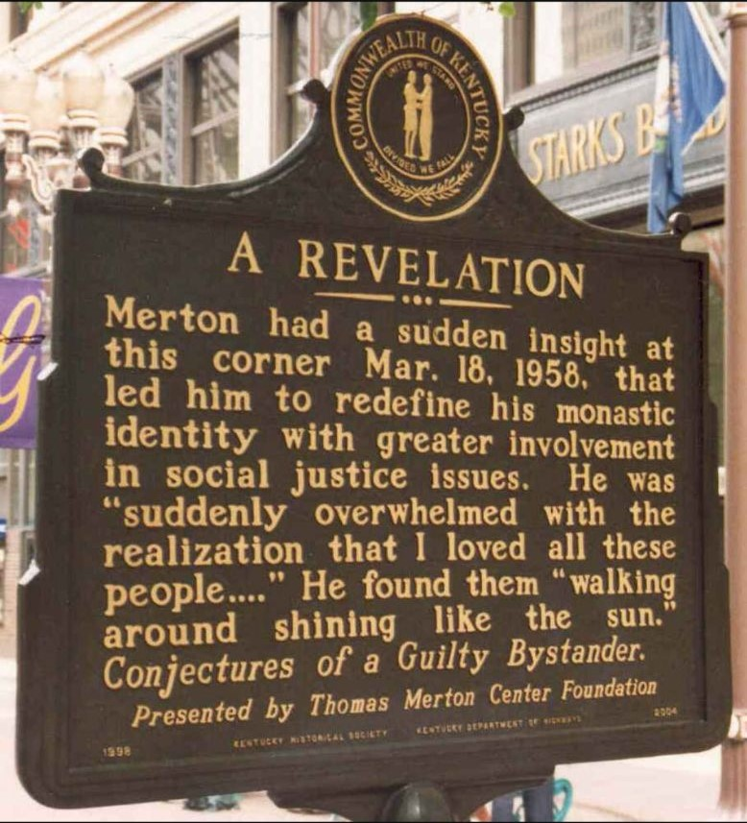
READING 3 (Sr. Marie McCarthy)
Thomas Merton believed that because God has already found us, at our essence we are “lights of the world.” And so, “we all become doors and windows through which God shines back into God’s own house.” In Kentucky, there is a plaque marking the exact spot at which Merton had a revelation in which the meaning of being light became clear. He wrote:
“In Louisville, at the corner of Fourth and Walnut, in the center of the shopping district, I was suddenly overwhelmed with the realization that I loved all these people, that they were mine and I theirs, that we could not be alien to one another even though we were total strangers. It was like waking from a dream of separateness, of spurious self-isolation in a special world. . . .
This sense of liberation from an illusory difference was such a relief and such a joy to me that I almost laughed out loud. . . . I have the immense joy of being human, a member of a race in which God became incarnate. As if the sorrows and stupidities of the human condition could overwhelm me, now that I realize what we all are. And if only everybody could realize this! But it cannot be explained. There is no way of telling people that they are all walking around shining like the sun.
Then it was as if I suddenly saw the secret beauty of their hearts, the depths of their hearts where neither sin nor desire nor self-knowledge can reach, the core of their reality, the person that each one is in God’s eyes. If only they could all see themselves as they really are. If only we could see each other that way all the time. There would be no more war, no more hatred, no more cruelty, no more greed.”
― Thomas Merton, Conjectures of a Guilty Bystander
(Slight pause)
REFLECTION QUESTIONS 3 (Kathleen Cross)
- What puts you in touch with the experience of walking around shining like the sun?
- What may be needed to liberate the light within yourself?
- Recall moments when you noticed that illusory differences disappeared for you.
COMMUNAL SILENCE (Bill: Share slide 3 with Merton plaque, time 2:00, chime, stop slide.)
Debbie: Jo’Ann De Quattro will now lead our sharing.
SHARING (Jo’Ann De Quattro)
We invite you to share briefly what emerged in your heart this morning as you listened and as you reflected on these readings. That helps us to glimpse the many ways God is among us. We welcome new voices, and we also know that the wisdom of this community includes both words shared and silent listening. And let's leave a breath of silence between speakers which allows us to take in more fully what was just said.
We begin in silence as we gather our reflections. [Long pause.]
Please unmute yourself to speak, and mute again afterwards. Who would like to begin?
(Sharing)
[Let sharing continue for about 20 minutes ending by twenty minutes after the hour.]
Thank you. We have to stop now, and we can continue after the final song, as we often do.
Jo’Ann: Now Jennie will lead us in prayer.
PRAYERS OF THE COMMUNITY (Jennie Lechtenberg)
Our answer to “What is to be done?” must be a resounding “I shall not withhold myself!” Let us pray together that we both recognize and help those in need, and grow in relationship with each other.
Let us be troublemakers to champion those we love and care for, and for those we don’t know intimately who need our help. Help us be powerful voices for systemic change.
For this we pray: Spirit of Light, hear our prayer.
Let us be deeply disturbed by violations of another’s rights to life, liberty, and happiness. Find us faithful and in service to light-led movements with others, and leading the charge when it is up to us to do so.
For this we pray: Spirit of Light, hear our prayer.
Help our leaders stop putting individuals into dualistic opposition, and focus instead on repairing broken systems. Help us have the light to fully recognize our own participation in unjust systems.
For this we pray: Spirit of Light, hear our prayer.
May we recognize the example of religious sisters all over the world who clang the bells of freedom, and show us that when ten thousand are whispering, we must be the one who is listening.
For this we pray: Spirit of Light, hear our prayer.
Now let’s remember the feelings and prayers that arose in us as we shared reflections, and also the prayers we carry with us. [Pause.]
Now, for what else shall we pray? Please remember to unmute and mute yourself.
(People speak.) Spirit of Light, hear our prayer.
Thank you.
O God, we give you all our prayers, spoken and unspoken. We will do all that we can to put our prayers into action – while entrusting the outcome to you. Amen.
Jennie: Now Kathy Heller will lead us in the Celebration of Communion:
CELEBRATION OF COMMUNION (Kathy Heller)
As bread that was scattered on the hillside was gathered together and made one, so too, we, your grateful people, scattered throughout the world, are gathered together here and become one.
As grapes grown in the fields are gathered and pressed into wine, so too are we drawn together and pressed by our times, disappointments and heartbreak yet transformed into your life-blood for all.
Make us nourishment for others, inviting the stranger, weary for justice, to our tables, and eliminating artificial divisions that separate us. Surely these encounters will transform us into the Body of Christ.
May it be so! Amen.
Kathy Heller: Now Norb Bufka will lead us in the Our Father, Our Mother.
OUR FATHER, OUR MOTHER (Norb Bufka)
Now let us join our hearts to pray in harmony with all beloved by God in the words that Jesus gave us:
All (muted):
Our Father, Our Mother, who unite heaven and earth, holy is your name.
Your kingdom come.
Your will be done on earth as it is in heaven.
Give us this day our living bread,
and forgive us our trespasses as we forgive those who trespass against us,
and do not let us fall into temptation, but deliver us from evil.
For the kingdom, the power, and the glory are yours, now and forever. Amen.
FINAL and COMMUNITY BLESSINGS ( Judy Sholes)
Light the gospel torch of revolution in our hearts.
Stand us upright on a foundation of faith casting light on our next steps.
Grant us the tools and illumination to see near and far, and find us adjusting our lens often.
Most of all, may we dwell in the totality of all that is by allowing the light of our souls to join with the light of the world.
And, now, in this very particular moment in time, knowing that we dwell, along with all of creation, in the fullness of light and love:
Let us all raise our hands so we can together pray a Special Community Blessing over Betty Thompson, who will be undergoing surgery tomorrow.

Compassionate and healing God, we call upon you to wrap your loving arms around Betty and fill her with courage, strength and peace as she prepares for her surgery on February 6.
May she also feel the warm embrace and support of this community that she has been serving so lovingly for almost three years.
Loving God, we ask you to guide the surgeon’s hands for a successful procedure, and bless Betty with a gentle and fruitful recovery. Amen.

Anne Regan: Let’s sing with Melanie DeMore, knowing light is available for sending and receiving at all times. May we sing with special tenderness for accompanying all who are most in need.
CLOSING SONG Sending You Light Melanie DeMore
https://youtu.be/cIsZuoNFtXg (start 0:40, and play through 3:18)

I am sending you light, to heal you, to hold you
I am sending you light, to hold you in love
I am sending you light, to heal you, to hold you
I am sending you light, to hold you in love
No matter where you go
No matter where you’ve been
You’ll never walk alone
I feel you deep within
So I am sending you light, to heal you, to hold you
I am sending you light, to hold you in love
I am sending you light, to heal you, to hold you
I am sending you light, to hold you in love
No matter what you feel or what you choose to show
I’m always there for you
And so I want you to know
That I am sending you light, to heal you, to hold you
I am sending you light, to hold you in love
I am sending you light, to heal you, to hold you
I am sending you light, to hold you in love
I am sending you light, to heal you, to hold you
I am sending you light, to hold you in love

RESOURCES
Moments of Awareness
So much of life we all pass by
With heedless ear, and careless eye.
Bent with our cares we plod along,
Blind to the beauty, deaf to the song.
But moments there are when we pause to rest
And turn our eyes from the goal's far crest.
We become aware of the wayside flowers,
And sense God's hand in this world of ours.
We hear a refrain, see a rainbow's end,
Or we look into the heart of a friend.
We feel at one with humankind. We share
God’s griefs and glories, joy and care.
The sun flecks gold through the sheltering trees,
And we shoulder our burdens with twice the ease.
Peace and content and a world that sings
The moment of true awareness brings.
~Helen Lowrie Marshall
Opening Prayer
Sr. Regina Bechtle, SC. “Going with God’s Flow: The Charity of Christ Impels us.” 2006 www.vincentians.com

1st and 2nd Readings
The Claretian Missionaries
http://www.godgossip.org/calendar-of-readings/daily-gospel/?f=2023-02-05
Used under Creative Commons license
https://creativecommons.org/licenses/by-nc-sa/3.0/es/deed.en

3rd Reading
Thomas Merton
https://www.goodreads.com/work/quotes/404737-conjectures-of-a-guilty-bystander
Bonnie Bowman Thurston
http://www.thomasmertonsociety.org/Guard/Thurston.pdf
Prayers of the Community
Derived from Pixie Lighthorse, Prayers of Honoring Voice - Honoring Advocacy
As posted on The Center for Action and Contemplation
https://cac.org/daily-meditations/prophetic-truth-weekly-summary-2023-01-21/
Author, poet, and spiritual teacher Pixie Lighthorse is an enrolled member of the Choctaw Nation of Oklahoma. With her prayer, we ask the Divine to give us all that we need to advocate for others.

Images
https://www.studioanneli.com/project/city-on-a-hill/ permission requested

