Solidarity with Sisters’ Communal Prayer for Advent
December 11, 2022, Third Sunday

Joyful patience

HELLOs and then the Zoom host mutes everyone. (Betty Thompson)

WELCOME (Lynn Bufka)

Welcome, everyone!
- Introductions – people who haven’t been here before?
- Announcements:
  - We want to be sure you know that our Christmas Eve prayer will begin at 4 PM Eastern, with hellos before that. We love seeing your loved ones, too, even if you and they have time only to stop by and say hi at 3:45. .
  - If you’d like to read on Christmas Eve, please contact Suzie or Betty. They are putting their emails in Chat.
  - And if you’d like to read on Sunday, January 1, please email Alicia Urban. Her email will also be in Chat.
- I had the privilege of preparing today’s communal prayer.
- THANK YOU everyone who responded to my request for available readers for this week (even more than I needed)! Srs. Jennie, Jo’Ann and Vera are the planners for Dec. 18.
- Thanks to Kathleen Cross for lighting her Advent wreath with us this week.
- Thanks to Debra Street and Marilyn Voigt for leading our music.
- Thanks to the people who will be reading and leading us in prayer today: Ann Jelen, Anne Regan, Bill Fanelli, Kate Monagan, Judith Galleazzi, Mary Dolmage, Cecilia Estrada, Kathy Heller, Karen and Dan McCarthy, Peg Duchesne, Charlotte Cook, Mary Ott, George and Alicia Urban.

SETTLING IN (Anne Regan)

(read slowly pausing after each line:)
Together, here, now, let us settle into the presence of God. Breathe gently as you hear these words:
Be still and know that I am God.
Be still and know that I am.
Be still and know.
Be still.
Be.

Now let us welcome the light.

OPENING AND LIGHTING OF ADVENT WREATH (Debra Street and Marilyn Voigt and Kathleen Cross)
Week 3:

Singer 1: You are Dawn, morning stars shall sing!
Singer 2 and everyone, muted: Come, O Come, Emmanuel.
Singer 1: You are Dawn, birds awake and sing!
Singer 2 and everyone, muted: Come, O Come, Emmanuel.
Singer 1: You are Dawn, rising sun shall sing!
Singer 2 and everyone, muted: Come, O Come, Emmanuel.
Singer 1: You are Dawn, light of justice sing!
Singer 2 and everyone, muted: Come, O Come, Emmanuel.

Kathleen Cross: Please join us in lighting your Advent candles. (Light candles.) We pray –
God of light, let us be your peace to all we meet. Give us light for our next step
Singer 2 (and all, muted): Rejoice! Rejoice, Emmanuel shall come to you, O Israel.

GATHERING PRAYER (Mary Ott)

We gather because God comes to us, not only in a singular Christmas event but also in each person and in each generation’s lifetime. The scriptures tell us a long-treasured story of salvation for a people beloved of God. We are called today to tell this story in a fresh, compelling way – with our lives. We ask to make the pathway straight for the coming of God.
And so we pray: Emmanuel, God with us, we give you this next hour with confidence that you will act in us and through us. We believe that you will give us light for our next step. Amen.

INTRODUCTION TO THEME (Lynn Bufka)

Each Advent we hear the familiar stories that lead us toward Bethlehem. This year we are invited to look at this time with three-dimensional vision: first Jesus’ coming 2000 years ago to Bethlehem; and God coming to us in our lives and at our death; and the coming of the reign of God.

The third Sunday of Advent is sometimes also known as Joyful Sunday. This day has special meaning for me, because my mother-in-law died on the third Sunday of Advent and I always understood that as her way of telling us to not be filled only with sadness but to also have joy, to have faith, to know that there is life eternal. As I reflected on today’s readings and commentaries and the meaning of Joyful Sunday, I thought about what it means to really have joy, especially when life feels hard, the world is in turmoil, we see suffering around us, or we are mourning.

We are called to wait, to move, to have patience, to have joy. All of this, in seeming contradiction, is our calling.

Now Judith Galleazzi will read from the book of James and the Gospel of Matthew. Then Peg Duchesne will offer questions for our reflection. You can stay with whatever question calls you.

(Slight pause)

READING 1 – (Judith Galleazzi)
James 5: 7, 10
Be patient, friends, until the coming of our God. Take as an example of hardship and patience, the prophets who spoke in the name of Yahweh.
Matthew 11:2-11
When John the Baptist heard in prison of the works of the Christ, he sent his disciples to Jesus with this question, “Are you the one who is to come, or should we look for another?”
Jesus said to them in reply, “Go and tell John what you hear and see: the blind regain their sight, the lame walk, lepers are cleansed, the deaf hear, the dead are raised, and the poor have the good news proclaimed to them. And blessed is the one who takes no offense at me.”
As they were going off, Jesus began to speak to the crowds about John, “What did you go out to the desert to see? A reed swayed by the wind? Then what did you go out to see? Someone dressed in fine clothing? Those who wear fine clothing are in royal palaces.
Then why did you go out? To see a prophet? Yes, I tell you, and more than a prophet.
This is the one about whom it is written: Behold, I am sending my messenger ahead of you; he will prepare your way before you. Amen, I say to you, among those born of women there has been none greater than John the Baptist; yet the least in the kingdom of heaven is greater than he."

QUESTIONS 1 (Pause after each question.) (Peg Duchesne)
Imagine you are a disciple of John the Baptist. (pause) Jesus speaks to you of both his and John’s works. How are you feeling and what are you thinking?

Whether physically or in other ways, when have you gone outside your comfort zone to take a look at someone you thought might be a prophet?

COMMUNAL SILENCE (Share slide 1, time 2:00, chime, stop slide – Betty)

Lynn: Now Ann Jelen will read “Psalm of an Emerging Emmanuel.”

READING 2 – (Ann Jelen)

“O Come, O Come, Emmanuel,”
I pray with upraised eyes.
Drop down, O Dew of Heaven,
that God might walk and talk on earth,
might heal and feed our sin-soaked world.

O Come, O Come, Emmanuel,
my prayers like searchlights
comb the starry winter skies.
Descend from the black hole of some neighboring galaxy
to green with your grace
our barren earth.

Such an Advent waiting prayer
can be a lifelong profession of patient longing,
unless I Know, with all my heart,
that Emmanuel not only comes down
but also comes forth and emerges.

O Come, O Come Emanuel,
come forth from deep within me
with Christmas luminous beauty.
For my heart has become the sacred crib,
the birthing place of God-among-us.

Peace on earth and justice for all
will only become manifest in our lives
when enough of your children
awaken to your divine design
that has made each of us
an emerging Emmanuel.

QUESTIONS 2 (Pause after each question.) (Peg Duchesne)
Reflect on what it is like that your heart is the sacred crib from which Emmanuel will emerge.

What is your Advent waiting prayer?

COMMUNAL SILENCE (Share slide 1, time 2:00, chime, stop slide – Betty)

Lynn: Let’s listen as Mary Dolmage reads from an excerpt from Julie Hanlon Rubio of Catholic Women Preach.

READING 3 – (Mary Dolmage)

“…Patience is a theme in this week’s readings. …

The author of James counsels, “Take as an example of patience the prophets who spoke in the name of Yahweh.”
The prophets. Be patient like the prophets. What is that?
Though the gospel gives us John the Baptist, my mind turned to another prophet who spent time behind bars, Martin Luther King, who had his own take on patience.
In his famous letter from a Birmingham jail, King wrote, “For years now, I have heard the word, “Wait!” It rings in the ear of every Negro with piercing familiarity. This “Wait” has almost always meant, “No.”
We have been waiting, he said. When you have seen what I have seen, patience is no longer reasonable, he said.
He closed the letter to white ministers, “If I have said anything in this letter that overstates the truth and indicates on unreasonable impatience, I beg you to forgive me. If I have said anything that understates the truth and indicates my having a patience that allows me to settle for anything less than brotherhood, I beg God to forgive me.”
Prophetic patience, it seems, does not mean settling.
John the Baptist, Jesus, Martin King—all looked to the prophets of old ‘who spoke in the name of Yahweh’, who communicated God’s judgement and God’s promise. We need to listen to these prophets to understand the way they practiced patience.”

QUESTIONS 3 (Pause after each question.) (Peg Duchesne)
Think of someone in your life who exemplifies prophetic patience. How have they lived that in their community?

When you have been in a situation where "patience is no longer reasonable," what have you done?

Where are you called to be patient but not to settle?

COMMUNAL SILENCE (Share slide 1, time 2:00, chime, stop slide – Betty)

Lynn: Charlotte Cook will lead us in sharing our personal reflections.

SHARING (Charlotte Cook)

We invite you to share briefly what emerged in your heart this morning as you listened and as you reflected on these readings. That helps us to glimpse the many ways God is among us. We welcome new voices, and we also know that the wisdom of this community includes both words shared and silent listening. And let’s leave a bridge of silence between speakers.

We begin in silence as we gather our reflections. (Long pause.)

Please unmute yourself to speak, and mute again afterwards.

Who would like to begin?

(Sharing)

(Let sharing continue for about 20 minutes. Long silences often indicate fruitful reflection.)

Thank you for your insights and thoughts. We have to stop now, and we can continue after the final song, as we often do. Now let us pray, led by Dan and Karen McCarthy.

PRAYERS OF THE COMMUNITY (Dan & Karen McCarthy)

Let us pause and gather the prayers that are rising in us. (Pause.)

Our response will be: Emmanuel, hear our prayer.

We pray that we become the sacred crib from which Emmanuel can emerge to give light to the world. For this we pray: Emmanuel, hear our prayer.

We ask that we be granted prophetic patience to ground us and give us strength to call out, to sing, to wait but not settle through the ‘not yet ness’ of the church and the world. For this we pray: Emmanuel, hear our prayer.

We pray that the prophetic voices of women religious shall be heard. For this we pray: Emmanuel, hear our prayer.

For what else shall we pray? Please remember to unmute and mute yourself.

(People speak.) Emmanuel, hear our prayer.

Thank you.

O God, we give you all our prayers, spoken and unspoken. We will do all that we can to put our prayers into action – while entrusting the outcome to you. Amen.

OFFERTORY (Kathy Heller)

Kathy Heller: Each of us has traditional ways of Advent preparation. Today Kate Monagan will share hers.

Kate Monagan: (1-2 minutes)

Kathy Heller: We thank you, Holy One, for all that we treasure in our lives, all that sustains our lives. In grateful quiet, each of us will now tell you something we will do or offer this week for you and your creation. (Pause.)

Blessed be.

CELEBRATION OF COMMUNION (George and Alicia Urban)

O Great Love, we are humbled and emboldened
to know that you trust us to be your body in this world.
We are part of that body as we let go of all that separates us from you,
and as we embrace one another and your entire creation with merciful love.
We give you thanks for your presence in and among us. [Pause.]

We remember the night before Jesus died.
At dinner with friends, Jesus knew all that would soon be asked of them,
and, loving them to the end, Jesus showed them how to care for each other
as they went out into the world.
First Jesus washed their feet
and said, “… as I have done for you, you should also do.”
Then he looked at what was in front of them, the bread and the cup,
gifts of the earth and work of human hands, and blessed them.
So let us, too, invite God right now into what is front and center in our lives
knowing that God will indeed enter what we offer – and bless it. [Pause.]

Holy One, make us your bread of abundance. Make us your wine of joy.
Let even our fragments be plenty to share.
Blessed be.

OUR FATHER, OUR MOTHER (Bill Fanelli)

Now let us join our hearts with all who seek the coming of God, using the words that Jesus gave us:

All (muted): Heavenly Father, heavenly Mother, Holy and blessed is your true name. We pray for your reign of peace to come, We pray that your good will be done, Let heaven and earth become one. Give us this day the bread we need, Give it to those who have none. Let forgiveness flow like a river between us, From each one to each one. Lead us to holy innocence Beyond the evil of our days — Come swiftly Mother, Father, come. For yours is the power and the glory and the mercy: Forever your name is All in One. Amen.

FINAL BLESSING (Cecilia Estrada)

As we end our prayer today, let us listen to Sr. Thea Bowman, talking to the US bishops in 1989,
“Today we’re called to walk together in a new way toward that Land of Promise and to celebrate who we are and whose we aren’t. If we, as a Church, walk together – don’t let nobody separate you – that’s one thing black folk can teach you – don’t let folks divide you up – you know, put the lay folk over here and the clergy over here – put the bishops in one room and the clergy in the other room – put the women over here and the men over here – The Church teaches us that the Church is a family of families and the family got to stay together and we know, that if we do stay together– we know that if we do stay together – if we walk and talk and work and play and stand together in Jesus’ name – we’ll be who we say we are – truly Catholic, and we shall overcome – overcome the poverty – overcome the loneliness – overcome the alienation and build together a Holy city … where they’ll know that we are here because we love one another.”
May we go forward this week as part of the ‘family of families,’ to walk and talk and work and play together. To be joyful and patient like the prophets.

Blessed Be!

Lynn: Please sing along with our closing song, “Let the Valleys Be Raised.”

CLOSING SONG https://www.youtube.com/watch?v=4useJfL0lbw

Let the Valleys Be Raised by Dan Schutte
Let the valleys be raised, and the mountains made low,
Every meadow and field overturn.
Make the pathway straight; and the highway run smooth,
For the coming of God in our day.

- God has come to His people,
As He promised of old.
He has raised up a Savior,
In the sight of us all. Refrain

- You little child, go before Him,
Like the prophets of old,
Bringing news of His coming,
By the mercy of God. Refrain

- God has come like the morning,
On the darkness of night,
As a light to the people,
Like the breaking of day. Refrain

RESOURCES:

Advent Joy: https://todaydevotional.com/blog/advent-joy#:~:text=On%20the%20third%20Sunday%20of,Advent%20is%20called%20Joyful%20Sunday.

Psalm of an Emerging Emmanuel from Prayers for a Planetary Pilgrim by Edward Hays, 1988.

Third reading: https://www.catholicwomenpreach.org/preaching/12112022

The universal prayer of Jesus from Parker J. Palmer
https://www.elkgroveumc.org/wp-content/uploads/2017/05/Alternative-versions-of-the-Lord.pdf

I couldn’t decide on images so the first 3 images are ones I selected for today’s prayer and the second 3 images are alternates, in case you find images helpful to you in your spirituality.

The mosaic images are from the Basilica of the National Shrine of the Immaculate Conception

Questions 1
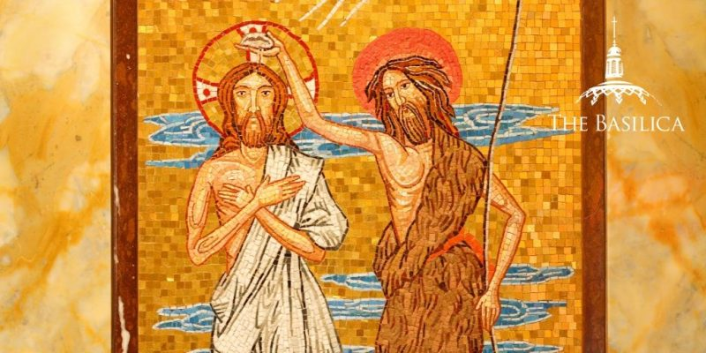

Questions 2
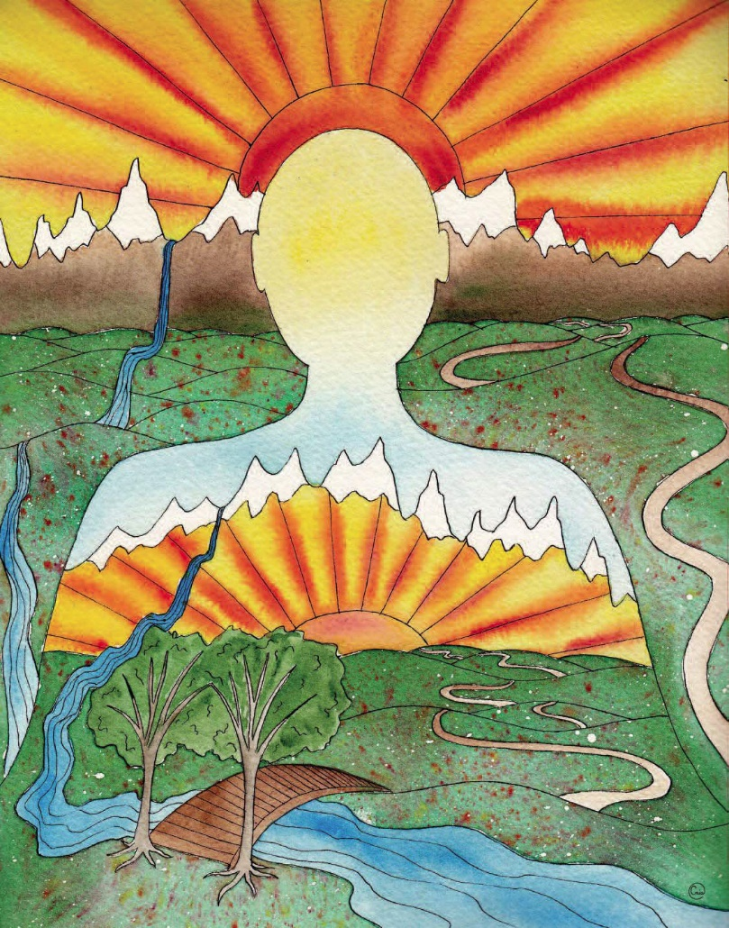

Questions 3

The next two pages are alternative images for question sets 1-3.
