Solidarity with Sisters’ Communal Prayer
June 12, 2022 – The Solemnity of the Most Holy Trinity

“The love of God has been poured out into our hearts
through the Holy Spirit.”
Rom 5:5

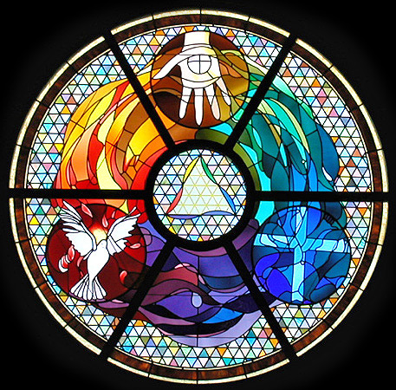
Trinity Window, St. Gabriel of the Sorrowful Mother, Avondale, PA

HELLOs and then Betty mutes everyone. (Betty Thompson)

WELCOME (Richard McGinnis)

Welcome, everyone!
- Introductions – people who haven’t been here before?
- I (Richard McGinnis) prepared today’s communal prayer.
- Thanks to the people who will be reading and leading us in music and prayer today: Debra Street, Marilyn Voigt, Mary Dolmage, Bill Fanelli, Anne Regan, Kathy Linaberry, Maryann Dolan, Dan McCarthy, Karen McCarthy, Sister Jo’Ann De Quattro, Sister Jennie Lechtenberg, Rose Marie Smith and Terri Butel.
- If you’d like to read on future Sundays, please get in touch.

SETTLING IN (Richard McGinnis)

Settle into in a position where you feel supported and comfortable. Let your breath slow and deepen and find its natural pace… in and out…. [Pause.] Become aware of divine peace surrounding you…. [Pause.] Let that peace flow into three collective breaths: one to be here…. One to be together….. And one to welcome the Holy Spirit. [Pause.]

Now Debra Street will lead us into our prayer together.

OPENING SONG--“They'll Know We Are Christians by Our Love” by Peter Scholtes (Debra Street)

We are one in the Spirit, we are one in the Lord;
We are one in the Spirit, we are one in the Lord;
And we pray that all unity will one day be restored.
Chorus: And they'll know we are Christians by our love, by our love,
yes, they'll know we are Christians by our love.
We will walk with each other, we will walk hand in hand;
We will walk with each other, we will walk hand in hand;
And together we'll spread the news that God is in our land.
Chorus: And they'll know we are Christians by our love, by our love,
yes, they'll know we are Christians by our love.
We will work with each other, we will work side by side;
We will work with each other, we will work side by side;
And we'll guard each one’s dignity and save each one’s pride.
Chorus: And they'll know we are Christians by our love, by our love,
yes, they'll know we are Christians by our love.
All praise to the Father, from whom all things come;
And all praise to Christ Jesus, His only Son.
And all praise to the Spirit who makes us one.
Chorus: And they'll know we are Christians by our love, by our love,
yes, they'll know we are Christians by our love.

GREETING (Mary Dolmage)

God’s beloved people, we welcome you with joy! May grace and peace be with you.

All: And with you, too. Thanks be to God!

CALL TO WORSHIP/ GATHERING PRAYER (Mary Dolmage)

We are here to celebrate that God loves us more than we can imagine.

We gather as imperfect people who are called and challenged to follow Jesus. We seek to live our vocation as people who continue God’s work of creation. And so we pray:

May the witness to Christ be strong among us, and fill us with the gifts of the Spirit as we work for and wait for the fullness of God’s reign. May God keep us steady as we inquire, nudge, and challenge each other. May it be so. [Pause.]

Richard McGinnis will introduce us to today’s theme.

INTRODUCTION TO THEME (Richard McGinnis)

Why do we have Trinity Sunday right after Pentecost? It may be because we have just received the Holy Spirit, and the only way to know the Spirit is by entering the mystery of loving relationship.
While a full understanding is beyond our comprehension, the mystery of the Trinity is at heart a mystery of love. The triune God is love constantly outpoured.
We see this outpouring in our readings for today, often in surprising ways. For example, Paul says it is not our actions that save us because we are “justified by faith.” Then in the Gospel Jesus tells us that all that was given to him will also be given to us. Sister Mary McGlone cautions us against thinking that only mystics and theologians can understand the mystery of the Trinity. As disciples, we are explicitly invited into the dynamic of that mystery and its core meaning of love.

[Slight pause]

Now Anne Regan will read from the Letter of Saint Paul to the Romans. Bill Fanelli will offer questions that will lead us into silence.

READING 1 Romans 5:1-5 (Anne Regan)

Brothers and sisters:
now that we have been justified by faith,
we are at peace with God through our Lord Jesus Christ.
It is through Christ and by faith that
we live in this grace in which we stand,
exulting in hope of the glory of God.
Not only that, but we even exult in our afflictions,
knowing that affliction produces endurance
and endurance produces proven character,
and proven character produces hope.
Hope does not disappoint
because the love of God has been poured out into our hearts
through the Holy Spirit that has been given to us.

QUESTIONS 1 [Pause after each question.] (Bill Fanelli)

What are the barriers to your love for others; how do you overcome them?

What do you do when remaining hopeful becomes a challenge?

How did you emerge stronger or wiser from a stressful period?
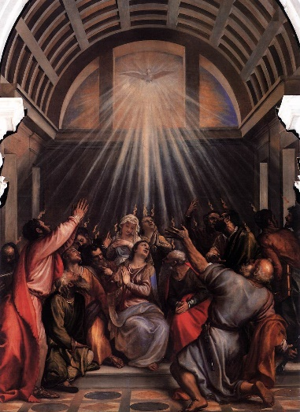

Titian, “The Descent of the Holy Ghost”. https://upload.wikimedia.org/wikipedia/commons/5/5a/Titian_-_The_Descent_of_the_Holy_Ghost_-_WGA22768.jpg

COMMUNAL SILENCE Betty: Share slide 1, time 2:00, chime, stop slide.]

Richard: Now Kathy Linaberry will read from the Gospel of John.

READING 2 John 16:12-15 (Kathy Linaberry )

Jesus said to his disciples:
I have much more to tell you, but you cannot bear it now.
But when the Spirit comes,
the Spirit will guide you to all truth.
The Spirit will glorify me,
because the Spirit will take from what is mine and reveal it to you.
Everything that Abba God has
belongs to me.

That is why I said that
the Spirit will take what is mine and reveal it to you.

[Slight pause]

QUESTIONS 2 [Pause after each question.] (Bill Fanelli)

When has your heart been softened by the example or words of a holy person?
How has the Spirit been your interior teacher, guiding you to the truth?
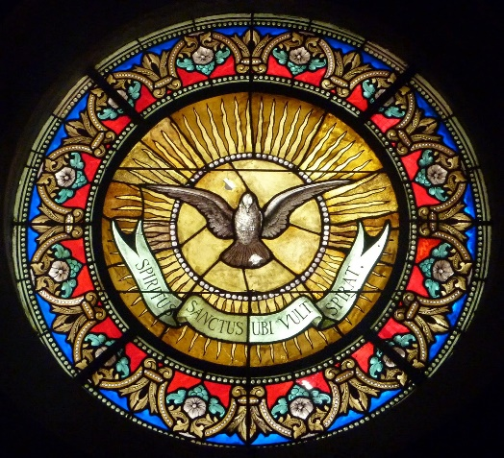
Lindas Palavras: Veni Creator Spiritus (Vem, Espirito Criador)
http://1.bp.blogspot.com/-IoxadKL5yWc/U5Wzegg1JMI/AAAAAAAAFmw/ceKoo0WmI1o/s1600/VENI,+CREATOR+SPIRITUS.jpg

COMMUNAL SILENCE Betty: Share slide 1, time 2:00, chime, stop slide.]

Richard: Now Maryann Dolan will read from an adaptation of a reflection on the Scriptures by Sister of St. Joseph Mary M. McGlone.

READING 3 (Maryann Dolan)

The mystery of the Trinity we celebrate today is a mystery of a loving relationship constantly outpouring. Christianity symbolizes the dynamic mystery of the Trinity in three names, traditionally Father, Son and Spirit. Other names could be Creator, Redeemer, Sanctifier; Mother, Child, and Womb; Lover, Beloved, Love.

In the gospel, we hear Jesus before the Ascension. As he prepares to go away, he promises his disciples that the Spirit will come and be his “forever presence.” Jesus pledges that the Spirit will keep the disciples aware of who he is and guide them to all truth. Jesus promises the Spirit as the energy or bond that will bring his disciples to share his own union with God.

When Jesus speaks of the Spirit, he makes it explicit that we are invited into the dynamic of that love. Jesus taught that he and God are one and everything that belongs to God also belongs to Jesus. Now Jesus says that his work will be carried on through the Spirit who shares all of this with us.
Listen again: Jesus promises the Spirit as the energy or bond that will bring his disciples, and us, to share his own union with God.
Remember, in this gospel Jesus is not talking to mystics in monasteries. He is talking to the bumblers who had walked with him for three years, declared their love, and then ran away from his suffering. Jesus’ followers were the most ordinary of sinful saints. The example of their lives leaves the rest of us no room to call ourselves too simple, weak or fearful.

Our faith reveals God as the One who reaches out to us, coming to us in terms that are both understandable and intriguingly mysterious. Christianity teaches that we are invited into this dynamic mystery symbolized by three names.

Perhaps the other three-word formula we can use is simply: “God is love.”

QUESTIONS 3 [Pause after each question.] (Bill Fanelli)

What names do you call our Triune God?
When has the energy of the Spirit uplifted you?
How does it feel to imagine hope that does not depend on what you do, but on your faith in God’s love pouring out to you?
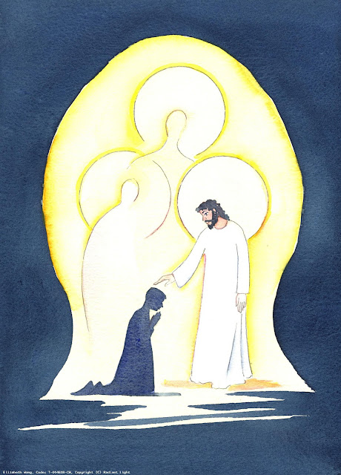
“Trinity”. Illustration by Elizabeth Wang

COMMUNAL SILENCE Betty: Share slide 3, time 2:00, chime, stop slide.]

Richard: Dan McCarthy will lead our sharing.

SHARING (Dan McCarthy)

We invite you to briefly share whatever is emerging in your heart this morning as you reflect on these readings. This helps us to glimpse the many ways God is among us. We welcome all voices, and we know that the wisdom of this community includes both words shared and silent listening.

As you share your feelings, please use "I” or “me". And let's leave a breath of silence between speakers. A bridge of silence allows us to take in what was just said as we sense how the Spirit is moving in us.

So let’s begin in silence as we gather our reflections. [Long pause.]

Please unmute yourself to speak, and mute again afterwards.

Who would like to start our sharing? [Let silence extend until someone is moved to speak.]
[Sharing]
[If there is extended silence during the sharing:] Is there anyone else who would like to share? [Long-ish pause]
If necessary say – “Those are wonderful resources but let’s save them for after our final song and return to personal sharing.”

[Stop by about 11:20.]
Thank you. We can continue after the final song, as we often do.

Now Karen McCarthy will lead us in prayer.

PRAYERS OF THE COMMUNITY (Karen McCarthy)

Let’s pause to notice the prayers that arise in us now. [Pause] Our response will be: “Spirit of Truth, guide us.”

God of love, grant us a sense of wonder in our relationships with one another and of reverence for all of the earth and its creatures. Let us pray. Spirit of Truth, guide us.
God of intimate presence, soften our hearts toward those who mourn, who are isolated, and who have suffered the fracture of relationships; those who seek acceptance by a society that has marginalized and targeted them, and those who yearn for family, friends, and community. Let us pray. Spirit of Truth, guide us.
God of wisdom, help us, together with the sisters and Leadership Conference of Women Religious, to recognize and embrace the truth that the Spirit reveals to us. Let us pray. Spirit of Truth, guide us.

For what else shall we pray? Please unmute yourself to speak, and mute yourself afterwards.

[Shared prayers] Spirit of Truth, guide us.

O You who see us, hear us, and love us more than we can imagine, thank you for receiving our intentions, spoken and unspoken. We entrust all to you. Amen.

OFFERTORY (Sister Jo’Ann De Quattro)

Take time to notice how Christ’s Spirit is active and moving in you right now. What would it look like for this Spirit to pour out of you this week? [Pause.]

Let us pray. God who loves us more than we can imagine, we offer you the gifts of our comfortable lives. Show us how to love more fully, imagine more creatively, and share more recklessly. Amen.

CELEBRATION OF COMMUNION (Sister Jennie Lechtenberg)

O Great Love, we are humbled and emboldened
to know that you trust us to be your body in this world.
We are part of that body as we let go of all that separates us from you,
and as we embrace one another and your entire creation with merciful love.

We remember the night before Jesus died.
At dinner with friends, Jesus knew all that would soon be asked of them,
and, loving them to the end, Jesus showed them how to care for each other
as they went out into the world.
First Jesus washed their feet
and said, “… as I have done for you, you should also do.”
Then he looked at what was in front of them, the bread and the wine,
gifts of Earth and the work of human hands, and blessed them.
So let us, too, invite God right now into what is front and center in our lives
knowing that God will indeed enter what we offer – and bless it. [Pause.]

Holy One, we entrust ourselves to you and to one another.
Make us your bread of abundance. Make us your wine of joy.
Let even our fragments be plenty to share.

Amen.

THE PRAYER OF JESUS (Rose Marie Smith)

Now let us join our hearts as if we could join our hands in harmony with our family throughout the world:

All (muted):

Heavenly Father, heavenly Mother,
Holy and blessed is your true name.
We pray for your reign of peace to come,
We pray that your good will be done,
Let heaven and earth become one.
Give us this day the bread we need,
Give it to those who have none.
Let forgiveness flow like a river between us,
From each one to each one.
Lead us to holy innocence
Beyond the evil of our days —
Come swiftly Mother, Father, come.
For yours is the power and the glory and the mercy:
Forever your name is All in One.
Amen.

FINAL BLESSING (Terri Butel)

As we close, let us feel this blessing upon us.

Blessed are you
who bear the light
in unbearable times,
who testify
to its endurance
amid the unendurable,
who bear witness
to its persistence
when everything seems
in shadow
and grief.
Blessed are you
in whom
the light lives,
in whom
the brightness blazes—
your heart
a chapel,
an altar where
in the deepest night
can be seen
the fire that
shines forth in you
in unaccountable faith,
in stubborn hope,
in love that illumines
every broken thing
it finds. Amen.

Now Marilyn Voigt will lead us in “Now Thank We All Our God”.

CLOSING SONG– “Now Thank We All Our God” by Martin Rinkart, translated by Catherine Winkworth (Marilyn Voigt)
Now thank we all our God, with heart and hands and voices,
Who wondrous things has done, in Whom this world rejoices;
Who from our mothers’ arms has blessed us on our way
With countless gifts of love, and still is ours today.
Oh, may this bounteous God through all our life be near us,
With ever joyful hearts and blessed peace to cheer us;
And keep us in His grace, and guide us when perplexed;
And guard us through all ills in this world, till the next!
All praise and thanks to God the Father now be given,
The Son, and Him Who reigns with Them in highest Heaven—
The one eternal God, Whom earth and Heav’n adore;
For thus it was, is now, and shall be evermore.

RESOURCES

Scriptures.
Sourced from https://bible.usccb.org/bible/readings/061222.cfm with adaptations inspired by the Jerusalem Bible.

Reflection on Scriptures.

Adapted from Mary M. McGlone, CSJ, “Trinity Sunday, All the Names of Love”, May 22, 2016.
https://www.ncronline.org/news/spirituality/scripture-life/trinity-sunday

Questions. Inspired, in part by Joan DeMerchant, “Prayers, Trinity Sunday.”
https://www.ncronline.org/news/spirituality/scripture-life/trinity-sunday

The Prayer of Jesus. The universal prayer of Jesus from Parker J. Palmer.
https://www.elkgroveumc.org/wp-content/uploads/2017/05/Alternative-versions-of-the-Lord.pdf

Final blessing. Jan Richardson: https://adventdoor.com/2014/12/12/advent-3-testify-to-the-light/
Music.
“They'll Know We Are Christians By Our Love” by Peter Scholtes.
https://wordtoworship.com/song/14526

“Now Thank We All Our God” by Martin Rinkart, translated by Catherine Winkworth.
https://library.timelesstruths.org/music/Now_Thank_We_All_Our_God/midi/

Music Options.

“They'll Know We Are Christians By Our Love” (Lynda Randle w/ Lyrics)
Video with lyrics for verses 1, 2, and 4; 10 to 2:12
https://www.youtube.com/watch?v=C5aR6smn3TE
“Now Thank We All Our God.”
Video with lyrics, 24 to 3:10.
https://www.youtube.com/watch?v=dCKRHp2Yuzs

Sacred Art.

a.Trinity Window, St. Gabriel of the Sorrowful Mother, Avondale, PA.
Beyer Studio-Stained Glass
https://beyerstudio.com/images/portfolio/SGAP/1.jpg
b. Titian, “The Descent of the Holy Ghost”.
https://upload.wikimedia.org/wikipedia/commons/5/5a/Titian_-_The_Descent_of_the_Holy_Ghost_-_WGA22768.jpg

c. Lindas Palavras: Veni Creator Spiritus (Vem, Espirito Criador)
http://1.bp.blogspot.com/-IoxadKL5yWc/U5Wzegg1JMI/AAAAAAAAFmw/ceKoo0WmI1o/s1600/VENI,+CREATOR+SPIRITUS.jpg

d. Illustration by Elizabeth Wang, T-00461B-CW, ‘Trinity’, copyright © Radiant Light 2006, www.radiantlight.org.uk
Source:http://radiantlight.org.uk/images/image/310?search=trinity&searchType=both&start=0
Image address: https://3.bp.blogspot.com/-FFzwLLDjmwA/WvycC_szjGI/AAAAAAAAH3g/Uq0pAaib_fw00vJvAo38BpwCYfbZxo5CQCKgBGAs/s640/Trinity-wang-T-00461B-CW.jpg

