Solidarity with Sisters Communal Prayer January 1, 2023

The Octave Day of Christmas

Solemnity of the Blessed Virgin Mary, the Mother of God

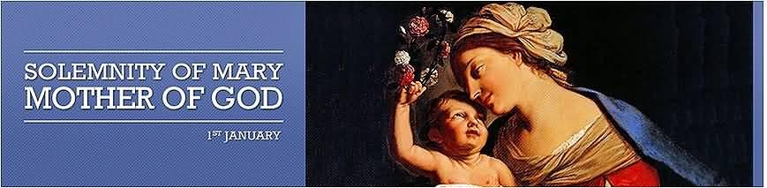

HELLOs AND HAPPY NEW YEAR! and then Betty mutes everyone.

WELCOME (George Urban)
Welcome, everyone.
- Introductions – people who haven’t been here before?
- Alicia and I have prepared today’s communal prayer. And we send out a thank you to Suzie and Betty for their collaboration with us.
- Thank you for all who are taking part in our service today: Charlette Cook, Rose Marie Smith, Debra Street, Judith Galleazzi, Mia and Tim Brown, Maria Desjardins, Lynn Bufka, Kathy and Bill Cavanaugh.
- Please remember to unmute yourself before speaking and mute again afterwards.
- If you are willing to read in the future, please let us know. For Jan. 7, please contact Kathy and Bill Cavanaugh and for Jan. 14, please contact Norb Bufka. Their emails will be in Chat. [Suzie post in Chat]

SETTLING IN (Alicia Urban)

Take some time to be still and relax. Be aware of the gift of life as we breathe together. Breathe together to the count: “Breathe in: 1,2,3, Exhale slowly: 1, 2, 3, 4, 5, 6. Repeat …
Take a slow breath again to celebrate our being in God and with each other. ... Finally, breathe together and reflect on God’s gift that calls us to be here to celebrate this New Year’s morning.” (Pause)

Now listen to and sing our opening song!

OPENING SONG: Mary, did you know? (Betty – play
https://www.youtube.com/watch?v=huBusTlJ2-8 – play until 2:40.)

Mary, did you know that your baby boy
Would one day walk on water?
Mary, did you know that your baby boy
Would save our sons and daughters?
Did you know that your baby boy
Has come to make you new?
This child that you delivered, will soon deliver you.
Mary, did you know?
Mary, did you know?
Mary, did you know? Mary, did you know?
Mary, did you know that your baby boy
Is Lord of all creation?
Mary, did you know that your baby boy
Would one day rule the nations?
Did you know that your baby boy
Is heaven's perfect Lamb?
That sleeping child you're holding is the great, I Am.
The blind will see, the deaf will hear,
The dead will live again,
The lame will leap, the dumb will speak
The praises of the Lamb.
Mary, did you know?
Mary, did you know?
Mary, did you know? Mary, did you know?
Mary, did you know? Mary, did you know?
Mary, did you know? Mary, did you know?

Alicia: George Urban will call us to worship and Lynn Bufka will lead us in prayer.

CALL TO WORSHIP (George Urban)

As we celebrate this Feast of Mary, Mother of God, we pray:
Jesus, we deeply desire for you to join us
To lead us in our prayers,
To bring the Holy Spirit into our hearts,
To guide us on our journey,
toward peace, love, and justice.

GATHERING PRAYER (Lynn Bufka)

God of hope, who brought love into this world,
be the love that dwells between us.
God of hope, who brought peace into this world,
be the peace that dwells between us.
God of hope, who brought joy into this world,
be the joy that dwells between us.
God of hope, the rock we stand upon,
be the center, the focus of our lives
always, and particularly on this solemn day.

INTRODUCTION OF THE THEME (Alicia Urban)

On this feast day, in the Octave of Christmas, we will hear from Paul and the Gospel of Luke. Then we will reflect on Pope Francis’ homily that includes the statement that “to receive grace we must be active.” These readings are all about verbs. To be adopted. To bless. To be born. To find. The first reading from Numbers will be our final blessing.

Paul is speaking to the Galatians who were primarily gentile Christians in the area that is Egypt today. He is addressing the importance of “The Son of God being born of a woman” and our being “adopted sons and daughters of God.” Then the Gospel describes the shepherds as constantly on the lookout, constantly on the move: “they went with haste, they found, they made known, they returned, glorifying and praising God.” They were not passive. Let’s say together: “Glory to God in the Highest.” (pause)

We celebrate Mary’s motherhood today, and like all mothers she both “pondered things in her heart” and actively engaged with her child from the moment of her “yes” to her pregnancy.

What about ourselves? What are we called to find at the beginning of this year? Time is a treasure that all of us possess. We can no longer be passive. Let us use this hour to ask for the grace to find time for God and for each other.

Now Charlotte Cook will read from Galatians, and Debra Street will offer questions for your reflection. Follow whatever question might call you.

READING 1: Gal 4:4-7 (Charlette Cook)

Brothers and sisters:
When the fullness of time had come, God sent the Son,
born of a woman, born under the law,
to ransom those under the law,
so that we might receive adoption as sons and daughters.
As proof that you are children,
God sent the Spirit of the Son into our hearts,
crying out, “Abba!”
So you are no longer a slave but a child,
and if a child, then also an heir, through God.

QUESTIONS 1 [Pause after each question.] (Debra Street)
What is the particular blessing you feel today as an adopted child of God?

How do you respond to: “in the fullness of time, God sent his Son, as a ransom under the law?”
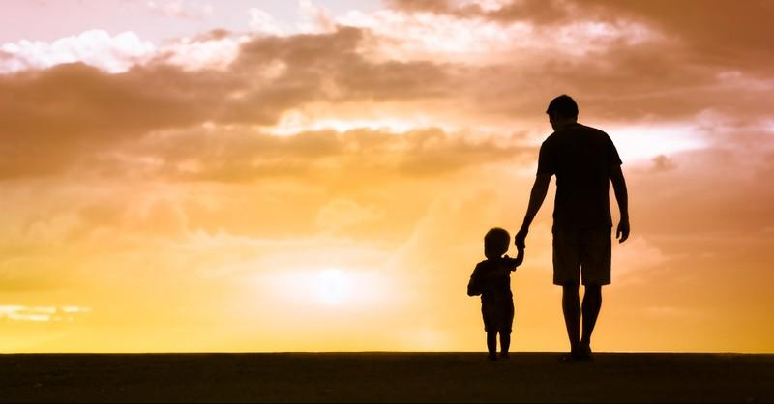

(Betty) Let us listen as Rose Marie Smith reads from the Gospel of Luke.

READING 2: Lk 2:16-21 (Rose Marie Smith)

The shepherds went in haste to Bethlehem and found Mary and Joseph,
and the infant lying in the manger.
When they saw this,
they made known the message
that had been told them about this child.
All who heard it were amazed
by what had been told them by the shepherds.
And Mary kept all these things,
reflecting on them in her heart.

Then the shepherds returned,
glorifying and praising God
for all they had heard and seen,
just as it had been told to them.
When eight days were completed for his circumcision,
he was named Jesus, the name given him by the angel
before he was conceived in the womb.

QUESTIONS 2 [Pause after each question.] (Debra Street)
Put yourself in the stable and sense your reaction as the shepherds say what the angels told them about this child.

What is the amazing news of this day for you?

What might you say to Mary?

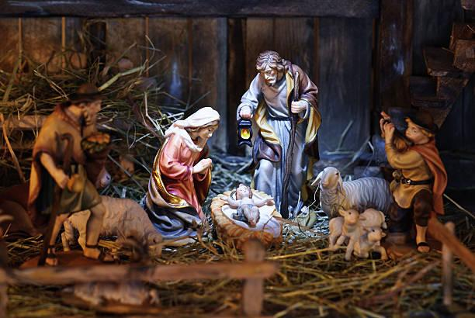

READING 3: (George Urban)

Our third reading is a summary of the Homily of His Holiness Pope Francis
on the Solemnity of Mary, Mother of God, and the 54th World Day of Peace on Friday, 1 January 2021.

Pope Francis points to three verbs that find their fulfilment in the Mother of God: to bless, to be born and to find.

To bless:
Today we celebrate the Son of God, who is “blessed” by nature, who comes to us through his Mother, “blessed” by grace. In this way, Mary brings us God’s blessing. Wherever she is, Jesus comes to us.
We too are called to bless, to “speak well” in God’s name. Our world is gravely polluted by the way we “speak” and think “badly” of others, of society, of ourselves. Speaking badly corrupts and decays, whereas blessing restores life and gives the strength needed to begin anew each day.
The second verb is to be born. Saint Paul points out that the Son of God was “born of a woman” (Gal 4:4). In these few words, he tells us something amazing: that the Lord was born like us. He did not appear on the scene as an adult, but as a child. He came into the world not on his own, but from a woman, after nine months in the womb of his mother. The heart of the Lord began to beat within Mary; the God of life drew oxygen from her. Ever since then, Mary has united us to God because in her, God bound himself to our flesh, and he has never left it. Saint Francis loved to say that Mary “made the Lord of Majesty our brother.” Through Mary, we encounter God the way he wants us to: in tender love, in intimacy, in the flesh.
We are in this world not to die, but to give life. The holy Mother of God teaches us that the first step in giving life to those around us is to cherish it within ourselves. Everything starts from this: from cherishing others, the world and creation. This year, while we hope for new beginnings and new cures, let us not neglect care. Together with a vaccine for our bodies, we need a vaccine for our hearts. That vaccine is care.
The third verb is to find. The shepherds “found Mary and Joseph and the child,” a simple family perhaps like their own. Yet there they truly found God, who is grandeur in littleness, strength in tenderness. But how were the shepherds able to find this inconspicuous sign? They were called by an angel. We too would not have found God if we had not been called by grace. We could never have imagined such a God, born of a woman, who revolutionizes history with tender love. Yet by grace we did find him. And we discovered that his forgiveness brings new birth, his consolation enkindles hope, his presence bestows irrepressible joy and each day he has to be found anew. The Gospel describes the shepherds as on the move. They were not passive, because to receive grace we must be active.
What about ourselves? What are we called to find at the beginning of this year? Time is a treasure that all of us possess. Let us ask for the grace to find time for God and for our neighbor.

QUESTIONS 3 [Pause after each question.] (Debra Street)

What is your feeling or response about: “blessing restores life and gives the strength”?

Respond with your feelings: “Together with a vaccine for our bodies, we need a vaccine for our hearts. That vaccine is care.”

What are you called “to find” at the beginning of this year?

SHARING (Judith Galleazzi)

We invite you to share briefly what emerged in your heart this morning as you listened and as you reflected on these readings that help us to glimpse the many ways God is among us. We welcome new voices, and we also know that the wisdom of this community includes both words shared and silent listening. And let’s leave a bridge of silence between speakers.

We begin in silence as we gather our reflections. [Long pause.]

Please unmute yourself to speak, and mute again afterwards. Who would like to begin?

Ask when closer to the time limit, “Would anyone else like to share?”
(Let sharing continue for a total of about 20 minutes.)

Thank you for your insights and thoughts. We have to stop now, but we can continue after the final song, as we often do.

Now let us pray together.

PRAYERS OF THE COMMUNITY (Mia and Tim)

Our response is: Jesus with Mary, pray for us.

For those in Ukraine and so many other places experiencing war or oppression, may they be blessed and remembered, we pray:
Jesus with Mary, pray for us.

May those who have experienced destruction from natural disasters and violence, find comfort, and for those who reach out to them, we pray:
Jesus with Mary, pray for us.

For our world as it, and all of us, facing destruction from human neglect, and denial of what may lead to the end of life as we know it, we pray:
Jesus with Mary, pray for us.

That those who have devoted their lives in service to all who are church, as well as members of religious orders, be blest with a dignified and happy retirement, we pray,
Jesus with Mary, pray for us.

That the light of Christ may be reflected in our lives in the new year, we pray,
Jesus with Mary, pray for us.

For what else shall we pray? (Please unmute and then mute yourself after your intention.)

[Shared prayers] Jesus with Mary, pray for us.

End with: Thank you. Marie Desjardins will continue our celebration.

CELEBRATION OF COMMUNION (Maria Desjardins)

O Great Love, we are humbled and emboldened
to know that you trust us to be your body in this world.
We are part of that body as we let go of all that separates us from you,
and as we embrace one another and your entire creation with merciful love.
We give you thanks for your presence in and among us. [Pause.]

We remember the night before Jesus died.
At dinner with friends, Jesus knew all that would soon be asked of them,
and, loving them to the end, Jesus showed them how to care for each other
as they went out into the world.
First Jesus washed their feet
and said, “… as I have done for you, you should also do.”
Then he looked at what was in front of them, the bread and the cup,
gifts of the earth and work of human hands and blessed them.
So let us, too, invite God right now into what is front and center in our lives
knowing that God will indeed enter what we offer – and bless it. [Pause.]

Holy One, make us your bread of abundance. Make us your wine of joy.
Let even our fragments be plenty to share.
Amen.

THE JESUS PRAYER (Lynn Bufka) ALL MUTED

O most Compassionate Life-giver,
may we honor and praise you;
May we work with you to establish your new order of justice, peace and love;
Give us what we need for growth,
And help us, through forgiving others, to accept forgiveness.
Strengthen us in the time of testing, that we may resist all evil,
For all tenderness, strength and love are yours, now and forever.
Amen.
FINAL BLESSING: from today’s 1st reading: Numbers 6 (Kathy Cavanaugh))
Holy Mother of God, to you we consecrate this New Year. You, who know how to cherish things in your heart, care for us, bless our time, and teach us to find time for God and for others. Let us use these words from Numbers as our first blessing of 2023.
Yahweh blesses you and keeps you!
let Yahweh’s face shine upon you and be gracious to you!
May God look upon you kindly and
give you peace!
Now let us join the Glasgow Church of Christ in singing Hark ,the Herald Angels Sing!

CLOSING SONG: “Hark, the Herald Angels Sing!” (Betty)
”https://www.youtube.com/watch?v=I5t_mHRSnHI

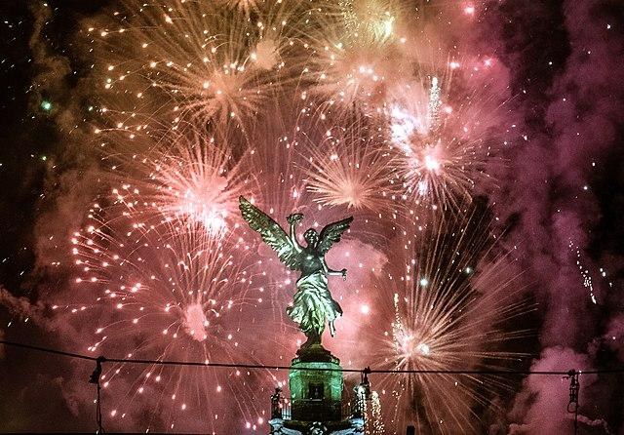

“Hark the Herold Angels Sing”

Hark! The herald angels sing
"Glory to the new-born king!
Peace on earth and mercy mild,
God and sinners reconciled."
Joyful all ye nations rise
Join the triumph of the skies
With th’angelic host proclaim.
"Christ is born in Bethlehem!"
Hark! The herald angels sing
"Glory to the new-born king!"
Mild He lays His glory by,
Born that we no more may die,
Born to raise us from the earth,
Born to give us second birth.
Veiled in flesh the Godhead see,
Hail the incarnate Deity
Pleased with us in flesh to dwell,
Jesus, our Emmanuel!
Hark! The herald angels sing
Glory to the newborn King!

Hail the heav’n-born Prince of Peace!
Hail the Sun of Righteousness!
Light and life to all He brings,
Ris’n with healing in His wings.
Mild He lays His glory by,
Born that we no more may die,
Born to raise us from the earth,
Born to give us second birth,
Hark! The herald angels sing,
"Glory to the new-born king!"

Resources:

Proclaim - Mary did you know

https://www.youtube.com/watch?v=huBusTlJ2-8

Homily of His Holiness Pope Francis: Solemnity of Mary, Mother of God, 54th World Day of Peace, Friday, 1 January 2021
USCCB: Readings for Jan. 1, 2022
Hark the Herold Angels Sing https://www.youtube.com/watch?v=I5t_mHRSnHI

